**USER GUIDE TO XML & DATA MODEL FOR AIR QUALITY PLANS (H-K)**

v1

Jaume Targa, Tony Bush, Barbara Magagna and Lorena Banyuls(ETC/ACM)

Optimised for schema version 1.0.9

August 2017

Table of contents

Introduction 5

Online resources 6

Guidance, guides and guideline documents 6

The EEA’s helpdesk for AQ e-Reporting 7

INSPIRE data specifications 8

PaPeRS 8

Accessing the system 9

Quick guide for PaPeRS 10

H-K Plans and Programmes 12

Reporting header <aqd:AQD_ReportingHeader> 16

H- Information on the air quality plan(s) (Art. 13) 19

Plan <aqd:AQD_Plan> 19

AQ Plan identifier- <aqd:inspireId> 22

AQ Plan code- <aqd:code> 23

AQ Plan name- <aqd:name> 24

Competent Authority- <aqd:competentAuthority> 24

Reference Year of first exceedance - <aqd:firstExceedanceYear> 27

Status - <aqd:status> 28

Pollutants covered - <aqd:pollutants> 29

Date of official adoption - <aqd:adoptionDate> 31

Timetable of implementation - <aqd:timeTable> 32

Reference to AQ Plan - <aqd:referenceAQPlan> 33

Reference to implementation - <aqd:referenceImplementation> 34

Relevant publication - <aqd:publication> 34

Comment - <aqd:comment> 37

Information on exceedance situation(s) - <aqd:exceedanceSituation> 38

I - Quantitative source apportionment 40

Reporting header- <aqd:AQD_ReportingHeader> 40

Air quality source apportionment - <aqd:AQD_SourceApportionment> 41

Air Quality Source Apportionment identifier- <aqd:inspireId > 45

Reference Year - <aqd:referenceYear> 46

Regional Background - <aqd:regionalBackground> 47

Urban Background - <aqd:urbanBackground> 54

Local Increment - <aqd:localIncrement> 64

Macro Exceedance Situation 75

Comments - <aqd:comments> 95

AQD Plan - <aqd:usedInPlan xlink:href> 96

Parent exceedance situation - <aqd:parentExceedanceSituation xlink:href> 97

J – Baseline and Evaluation Scenarios - <aqd:AQD_EvaluationScenario> 99

AQD Evaluation Scenario identifier- <aqd:inspireId> 102

Code of scenario - <aqd:codeOfScenario> 103

Relevant Publication - <aqd:publication> 104

Attainment year for which the projections are calculated - <aqd:attainmentYear> 106

Reference year - <aqd:startYear> 107

Baseline Scenario - <aqd:baselineScenario> 109

Projection Scenario - <aqd:projectionScenario> 117

AQ Plan - <aqd:usedInPlan> 124

AQ Source Apportionment - <aqd:sourceApportionment> 125

K - Documentation of measures 126

Reporting header <aqd:AQD_ReportingHeader> 126

Air quality mdentifier - <aqd:inspireId> 130

Air quality measures code - <aqd:code> 131

Air quality measure name - <aqd:name> 132

AQ Measure description - <aqd:description> 132

Air quality measure classification - <aqd:classification> 133

Air quality measure type - <aqd:type> 135

Administrative level - <aqd:administrativeLevel> 136

Time scale - <aqd:timeScale> 137

Costs - <aqd:costs> 138

Affected source - <aqd:sourceSectors> 145

Spatial scale - <aqd:spatialScale> 146

Planned implementation - <aqd:plannedImplementation 147

Reduction in emissions due to applied measure - <aqd:reductionOfEmissions 157

Expected impact on ambient concentrations - <aqd:expectedImpact 160

Comment for clarification - <aqd:comment 165

Code of source apportionment - <aqd:exceedanceAffected> 166

Code of evaluation scenario - <aqd:usedForScenario> 167

# Introduction

The user guide to the AQ e-Reporting XML schema & data model for Air Quality Plans and Programmes is targeted at air quality experts to support the implementation of reporting under [Decision 2011/850/EU](http://eur-lex.europa.eu/LexUriServ/LexUriServ.do?uri=OJ:L:2011:335:0086:0106:EN:PDF). This guide aims to provide necessary information for data flows and elements required by this Decision in relation to Air Quality Plans and Programmes.

The guide currently describes in detail the following information items from an air quality perspective:

* Online resources
* Common XML structure for e-reporting
* Common information elements / data types
  + The GML identifier
  + The INSPIRE identifier
  + The e-Reporting reporting header
  + The Environmental objective data object
* Data flow H– Information on air quality plans (Article 13)
* Data flow I – Information on source apportionment (Article 13)
* Data flow J – Information on the scenario for the attainment year (Article 13)
* Data flow K – Information on measures (Article 13 and 14)

Furthermore this user guide focuses on the use of the **Plans and Programmes e-Reporting System** (PaPeRS) developed by JRC, Ispra and hosted at the EEA through the centralized EEA solution: <http://papers.eionet.europa.eu/>. This software supports air quality experts in preparation of XML reports which then should be delivered by authorised national representatives to the EEA’s Central Data Repository (see at: <http://cdr.eionet.europa.eu/>). Access to the PaPeRS software does not authorise air quality experts to report AQ Plans and Programmes to the EEA, its merely a tool for compiling the XML reports.

Air quality plans have to be reported according to the new e-Reporting schema which links all of the air quality related data. The PaPeRS tool takes advantage of the interlinked data by importing and referring directly to XML reports on attainment (G). To acheive this the attainment data must first be uploaded and released on CDR as part of a normal reporting obligation in September each year. Then as PaPeRs can reference or cite this information as part of data flows H-K.

A ***standalone solution*** has been also made available for those reporting authorities who would want to deploy the system as part of their own infrastructure: *source code*, provided through git repository, available [here](https://github.com/eea/aqr-public).

## Online resources

In order to facilitate the implementation of the [Decision 2011/850/EU](http://eur-lex.europa.eu/LexUriServ/LexUriServ.do?uri=OJ:L:2011:335:0086:0106:EN:PDF), the European Environment Agency (EEA) has set up the [Air Quality Portal](http://www.eionet.europa.eu/aqportal) to support the transition to e-Reporting. The Air Quality Portal, managed by ETC/ACM, is the central information hub for reporting air quality data across Europe via e-Reporting. The Air Quality Portal includes online resources for:

* Guidelines & reports for e-Reporting - [here](http://eeadmz1-cws-wp-air.azurewebsites.net/toolbox-for-e-reporting/guidance-on-the-commision-ipr-decision/),
* Controlled code lists and vocabularies for e-Reporting – [here](http://eeadmz1-cws-wp-air.azurewebsites.net/toolbox-for-e-reporting/code-lists/),
* The latest data model & AQD schemata - [here](http://eeadmz1-cws-wp-air.azurewebsites.net/toolbox-for-e-reporting/data-model-and-schema/),
* Central repository for data deliveries – piloting phase [here](http://eeadmz1-cws-wp-air.azurewebsites.net/toolbox-for-e-reporting/repository/)
* Helpdesk for reporting – [here](http://projects.eionet.europa.eu/implementation-2011-850-eu/library/).
* Guidelines for Reporting of Air Quality Plans and Programs with the open-source e-reporting system developed by JRC, Ispra - [here](http://eeadmz1-cws-wp-air.azurewebsites.net/toolbox-for-e-reporting/pp-tool/#PaPeRS User Manual)
* Access to Plans and Programmes e-Reporting System (PaPeRS) through the centralized EEA solution - [here](http://eeadmz1-cws-wp-air.azurewebsites.net/toolbox-for-e-reporting/pp-tool/#Access to PaPeRS)

### Guidance, guides and guideline documents

A range of guidance documents has been prepared by DG-ENV, the EEA and ETC/ACM to describe different components of the e-Reporting process. These support the implementation of both legal obligations (implementing provisions) and provide informative best practice on effective e-Reporting. A list is available on the air quality portal covering:

* User guide to XML and data model (latest version)
* Aggregation rules for e-Reporting
* Aggregation benchmarking datasets
* The latest version of DG Environment’s Guidance on the “Commission Implementing Decision laying down rules for Directives 2004/107/EC and 2008/50/EC of the European Parliament and of the Council as regards the reciprocal exchange of information and reporting on ambient air (Decision 2011/850/EU)”.

### The EEA’s helpdesk for AQ e-Reporting

EEA’s Air Quality portal includes a helpdesk to support Eionet countries in participation in e-Reporting. Questions can be submitted to the helpdesk by [email](mailto:aqipr.helpdesk@eionet.europa.eu). The historical questions can be accessed directly from the [portal](http://projects.eionet.europa.eu/implementation-2011-850-eu/library).

|  |
| --- |
|  |
| Figure – Helpdesk for e-Reporting - http://www.eionet.europa.eu/aqportal |

**Focus On**

**NEW helpdesk email**

|  |
| --- |
| [aqipr.helpdesk@eionet.europa.eu](mailto:aqipr.helpdesk@eionet.europa.eu) |

## INSPIRE data specifications

A list of latest INSPIRE data specifications upon which the Air Quality Data Model has been based, is also available at the portal. Links to this information on the INSPIRE web site have been provided on the portal and below. An air quality specific interpretation of these INSPIRE requirements including how they are implemented in the e-Reporting data model is summarised in this document to facilitate adoption of INSPIRE elements within the air auality community:

[INSPIRE Basics](http://inspire.ec.europa.eu/node/563)

[Data Specification on Area management/restriction/regulation zones and reporting units - Technical Guidelines](http://inspire.ec.europa.eu/Themes/139/2892)

[Data Specification on Environmental monitoring Facilities - Technical Guidelines](http://inspire.ec.europa.eu/Themes/120/2892)

[Data Specification on Atmospheric Conditions - Meteorological geographical features](http://inspire.ec.europa.eu/Themes/142/2892)

[INSPIRE Generic Conceptual Model](http://inspire.ec.europa.eu/documents/inspire-generic-conceptual-model)

[Draft Guidelines for the use of Observations & Measurements and Sensor Web Enablement - related standards in INSPIRE Annex II and III data specification development](http://inspire.ec.europa.eu/documents/guidelines-use-observations-measurements-and-sensor-web-enablement-related-standards-0)

## PaPeRS

The following general features are built into the PaPeRs e-reporting solution:[1]

* **Hierarchical access**: Structurally the system provides three levels of access which have different controls over the functionality of the system, depending on their level of access. Those are: “EEA Administrator”, “National Administrator” and “User”.
* **A Localized** **user interface**: The system allows localization (translation) into any language to allow users to translate the interface into any of the 24 official languages of the European Union.
* **Extensibility**: The system uses generic software components, and the source code is well documented, thus allowing easy extensibility for providing functionality which is currently not being implemented. Data upload: Information represented through XML for any of the H-K dataflows (Plans, Source Apportionment, Measures, Evaluation Scenarios), as well as dataflow “G” (Attainments) can be imported into the system if they pass a validation step during the import process against the air quality schema.
* **Data reuse**: Data which is already loaded can be reused through ‘clone’ functionality which creates identical records of already existing reports, which can then be modified and resubmitted to the EEA.
* **Data export**: The solution is implemented to strictly follow the air quality schema and data model which garantuees also the INSPIRE data models compatibility. There is built in functionality which controls the quality of the input against the model (mandatory fields, cardinalities, etc.). A dialogue boxes and tool tips provide an overview of mandatory fields which need to be populated to generate schema valid XML documents . Uploaded data records may be flagged and saved as either DRAFT when one or more of the mandatory fields are missing, and/or when a link to another dataflow is not provided. When all mandatory fields and link are populated reported records may be saved as complete.
* **Licencing**: The software product is entirely open source, licensed under the EUPL, allowing reuse of the code and unconstrained further development.

For more details on architecture, technology used, system installation as well as on user administration see [here](http://www.eionet.europa.eu/aqportal/toolbox/papers/usermanual/doc/JRC26862_AQPlans_en.pdf).

## Accessing the system

Access to the **Plans and Programs e-Reporting System** is provided by the centralized EEA solution: <http://papers.eionet.europa.eu/>

From the link above you will be redirected to the European Commission Authentication Service (ECAS) website in order to access the PaPeRS tool.

1. Log in to the European Commission Authentication System (ECAS) using an account created for your professional email address.
2. If you do not have an ECAS account yet follow the login link and register.
3. When logging in remember to use correct domain (“External” for most e-Reporting users).
4. In case of any problems with your ECAS account contact [ECAS Helpdesk](https://webgate.ec.europa.eu/cas/help.html).
5. Make sure that you have been granted access to the system by relevant national administrators:  
   [Austria](mailto:wolfgang.spangl@umweltbundesamt.at), [Belgium](mailto:fierens@irceline.be;peeters@irceline.be), [Bulgaria](mailto:z.solarska@eea.government.bg;fonmon@eea.government.bg;gyordanova@moew.government.bg), [Croatia](mailto:vedran.vadic@azo.hr), [Cyprus](mailto:skleanthous@dli.mlsi.gov.cy;cpapadopoulos@dli.mlsi.gov.cy), [Finland](mailto:Tarja.Lahtinen@ymparisto.fi;mika.vestenius@fmi.fi), [France](mailto:thomas.bouyer@developpement-durable.gouv.fr;soes-webdata-contact@developpement-durable.gouv.fr;aurelie.volokhoff@developpement-durable.gouv.fr), [Germany](mailto:marcel.richter@uba.de), [Hungary](mailto:gyarmatine.e@met.hu;puskas.monika@met.hu;judit.varga@fm.gov.hu), [Iceland](mailto:kristjan.andresson@ust.is;sigurdurb@ust.is;Vanda.Hellsing@umhverfisstofnun.is;thorsteinnj@ust.is), [Ireland](mailto:m.odwyer@epa.ie), [Latvia](mailto:tamara.vasiljeva@lvgmc.lv), [Lithuania](mailto:mindaugas.bernatonis@aaa.am.lt;vilma.bimbaite@aaa.am.lt;p.blonskis@aaa.am.lt;d.perkauskas@aaa.am.lt;z.siliene@aaa.am.lt), [Luxembourg](mailto:pierre.dornseiffer@aev.etat.lu;serge.solagna@aev.etat.lu;eric.vansuypeene@aev.etat.lu), [Netherlands](mailto:Hans.Berkhout@rivm.nl;wil.prins@minienm.nl;peter.vervoorn@rws.nl), [Norway](mailto:borghild.rime.bay@miljodir.no;silje.aksnes.bratland@miljodir.no;Sigmund.guttu@miljodir.no;Nina.Landvik@miljodir.no), [Poland](mailto:grazyna.sztandera@mos.gov.pl;marzena.zawalich@mos.gov.pl), [Portugal](mailto:cristina.figueiredo@ccdr-n.pt;dilia.jardim@apambiente.pt;isabel.marques@ccdr-lvt.pt;claudia.martins@apambiente.pt;sandra.mesquita@ccdr-lvt.pt;vitor.monteiro@ccdr-n.pt;luisa.nogueira@ccdr-lvt.pt), [Romania](mailto:alexandru.brusten@anpm.ro;patricia.lungu@anpm.ro), [Slovakia](mailto:jana.matejovicova@shmu.sk;radoslav.virgovic@sazp.sk), [Slovenia](mailto:Jana.Faganeli-Pucer@gov.si), [Spain](mailto:mpallares@magrama.es), [Sweden](mailto:Anders.Foureaux@naturvardsverket.se;titus.kyrklund@naturvardsverket.se;Matthew.Ross-Jones@Naturvardsverket.se;helena.sabelstrom@naturvardsverket.se), [United Kingdom](mailto:tony.bush@ricardo-aea.com;Sally.Cooke@ricardo-aea.com;Charlotte.Jones@defra.gsi.gov.uk;John.Newington@defra.gsi.gov.uk;John.Stedman@aeat.co.uk)
6. In case your country is not on the list contact [**AQ-IPR Helpdesk**](mailto:aqipr.helpdesk@eionet.europa.eu).

## Quick guide for PaPeRS

When the user logs into the system six tabs will be presented at the top of the screen, just under the European Commission banner. These tabs represent six main areas of the system that the user should get familiar with.



**Figure 2: tabs of PaPeRs**

The purpose of the tabs is as follows:

**1.** Home. This tab presents statistics on the data in the system of the users “home” country.

**2.** Plan. The tab for reporting data flow “H” data (Plans).

**3.** Source Apportionment. The tab for reporting data flow “I” data (Source apportionment).

**4.** Evaluation Scenario. The tab for reporting data flow “J” data (Evaluation Scenario).

**5.** Measures. The tab for reporting data flow “K” data (Measures).

**6.** Settings. Additional settings, user management and data flow “G” (Attainments) import functionality.

For each of the data flows a user can create new data flow record. The system will automatically populate the ‘provider’ section and the namespace with the information provided in the Settings tab. Each record in the table has a status, either ‘DRAFT’ or ‘COMPLETE’. This indicates whether or not all the required data from mandatory fields have been provided. Alternatively a user can upload an pre-existing H-K XML file e.g. a document previously exported by the PaPeRs tool, and import it to the system.If the uploaded file has an incorrect structure the procedure will terminate with an error. It is also possible to export records as XML file.

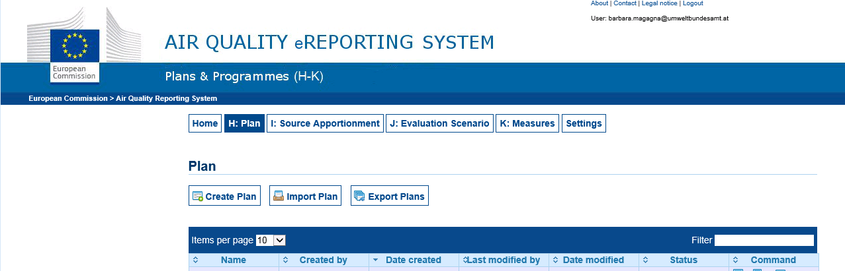

**Figure 3: Functionalities of PaPeRS**

H-K Plans and Programmes

The data flows H-K are interdependent and Figure 4 gives an overview of these dependencies.

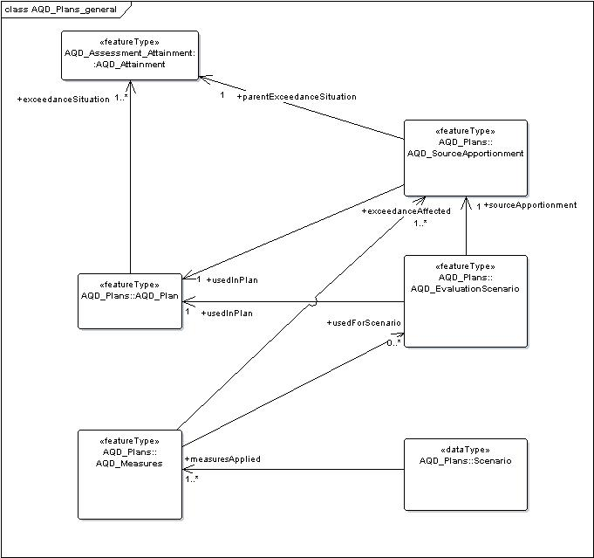

**Figure 4: Data Flows in Plans and Programs**

A key feature of the Plans and Programmes reporting is the different types of exceedance situation that are implemented (see Figure 5). In Plans and Programmes we distinguish between:

* **Parent** Exceedance Situations: This is the exceedance situation provided in data flow G which describes the maximum (highest) exceedance level observed within a zone either as a mean concentration of number of exceedances. The spatial coverage of all areas within a zone with levels greater than the LV, TV or LTO is also provided. spatial location(s) of all exceedances & the highest concentration in the zone.  
  Note: used in data flow G on Attainment
* **Macro** Exceedance Situation: Disaggregates the parent exceedance situation into groups exceedances with similar source apportionment. A zone may have one or more Macro Exceedance situations.  
  Note: used in data flow I on Source Apportionment
* **Micro** Exceedance Situation: Is any discrete location in a zone with an exceedance; micro exceedance situations with similar source apportionment may be grouped into a Macro Exceedance Situation.  
  Note: This concept is only of relevance within countries for management of data., For reporting purposes and air quality managment purposes micro exceedance situations will normally be grouped into a Macro Exceedance within data flow I, unless if aa country or adminisatrtion has particularly target air quality management policies and measures.

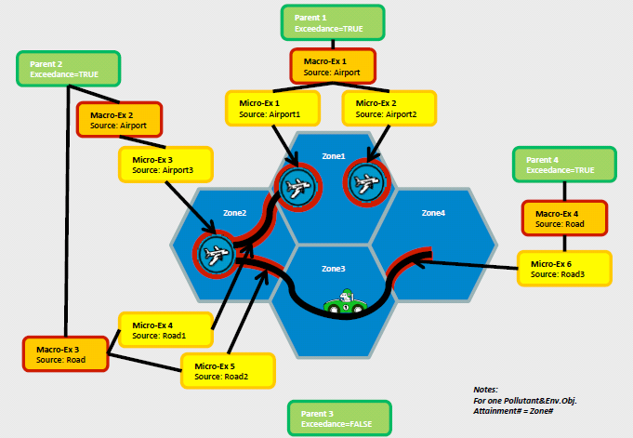

**Figure 5: Exceedance situations (parent – macro – micro)**

Based on this information the interdenpencies of H-K may be summatised as follows;

* Data flow H summarises the air quality plan and the parent exceedance situations that it will target which have previously been reported to the CDR in a data flow G delivery on Attainment. refers to one or more parent exceedance situation of dataflow G (AQD_Attainment).
* Data flow I on source apportionment describes the soure apportionment of a macro exceedance situation and is linked to one Plan record (data flow H) and to one parent exceedance situation of data flow G.
* Data flow J on on the evaluation scenario (data flow J) describe the baseline scenario for a macro exceedance situation before new measures are applied and also the projection scenario for a macro exceedance situation after new measures are applied. The evaluation scenario is linked to one Plan record and to one source apportionment record. Both base line and projection scenarios are linked to one or more Measures records (data flow K).
* Data flow K on measures, lists all measures implemented within a plan. Measures records must be linked to one or more macro exceedance situations via their source apportionment in data flow I and may also be linked to the baseline and evaluation scenarios in data flow J.

Reporting header <aqd:AQD_ReportingHeader>

An explanation of the air quality reporting header information class can be found in [Part 1 - USER GUIDE TO XML & DATA MODEL - Common elements & B-G](http://www.eionet.europa.eu/aqportal/toolbox/guidance/doc/UserGuide2_AQD_XML_v3.2.0.pdf). This is mandatory and includes common data types elements.

**aqd:AQD_ReportingHeader** includes:

* aqd:inspireId Mandatory (H.1.1)
* aqd:reportingAuthority Mandatory (H.1.2)
* aqd:change Mandatory (H.1.3/A.7.1)
* aqd:changeDescription Conditional (M if aqd:change=”True”) (H.1.3/A.7.2)
* aqd:reportingPeriod Mandatory (H.1.4)
* aqd:content Voluntary (Mandatory if aqd:change = “TRUE”)

PaPeRS

**Reporting Header section**

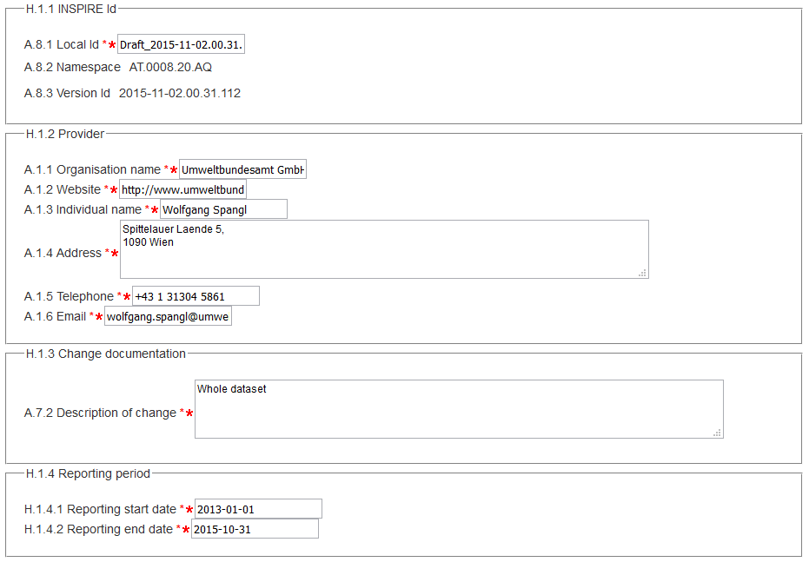Items marked with asterisk (*) are mandatory fields.

Items marked with asterisk (*) are conditional fields.

The Local Id of the INSPIRE Identifier is automatically filled in this format: [Draft/Complete]_[ReportingYear]-[Date of data entry]. [triple-digit number]. In the XML file you will find that the localId gets the prefix HDR_* (for Header) and the gml:id the prefix ATTR_HDR_*.

The system will automatically populate the namespace of the INSPIRE localId and the ‘provider’ section with the information provided in the Settings tab. The namespace should follow the nomenclature approach described in the ‘common’ data types section.

**Focus On**

**Recommended acronym for localId Prefixes**

**Object Acronym localId**

Plan PLA PLA.AT_001  
Source Apportionment SAP SAP.AT_023  
Evaluation Scenario EVS EVS.AT_005  
Measures MEA MEA.AT_342

In PaPeRS a when a new record is created a “draft” localID is automatically populated with the timestamp of the first editing session.It is possible to change this ID according to the recommended acronyms above or another local preferred nomenclature. The local ID must be globally unique within the country’s namespace i.e. only one occurrence within country’s air quality plans data management system.

H- Information on the air quality plan(s) (Art. 13)

In accordance with the procedure referred to in Article 13 of the Commission Implementing Decision as regards the reciprocal exchange of information and reporting on ambient air quality (2011/850/EU), Member States shall make available the information on air quality plans, no later than 2 year’s after the end of the calendar year in which the first exceedance was observed. The deadline for reporting within this context is 31 December.

Dataset H comprises Information on Air Quality Plans, partly covered by the 2004/224/EC Decision.The reporting XML contains both the air quality reporting header information class and the AQD_Plan class.

Plan <aqd:AQD_Plan>

The AQD_Plan element provides meta-information about the air quality plan such as the responsible authority and the related information on timescales, pollutants covered, parent exceedance situations and related publications. The AQD_Plan class is comprised of the child class out lined below;

**aqd:AQD_Plan** (C.4) includes:

* aqd:inspireId Mandatory (H.2.1)
* aqd:code Mandatory (H.2.2)
* aqd:name Mandatory (H.2.3)
* aqd:competentAuthority Mandatory (H.2.4)
* aqd:firstExceedanceYear Mandatory (H.2.5)
* aqd:status Mandatory (H.2.6)
* aqd:pollutants ()
  + aqd:pollutantCode Mandatory (H.2.7.1)
  + aqd:protectionTarget Mandatory (H.2.7.2)
* aqd:adoptionDate Mandatory (H.2.8)
* referenceAQPlan Mandatory (H.2.9)
* aqd:timetable Mandatory (H.2.10)
* aqd:referenceImplementation Mandatory (H.2.11)
* aqd:publication Mandatory (H.2.12)
* aqd: description Mandatory
* aqd: title Mandatory
* aqd:author Voluntary
* aqd:publicationDate Mandatory
* aqd: publisher Mandatory
* aqd: webLink Voluntary
* aqd:comment Voluntary (H.2.13)
* aqd:exceedanceSituation Mandatory (H.2.14)

Detailed information on the constraints and content for these e-Reporting classes is provided below. Figure 6 illustrates the majority of information classes that constitute AQD_AssessmentRegime.

**Focus On**

**AQD_AssessmentRegime – external links**

|  |
| --- |
| HTML based documentation for the element AQD_Plan:  [http://www.eionet.europa.eu/aqportal/doc/xsd/AirQualityReporting.html#Link17](%20http://www.eionet.europa.eu/aqportal/toolbox/datamodel/doc/xsd/AirQualityReporting_AQD_Plan.html#Link00000016 l)  Latest UML for AQD_Plan at:  <http://www.eionet.europa.eu/aqportal/doc/UML_AQDmodel_bmp/Plans_Programmes.pdf> |

|  |
| --- |
|  |
| Figure 6 – AQD_Plan – simplified illustration of elements described |

AQ Plan identifier- <aqd:inspireId>

The air quality plan identifier provides for the unique identification of the plan and its attributes within the XML delivery. The data provider is responsible for ensuring the identifier is unique and managing its lifecycle. An explanation of the identifier class can be found in [Part 1 - USER GUIDE TO XML & DATA MODEL - Common elements & B-G](http://www.eionet.europa.eu/aqportal/toolbox/guidance/doc/UserGuide2_AQD_XML_v3.2.0.pdf). recommended prefixes for the localId code are set out in the Reporting Header section. The gml:id is a copy of localId with the prefix ATTR added.

|  |  |
| --- | --- |
| aqd:inspireId |  |
| Minimum occurrence: | 1 (mandatory) |
| Maximum occurrence: | 1 (1 occurrence per XML document) |
| IPR data specifications found at: | H.2.1 (A.8.1, A.8.2, A.8.3) |
| Code list constraints: | None |
| QA/QC constraints: | See <http://dd.eionet.europa.eu/vocabulary/aq/cdrqaqc/view>, otherwise none other than the multiplicity and formats specified here. |
| Allowed formats: | Alphanumeric |
| XPath to schema location: | /aqd:AQD_Plan/aqd:inspireId/base:Identifier gml:id  /aqd:AQD_Plan/aqd:inspireId/base:Identifier/base:localId  /aqd:AQD_Plan/aqd inspireId/base:Identifier/base:namespace  /aqd:AQD_Plan/aqd:inspireId/base:Identifier/base:versionID |
| Further information found @ |  |
| Voidable: | No |

Example

**aqd:inspireId**

|  |
| --- |
| <aqd:AQD_Plan gml:id="ATTR_PLA_AT_60_PM10_2013">  <aqd:inspireId>  <base:Identifier>  <base:localId>PLA_ AT_60_PM10_2013</base:localId>  <base:namespace>AT.0008.20.AQ</base:namespace>  <base:versionId>2015-10-28.22.43.210</base:versionId>  </base:Identifier>  </aqd:inspireId> |

AQ Plan code- <aqd:code>

A unique local reference to air quality plan provided by the Member States starting with the 2-digit country code according to ISO 3166-1. May also include the pollutants, protection targets and reference year of the assessment triggering the Air Quality Plan.

|  |  |
| --- | --- |
| aqd:code |  |
| Minimum occurrence: | 1 (mandatory) |
| Maximum occurrence: | 1 (1 per plan) |
| IPR data specifications found at: | H.2.2 |
| Code list constraints: | None |
| QA/QC constraints: | See <http://dd.eionet.europa.eu/vocabulary/aq/cdrqaqc/view>, otherwise none other than the multiplicity and formats specified here. |
| Allowed formats: | Alphanumeric |
| XPath to schema location: | /aqd:AQD_Plan/aqd:code |
| Further information found @ |  |
| Voidable: | No |

PaPeRS

**Code**





XML Example

**aqd:code**

|  |
| --- |
| <aqd:code>AT_60_PM10_2013</aqd:code>  <aqd:code>UK0001_H_NO2_2011</aqd:code> |

AQ Plan name- <aqd:name>

A plain text denotation of the name of the air quality plan(s).

|  |  |
| --- | --- |
| aqd:name |  |
| Minimum occurrence: | 1 (mandatory) |
| Maximum occurrence: | 1 (1 per plan) |
| IPR data specifications found at: | H.2.3 |
| Code list constraints: | None |
| QA/QC constraints: | See http://dd.eionet.europa.eu/vocabulary/aq/cdrqaqc/view, otherwise none other than the multiplicity and formats specified here. |
| Allowed formats: | Alphanumeric |
| XPath to schema location: | /aqd:AQD_Plan/aqd:name |
| Further information found @ |  |
| Voidable: | No |

PaPeRS

**Name**



XML

**aqd:name**

|  |
| --- |
| <aqd:name>Graz PM10 Example</aqd:name> |

Competent Authority- <aqd:competentAuthority>

This attribute describes the organisation(s) responsible for the air quality plan. It is a mandatory INSPIRE requirement and makes use of the INSPIRE <base2:RelatedParty> class. It should not be confused with AQD_ReportingHeader base2:RelatedParty information which describes the organisation responsible for reporting the plan to the CDR.

|  |  |
| --- | --- |
| aqd:competentAuthority |  |
| Minimum occurrence: | 1 (mandatory) |
| Maximum occurrence: | 1 |
| IPR data specifications found at: | H.2.4 |
| Code list constraints: | None |
| QA/QC constraints: | See <http://dd.eionet.europa.eu/vocabulary/aq/cdrqaqc/view>, otherwise none other than the multiplicity and formats specified here. |
| Allowed formats: | Alphanumeric |
| XPath to schema location: | /aqd:AQD_Plan/aqd:competentAuthority  /aqd:AQD_Plan/am:competentAuthority/gmd:CI_ResponsibleParty/gmd:organisationName/gmd:LocalisedCharacterString  /aqd:AQD_Plan/am:competentAuthority/gmd:CI_ResponsibleParty/gmd:contactInfo/gmd:CI_Contact/gmd:onlineResource/gmd:CI_Onli  neResource/gmd:linkage/gmd:URL  /aqd:AQD_Plan/am:competentAuthority/gmd:CI_ResponsibleParty/gmd:individualName/gmd:LocalisedCharacterString  "/aqd:AQD_Plan/am:competentAuthority/gmd:CI_ResponsibleParty/gmd:contactInfo/gmd:CI_Contact/gmd:address/gmd:CI_Address/gm  d:deliveryPoint/gmd:LocalisedCharacterString  /aqd:AQD_Plan/am:competentAuthority/gmd:CI_ResponsibleParty/gmd:contactInfo/gmd:CI_Contact/gmd:address/gmd:CI_Address/gm  d:city/gmd:LocalisedCharacterString  /aqd:AQD_Plan/am:competentAuthority/gmd:CI_ResponsibleParty/gmd:contactInfo/gmd:CI_Contact/gmd:address/gmd:CI_Address/gm  d:postalCode/gmd:LocalisedCharacterString"  /aqd:AQD_Plan/am:competentAuthority/gmd:CI_ResponsibleParty/gmd:contactInfo/gmd:CI_Contact/gmd:phone/gmd:CI_Telephone/gm  d:voice/gmd:LocalisedCharacterString  /aqd:AQD_Plan/am:competentAuthority/gmd:CI_ResponsibleParty/ |
| Further information found @ |  |
| Voidable: | No |

PaPeRS

**Competent Authority**

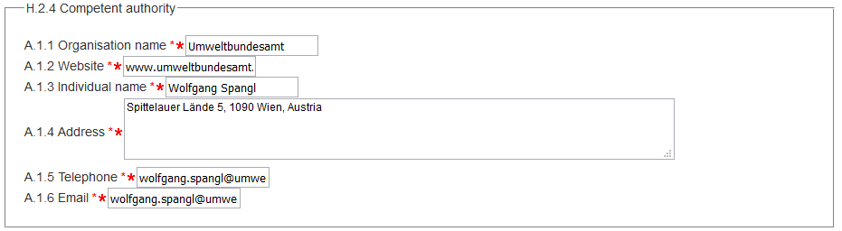

XML

**aqd:competentAuthority**

|  |
| --- |
| <aqd:competentAuthority>  <base2:RelatedParty>  <base2:individualName>  <gco:CharacterString>Wolfgang Spangl</gco:CharacterString>  </base2:individualName>  <base2:organisationName>  <gco:CharacterString>Umweltbundesamt</gco:CharacterString>  </base2:organisationName>  <base2:contact>  <base2:Contact>  <base2:address>  <ad:AddressRepresentation>  <ad:adminUnit>  <gn:GeographicalName>  <gn:language nilReason="unpopulated" xsi:nil="true"/>  <gn:nativeness nilReason="unpopulated" xsi:nil="true"/>  <gn:nameStatus nilReason="unpopulated" xsi:nil="true"/>  <gn:sourceOfName nilReason="unpopulated" xsi:nil="true"/>  <gn:pronunciation nilReason="unpopulated" xsi:nil="true"/>  <gn:spelling>  <gn:SpellingOfName>  <gn:text></gn:text>  <gn:script nilReason="unpopulated" xsi:nil="true"/>  </gn:SpellingOfName>  </gn:spelling>  </gn:GeographicalName>  </ad:adminUnit>  <ad:locatorDesignator>Spittelauer Lände 5, 1090 Wien, Austria</ad:locatorDesignator>  </ad:AddressRepresentation>  </base2:address>  <base2:electronicMailAddress>wolfgang.spangl@umweltbundesamt.at</base2:electronicMailAddress>  <base2:telephoneVoice>wolfgang.spangl@umweltbundesamt.at</base2:telephoneVoice>  <base2:website>www.umweltbundesamt.at</base2:website>  </base2:Contact>  </base2:contact>  </base2:RelatedParty>  </aqd:competentAuthority> |

Reference Year of first exceedance - <aqd:firstExceedanceYear>

Year of the (first) exceedance of the LV, LV+MoT) or TV, which triggered the implementation of the air quality plan. The accepted data type is a time instant in yyyy format.

|  |  |
| --- | --- |
| aqd:firstExceedanceYear |  |
| Minimum occurrence: | 1 (mandatory) |
| Maximum occurrence: | 1 |
| IPR data specifications found at: | H.2.5 |
| Code list constraints: | None |
| QA/QC constraints: | See http://dd.eionet.europa.eu/vocabulary/aq/cdrqaqc/view, otherwise none other than the multiplicity and formats specified here. |
| Allowed formats: | Date (YYYY) |
| XPath to schema location: | /aqd:AQD_Plan/aqd:firstExceedanceYear  /aqd:AQD_Plan/aqd:firstExceedanceYear/gml:TimeInstant gml:id  /aqd:AQD_Plan/aqd:firstExceedanceYear/gml:Instant/gml:timePosition |
| Further information found @ |  |
| Voidable: | No |

PaPeRS

**Reference Year**



XML

**aqd:firstExceedanceYear**

|  |
| --- |
| <aqd:firstExceedanceYear>  <gml:TimeInstant gml:id="FIRST_EXCEEDANCE_YEAR_eaefa8a20cfdfd6494b6b6cff3df6c30">  <gml:timePosition>2003</gml:timePosition>  </gml:TimeInstant>  </aqd:firstExceedanceYear> |

Status - <aqd:status>

SeProvides a description of the current status of the air quality plan based on a controlled vocabulary. Revisions or additions to the codelist should be directed to the Helpdesk. All request will be reviewed by the ETC/ACM, EEA and Commission.

|  |  |
| --- | --- |
| aqd:status |  |
| Minimum occurrence: | 1 (mandatory) |
| Maximum occurrence: | 1 |
| IPR data specifications found at: | H.2.6 |
| Code list constraints: | <http://dd.eionet.europa.eu/vocabulary/aq/statusaqplan> |
| Allowed formats: | See code list constraints |
| XPath to schema location: | /aqd:AQD_Plan/aqd:status |
| Further information found @ |  |
| Voidable: | No |

PaPeRS

**Status**

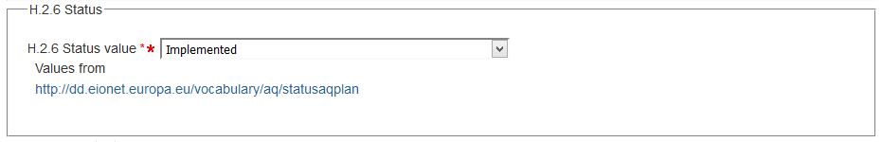

XML

**aqd:status**

|  |
| --- |
| <aqd:status xlink:href="http://dd.eionet.europa.eu/vocabulary/aq/statusaqplan/implemented"/> |

Pollutants covered - <aqd:pollutants>

A list of the pollutants and protection targets covered by the plan. It makes use of two code lists (pollutant and protectiontarget).

|  |  |
| --- | --- |
| aqd:pollutants |  |
| Minimum occurrence: | 1 (mandatory) |
| Maximum occurrence: | Unbounded |
| IPR data specifications found at: | H.2.7 (H.2.7.1. and H.2.7.2) |
| Code list constraints: | <http://dd.eionet.europa.eu/vocabulary/aq/pollutant>  <http://dd.eionet.europa.eu/vocabulary/aq/protectiontarget/> |
| Allowed formats: | See code list constraints |
| XPath to schema location: | /aqd:AQD_Plan/aqd:pollutants/aqd:Pollutant  /aqd:AQD_Plan/aqd:pollutants/aqd:Pollutant/aqd:pollutantCode xlink:href  /aqd:AQD_Plan/aqd:pollutants/aqd:Pollutant/aqd:protectionTarge xlink:href |
| Further information found @ |  |
| Voidable: | No |

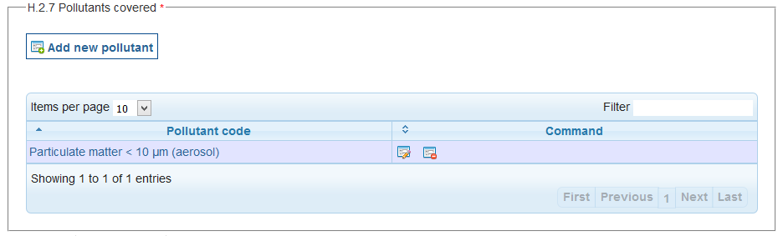

PaPeRS

**Pollutants**

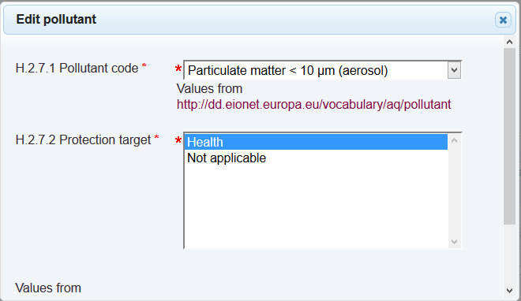

XML

**aqd:pollutants**

|  |
| --- |
| <aqd:pollutants>  <aqd:Pollutant>  <aqd:pollutantCode xlink:href="http://dd.eionet.europa.eu/vocabulary/aq/pollutant/5"/>  <aqd:protectionTarget xlink:href="http://dd.eionet.europa.eu/vocabulary/aq/protectiontarget/H"/>  </aqd:Pollutant>  </aqd:pollutants> |

Date of official adoption - <aqd:adoptionDate>

The date of official adoption of the plan by the country of administration. can only be given if the status is not “in preparation”, “in formal adoption process” or “under revision”. The accepted data type is a time instant in yyyy format.

|  |  |
| --- | --- |
| aqd:adoptionDate |  |
| Minimum occurrence: | 0 |
| Maximum occurrence: | 1 |
| IPR data specifications found at: | H.2.8 |
| Code list constraints: |  |
| Allowed formats: | Date (YYYY) |
| XPath to schema location: | /aqd:AQD_Plan/aqd:adoptionDate/  /aqd:AQD_Plan/aqd:adoptionDate/gml:TimeInstant gml:id  /aqd:AQD_Plan/aqd:adoptionDate/gml:TimeInstant/gml:timePosition |
| Further information found @ |  |
| Voidable: | Yes |



PaPeRS

**Adoption Date**

XML

**aqd:adoptionDate**

|  |
| --- |
| <aqd:adoptionDate>  <gml:TimeInstant gml:id="ADOPTION_DATE_eaefa8a20cfdfd6494b6b6cff3df6c30">  <gml:timePosition>2014-10-01</gml:timePosition>  </gml:TimeInstant>  </aqd:adoptionDate> |

Timetable of implementation - <aqd:timeTable>

Short textual description of timetable for the implementation of the air quality plan.

|  |  |
| --- | --- |
| aqd:timeTable |  |
| Minimum occurrence: | 1 |
| Maximum occurrence: | 1 |
| IPR data specifications found at: | H.2.9 |
| Code list constraints: |  |
| Allowed formats: | alphanumeric |
| XPath to schema location: | /aqd:AQD_Plan/aqd:timeTable |
| Further information found @ |  |
| Voidable: | No |

PaPeRS

**Adoption Timetable**



XML

**aqd:timeTable**

|  |
| --- |
| <aqd:timeTable>End 2015</aqd:timeTable> |

Reference to AQ Plan - <aqd:referenceAQPlan>

A URL to document or web resource describing the last version of full air quality plan.

|  |  |
| --- | --- |
| aqd:referenceAQPlan |  |
| Minimum occurrence: | 1 |
| Maximum occurrence: | 1 |
| IPR data specifications found at: | H.2.10 |
| Code list constraints: |  |
| Allowed formats: | alphanumeric |
| XPath to schema location: | /aqd:AQD_Plan/aqd:referenceAQPlan |
| Further information found @ |  |
| Voidable: | No |

PaPeRS

**Reference to AQ Plan**



XML

**aqd:referenceAQPlan**

|  |
| --- |
| <aqd:referenceAQPlan>www.umweltbundesamt.at</aqd:referenceAQPlan> |

Reference to implementation - <aqd:referenceImplementation>

A URL to a document or web resource where information about the implementation of the air quality plan can be found.

|  |  |
| --- | --- |
| aqd:referenceImplementation |  |
| Minimum occurrence: | 1 |
| Maximum occurrence: | 1 |
| IPR data specifications found at: | H.2.11 |
| Code list constraints: |  |
| Allowed formats: | alphanumeric |
| XPath to schema location: | /aqd:AQD_Plan/aqd:referenceImplementation |
| Further information found @ |  |
| Voidable: | No |

PaPeRS

**Reference to implementation**



XML

**aqd:referenceImplemenation**

|  |
| --- |
| <aqd:referenceImplementation>www.umweltbundesamt.at</aqd:referenceImplementation> |

Relevant publication - <aqd:publication>

This information class provides for e list of publications relevant to the air quality plan to be cited. Child elements of the information class include;

Publication: Short description of the publication. ISBN number should be provided if available.

* Title: Title as written in the publication.
* Author(s): If there are multiple authors, please provide in one field separated by commas.
* Publication date: ISO Format (YYYY) with gml id automatically prefilled by PaPeRS
* Publisher: Publishing institution, academic jourmal, etc.
* Web link: web link to documentation

|  |  |
| --- | --- |
| aqd:publication |  |
| Minimum occurrence: | 1 |
| Maximum occurrence: | unbounded |
| IPR data specifications found at: | H.2.12 |
| Code list constraints: |  |
| Allowed formats: | alphanumeric |
| XPath to schema location: | /aqd:AQD_Plan/aqd:publication  /aqd:AQD_Plan/aqd:publication/aqd:Publication  /aqd:AQD_Plan/aqd:publication/aqd:Publication/aqd:description  /aqd:AQD_Plan/aqd:publication/aqd:Publication/aqd:title  /aqd:AQD_Plan/aqd:publication/aqd:Publication/aqd:author  /aqd:AQD_Plan/aqd:publication/aqd:Publication/aqd:publicationDate  /aqd:AQD_Plan/aqd:publication/aqd:Publication/aqd:publicationDate/gml:TimeInstant gml:id  /aqd:AQD_Plan/aqd:publication/Publication/publicationDate/ gml:TimeInstant/gml:TimePosition  /aqd:AQD_Plan/aqd:publication/aqd:Publication/aqd:publicationDate/gml:TimeInstant  /aqd:AQD_Plan/aqd:publication/aqd:Publication/aqd:publicationDate/gml:TimeInstant/gml:timePosition  /aqd:AQD_Plan/aqd:publication/aqd:Publication/aqd:publisher  /aqd:AQD_Plan/aqd:publication/aqd:Publication/aqd:webLink |
| Further information found @ |  |
| Voidable: | No |

PaPeRS

**Publication**

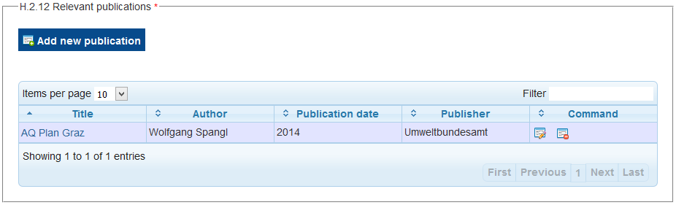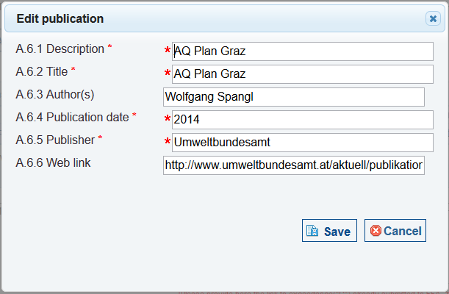

XML

**aqd:publication**

|  |
| --- |
| <aqd:publication>  <aqd:Publication>  <aqd:description>AQ Plan Graz</aqd:description>  <aqd:title>AQ Plan Graz</aqd:title>  <aqd:author>Wolfgang Spangl</aqd:author>  <aqd:publicationDate>  <gml:TimeInstant gml:id="PUBLICATION_DATE_93f1ddb2208025620f3747c5767d6144">  <gml:timePosition>2014</gml:timePosition>  </gml:TimeInstant>  </aqd:publicationDate>  <aqd:publisher>Umweltbundesamt</aqd:publisher> <aqd:webLink>http://www.umweltbundesamt.at/aktuell/publikationen/publikationssuche/publikationsdetail/?pub_id=2138</aqd:webLink>  </aqd:Publication>  </aqd:publication> |

Comment - <aqd:comment>

A short description or notes for clarification in relation to the plan. If the plan relates to exceedance situations which were declared by the 461 Air Quality Questionnaire (AQQ) aqd:comment may be used to link plans to exceedance in the old spreadsheet based systems, see the EEA’s [guiding note](http://www.eionet.europa.eu/aqportal/toolbox/guidance/doc/Guiding%20note%20on%20reporting%20AQ%20Plans.pdf).

|  |  |
| --- | --- |
| aqd:comment |  |
| Minimum occurrence: | 0 |
| Maximum occurrence: | 1 |
| IPR data specifications found at: | H.2.13 |
| Code list constraints: |  |
| Allowed formats: | alphanumeric |
| XPath to schema location: | /aqd:AQD_Plan/aqd:comment |
| Further information found @ |  |
| Voidable: | No |

PaPeRS

**Comment**

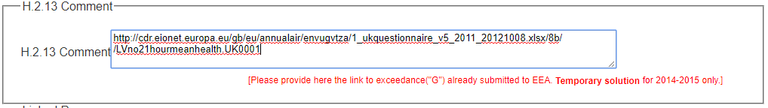

XML

**aqd:comment**

|  |
| --- |
| <aqd:comment>  /cdr.eionet.europa.eu/gb/eu/annualair/envugvtza/1_ukquestionnaire_v5_2011_20121008.xlsx/8b/ /LVno21hourmeanhealth.UK0001 </aqd:comment> |

Information on exceedance situation(s) - <aqd:exceedanceSituation>

An air quality plan is triggered by one or more exceedance situation. An exceedance situation describes the area where an environmental objective was exceeded, the maximum (highest)levels or number of exceedance and the time period of exceedance. The aqd:exceedanceSituation class provides reference via the namespace and localId to the AQD_Attainment features in data flow G which are covered by the air quality plan.

|  |  |
| --- | --- |
| aqd:exceedanceSituation |  |
| Minimum occurrence: | 1 |
| Maximum occurrence: | Unbounded |
| IPR data specifications found at: | H.2.14 |
| Code list constraints: |  |
| Allowed formats: | Alphanumeric |
| XPath to schema location: | /aqd:AQD_Plan/aqd:exceedanceSituation xlink:href |
| Further information found @ |  |
| Voidable: | No |

PaPeRS

**Exceedance Situation**

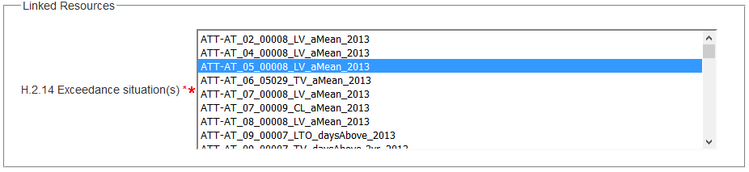

XML

**aqd:exceedanceSituation**

|  |
| --- |
| <aqd:exceedanceSituation xlink:href="AT.0008.20.AQ/ATT-AT_05_00008_LV_aMean_2013"/> |

I - Quantitative source apportionment

In accordance with the procedure referred to in Article 13 of the Commission Implementing Decision as regards the reciprocal exchange of information and reporting on ambient air quality (2011/850/EU), Member States shall make available the information on source apportionment no later than 2 years after the end of the calendar year in which the first exceedance observed. The deadline for reporting within this context is 31 December.

Where the exceedance situation covers a broad geographical area (as opposed to a point exceedance at a monitoring site) the source apportionment in the exceedance area at the location of highest measured or modelled concentration should be given.

The required information is listed in Annex II of AQD IPR.

The reporting XML contains both the air quality reporting header information class and the AQD_SourceAppointment class.

Reporting header- <aqd:AQD_ReportingHeader>

An explanation of the air quality reporting header information class can be found in  [Part 1 - USER GUIDE TO XML & DATA MODEL - Common elements & B-G](http://www.eionet.europa.eu/aqportal/toolbox/guidelines) . This is mandatory for all reporting data flows and includes common data types elements (I1.1, I.1.2, I.1.3 and I.1.4 from IPR excel mapping).

**aqd:AQD_ReportingHeader** includes:

* aqd:inspireId Mandatory (I.1.1)
* aqd:reportingAuthority Mandatory (I.1.2)
* aqd:change Mandatory (I.1.3/A.7.1)
* aqd:changeDescription Conditional (M if aqd:change=”True”) (I.1.3/A.7.2)
* aqd:reportingPeriod Mandatory (I.1.4)
* aqd:content Voluntary (Mandatory if aqd:change = “TRUE”,)

Air quality source apportionment - <aqd:AQD_SourceApportionment>

The AQD_SourceApportionment information class is the parent to the following child classes which hold information on the source apportionment at the location of highest measured or modelled concentration in the relevant exceedance area. The AQD_SourceApportionment class is aimed at identifiying the main sources of pollution contributing to the exceedance situation. Sources are grouped into source types e.g. contributions from the regional background (long distance sources), urban background the local increment. The AQD_SourceApportionment class is comprised of the child classes out lined below. Further details on cardinality is provided in the Commission’s IPR guidance documentation for air quality classes.

aqd:AQD_SourceApportionment (I.2) includes:

* aqd:inspireID Mandatory (I.2.1)
* aqd:referenceYear Mandatory (I.2.2)
* aqd:regionalBackground Mandatory (I.2.3)
  + aqd:total* Mandatory (I.2.3.1)
  + aqd:fromWithinMS* Mandatory (I.2.3.2)
  + aqd:transboundary* Mandatory (I.2.3.3)
  + aqd:natural* Mandatory (I.2.3.4)
  + aqd:other* Mandatory (I.2.3.5)
* aqd:urbanBackground Mandatory (I.2.4)
  + aqd:total* Mandatory (I.2.4.1)
  + aqd:traffic* Mandatory (I.2.4.2)
  + aqd:heatAndPowerProduction* Mandatory (I.2.4.3)
  + aqd:agriculture* Mandatory (I.2.4.4)
  + aqd:commercialAndResidential* Mandatory (I.2.4.5)
  + aqd:shipping* Mandatory (I.2.4.6)
  + aqd:offRoadMobileMachinery* Mandatory (I.2.4.7)
  + aqd:natural* Mandatory (I.2.4.8)
  + aqd:transboundary* Mandatory (I.2.4.9)
  + aqd:other* Mandatory (I.2.4.10)
* aqd:localIncrement Mandatory (I.2.5)
  + aqd:total* Mandatory (I.2.5.1)
  + aqd:traffic* Mandatory (I.2.5.2)
  + aqd:heatAndPowerProduction* Mandatory (I.2.5.3)
  + aqd:agriculture* Mandatory (I.2.5.4)
  + aqd:commercialAndResidential* Mandatory (I.2.5.5)
  + aqd:shipping* Mandatory (I.2.5.6)
  + aqd:offRoadMobileMachinery* Mandatory (I.2.5.7)
  + aqd:natural* Mandatory (I.2.5.8)
  + aqd:transboundary* Mandatory (I.2.5.9)
  + aqd:other* Mandatory (I.2.5.10)
* aqd:macroExceedanceSituation Mandatory (I.2.6)
  + aqd:exceedance Mandatory
  + aqd:numericalExceedance Conditional, mandatory
  + aqd:numberExceedances Conditional, mandatory
  + aqd:deductionAssessmentMethod

aqd:adjustmentMethod Conditional, mandatory

* + - aqd:assessmentMethod Mandatory
      * aqd:assessmentType Mandatory
      * aqd:assessmentTypeDescription Mandatory
      * aqd:samplingPointAssessmentMetadata/@xlink:href Conditional, mandatory or
  + aqd:modelAssessmentMetatdata/@xlink:href Conditional, mandatory
    - aqd:adjustmentType Conditional
    - aqd:adustmentSource Conditional
  + aqd:exceedanceArea Mandatory
    - aqd:areaClassification Mandatory
    - aqd:spatialExtent External
    - aqd:surfaceArea Conditional
      * aqd:quantification numerical Mandatory
      * aqd:units of measurement Mandatory
    - aqd:roadLength Conditional
      * aqd:quantification numerical Mandatory
      * aqd:units of measurement Mandatory
    - aqd:administrativeUnit/@xlink:href External
    - aqd:stationUsed/@xlink:href Conditional, mandatory or
  + aqd:modelUsed xlink:href Conditional, mandatory
  + aqd:exceedanceExposure
  + aqd:populationExposed Conditional, external
  + aqd:ecosystemAreaExposed Conditional, mandatory
    - aqd:quantification numerical Mandatory
    - aqd:units of measurement Mandatory
  + aqd:referenceYear Conditional, mandatory
  + aqd:reason Conditional, mandatory
  + aqd:reasonOther Voluntary
  + aqd:comment Voluntary
* aqd:comment Voluntary (I.2.7)
* aqd:parentExceedanceSituation/@xlink:href Mandatory (I.2.8)
* aqd:usedInPlan xlink:href Mandatory (I.2.9)

Detailed information on the constraints and content for these e-Reporting classes is provided below in Figure 7

**Focus On**

**AQD_SourceApportionment – external links**

|  |
| --- |
| HTML based documentation for the element AQD_SourceApportionment:  <http://www.eionet.europa.eu/aqportal/doc/xsd/AirQualityReporting.html#Link23>  Latest UML for AQD_Attainment at:  <http://www.eionet.europa.eu/aqportal/doc/UML_AQDmodel_bmp/Plans_Programmes.pdf> |

|  |
| --- |
|  |
| Figure 7 – AQ Source Apportionment –illustration of elements described |

Air Quality Source Apportionment identifier- <aqd:inspireId >

The identifier provides for the unique identification of the source apportionment information. The data provider is responsible for ensuring the identifier is unique and managing its lifecycle. An explanation of the identifier class can be found in [Part 1 - USER GUIDE TO XML & DATA MODEL - Common elements & B-G](http://www.eionet.europa.eu/aqportal/toolbox/guidance/doc/UserGuide2_AQD_XML_v3.2.0.pdf). The Inspire identifier for the air quality source apportionment may be built by concatenating prefix (SAP.), the zone code (e.g. AT01), the pollutant code (e.g. 1 or so2), the protection target (e.g. H – for health protection), reporting metric (e.g. daysAbove), and the reporting year of reference year (e.g. 2014), see example below.

|  |  |
| --- | --- |
| Aqd:inspireId |  |
| Minimum occurrence: | 1 (mandatory) |
| Maximum occurrence: | 1 (1 occurrence per XML document) |
| IPR data specifications found at: | I.2.1 (A.8.1, A.8.2, A.8.3) |
| Code list constraints: | None |
| QA/QC constraints: | See http://dd.eionet.europa.eu/vocabulary/aq/cdrqaqc/view, otherwise none other than the multiplicity and formats specified here. |
| Allowed formats: | Alphanumeric |
| XPath to schema location: | /aqd:AQD_SourceApportionment/aqd:inspireId/base:Identifier gml:id  /aqd:AQD_SourceApportionment/aqd:inspireId/base:Identifier/base:localId  /aqd:AQD_SourceApportionment/aqd inspireId/base:Identifier/base:namespace  /aqd:AQD_SourceApportionment/aqd:inspireId/base:Identifier/base:versionID |
| Further information found @ |  |
| Voidable: | No |

XML

aqd:inspireId

|  |
| --- |
| <aqd:AQD_SourceApportionment gml:id="ATTR_SAP_AT01_1_H_daysAbove_2014">  <aqd:inspireId>  <base:Identifier>  <base:localId> SAP_AT01_1_H_daysAbove_2014</base:localId>  <base:namespace>AT.0008.20.AQ</base:namespace>  <base:versionId>2015-10-28.22.44.592</base:versionId>  </base:Identifier>  </aqd:inspireId> |

Reference Year - <aqd:referenceYear>

The reference year element specifies the year for which source apportionment has been calculated. This element is conditional in the e-Reporting schema. It is mandatory if it is different to that of the exceedance situation. For best practice we recommend and encourage countries to populate the reference year element in all siruations, This will prevent any confusion. The accepted data type is a time instant in yyyy format. INSPIRE compliant identifiers will be created automatically in PaPeRS and will appear in the XML outputs.

|  |  |
| --- | --- |
| Aqd:referenceYear |  |
| Minimum occurrence: | 0 |
| Maximum occurrence: | 1 |
| IPR data specifications found: | I.2.2 |
| Code list constraints: | n/a |
| Formats Allowed: | Date (YYYY) |
| XPath to schema location: | /aqd:AQD_SourceApportionment//aqd:referenceYear/  /aqd:AQD_SourceApportionment//aqd:referenceYear/gml:TimeInstant gml:id  /aqd:AQD_SourceApportionment//aqd:referenceYear/gml:TimeInstant/timePosition |
| Voidable: | No |

PaPeRS

**Reference Year**

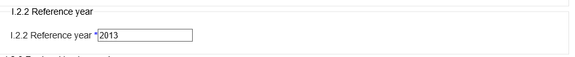

XML

**aqd:referenceYear**

|  |
| --- |
| <aqd:referenceYear>  <gml:TimeInstant gml:id="REFERENCE_YEAR_38ec3e80c453453cd4b455588db932e4">  <gml:timePosition>2013</gml:timePosition>  </gml:TimeInstant>  </aqd:referenceYear> |

Regional Background - <aqd:regionalBackground>

This information class specifies the split of total regional background and composite contributions to this total from; (i) within the MemberState, (ii) outside the Member State (transboundatry), (iii) natural sources and (v) ‘other’ sources. All units are in ug/m3. . The regional background contribution is the concentration of pollutants coming from sources >30km from the exceedance situation. The regional backbground shall be split, if appropriate data are available, into contributions from sectors specified in i-iv. .

The child class of each type of contribution to the regional background is aqd:quantityCommented which allows the quantification of the contribution (a number and unit of measurement, always given in ) and voluntary comment in text form. Textual comment is needed when the quantification cannot be provided or may be used to provide additional context on the validity of the quantification provided.

aqd:quantityCommented includes;

* quantity 0..1 Conditional, mandatory if not voided and no comment
* quantification numerical 1 Mandatory
* units of measurement 1 Mandatory
* comment 0..1 Conditional, mandatory if quantity not available

**NOTE:** The total regional background contribution value must equal the sum of all composite contributions from the sources i-iv.

PaPeRS

**Quantity commented with filled value**

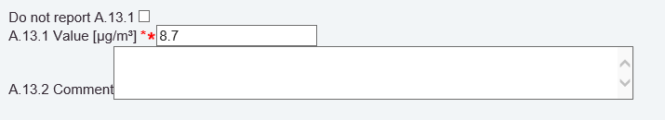

XML

**Quantity commented with filled value**

|  |
| --- |
| <aqd:QuantityCommented>  <aqd:quantity uom="http://dd.eionet.europa.eu/vocabulary/uom/concentration/ug.m-3" xsi:nil="false">8,7</aqd:quantity>  </aqd:QuantityCommented> |

In case you don’t have available information you should tick the ‘do not report’ box, choose a reason (unpopulated, unknown, withheld) and explain the reason in the comment box.

PaPeRS

**Quantity commented with no value**

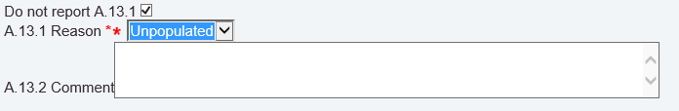

XML

**Quantity commented with no value**

|  |
| --- |
|  |

|  |  |
| --- | --- |
| Regional background – aqd:total | |
| Minimum occurrence: | 1 |
| Maximum occurrence: | 1 |
| IPR data specifications found: | I.2.3.1 (A.13.1, A.12.1, A.12.2, A.13.2) |
| Code list constraints: | n/a |
| Formats Allowed: | Datatype quantity commented |
| XPath to schema location: | /AQD_SourceApportionment/aqd:regionalBackground/aqd:RegionalBackground/aqd:total  /AQD_SourceApportionment/aqd:regionalBackground/aqd:RegionalBackground/aqd:total/aqd:QuantityCommented  /AQD_SourceApportionment/aqd:regionalBackground/aqd:RegionalBackground/aqd:total/aqd:QuantityCommented/quantity  /AQD_SourceApportionment/aqd:regionalBackground/aqd:RegionalBackground/aqd:total/aqd:QuantityCommented/comment |
| Voidable: | Quantity is voidable |

PaPeRS

**Regional background: total, from withinMS, transboundary, natural, other**

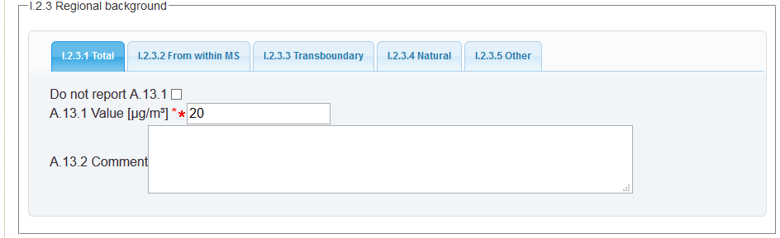

XML

**aqd:total**

|  |
| --- |
| <aqd:RegionalBackground>  <aqd:total>  <aqd:QuantityCommented>  <aqd:quantity uom="http://dd.eionet.europa.eu/vocabulary/uom/concentration/ug.m-3" xsi:nil="false">20</aqd:quantity>  </aqd:QuantityCommented>  </aqd:total> |

|  |  |
| --- | --- |
| Regional background – aqd:fromWithinMS (from within Member States) | |
| Minimum occurrence: | 1 |
| Maximum occurrence: | 1 |
| IPR data specifications found: | I.2.3.2 (A.13.1, A.12.1, A.12.2, A.13.2) |
| Code list constraints: | n/a |
| Formats Allowed: | Datatype quantity commented |
| XPath to schema location: | /AQD_SourceApportionment/aqd:regionalBackground/aqd:RegionalBackground/aqd:fromWithinMS  /AQD_SourceApportionment/aqd:regionalBackground/aqd:RegionalBackground/aqd:fromWithinMS/aqd:QuantityCommented  /AQD_SourceApportionment/aqd:regionalBackground/aqd:RegionalBackground/aqd:fromWithinMS/aqd:QuantityCommented/quantity  /AQD_SourceApportionment/aqd:regionalBackground/aqd:RegionalBackground/aqd:fromWithinMS/aqd:QuantityCommented/comment |
| Voidable: | Quantity is voidable |

XML

**aqd:fromWithinMS**

|  |
| --- |
| <aqd:fromWithinMS>  <aqd:QuantityCommented>  <aqd:quantity uom="http://dd.eionet.europa.eu/vocabulary/uom/concentration/ug.m-3" xsi:nil="false">12</aqd:quantity>  </aqd:QuantityCommented>  </aqd:fromWithinMS> |

|  |  |
| --- | --- |
| Regional background – aqd:transboundary | |
| Minimum occurrence: | 1 |
| Maximum occurrence: | 1 |
| IPR data specifications found: | I.2.3.3 (A.13.1, A.12.1, A.12.2, A.13.2) |
| Code list constraints: | n/a |
| Formats Allowed: | Datatype quantity commented |
| XPath to schema location: | /AQD_SourceApportionment/aqd:regionalBackground/aqd:RegionalBackground/aqd:transboundary  /AQD_SourceApportionment/aqd:regionalBackground/aqd:RegionalBackground/aqd:transboundary/aqd:QuantityCommented  /AQD_SourceApportionment/aqd:regionalBackground/aqd:RegionalBackground/aqd:transboundary/aqd:QuantityCommented/quantity  /AQD_SourceApportionment/aqd:regionalBackground/aqd:RegionalBackground/aqd:transboundary/aqd:QuantityCommented/comment |
| Voidable: | Quantity is voidable |

XML

**aqd:transboundary**

|  |
| --- |
| <aqd:transboundary>  <aqd:QuantityCommented>  <aqd:quantity uom="http://dd.eionet.europa.eu/vocabulary/uom/concentration/ug.m-3" xsi:nil="false">8</aqd:quantity>  </aqd:QuantityCommented>  </aqd:transboundary> |

|  |  |
| --- | --- |
| Regional background – aqd:natural | |
| Minimum occurrence: | 1 |
| Maximum occurrence: | 1 |
| IPR data specifications found: | I.2.3.4 (A.13.1, A.12.1, A.12.2, A.13.2) |
| Code list constraints: | n/a |
| Formats Allowed: | Datatype quantity commented |
| XPath to schema location: | /AQD_SourceApportionment/aqd:regionalBackground/aqd:RegionalBackground/aqd:natural  /AQD_SourceApportionment/aqd:regionalBackground/aqd:RegionalBackground/aqd:natural/aqd:QuantityCommented  /AQD_SourceApportionment/aqd:regionalBackground/aqd:RegionalBackground/aqd:natural/aqd:QuantityCommented/quantity  /AQD_SourceApportionment/aqd:regionalBackground/aqd:RegionalBackground/aqd:natural/aqd:QuantityCommented/comment |
| Voidable: | Quantity is voidable |

XML

**aqd:natural**

|  |
| --- |
| <aqd:natural>  <aqd:QuantityCommented>  <aqd:quantity uom="http://dd.eionet.europa.eu/vocabulary/uom/concentration/ug.m-3" xsi:nil="false">0</aqd:quantity>  </aqd:QuantityCommented>  </aqd:natural> |

|  |  |
| --- | --- |
| Regional background – aqd:other | |
| Minimum occurrence: | 1 |
| Maximum occurrence: | 1 |
| IPR data specifications found: | I.2.3.5 (A.13.1, A.12.1, A.12.2, A.13.2) |
| Code list constraints: | n/a |
| Formats Allowed: | Datatype quantity commented |
| XPath to schema location: | /AQD_SourceApportionment/aqd:regionalBackground/aqd:RegionalBackground/aqd:other  /AQD_SourceApportionment/aqd:regionalBackground/aqd:RegionalBackground/aqd:other/aqd:QuantityCommented  /AQD_SourceApportionment/aqd:regionalBackground/aqd:RegionalBackground/aqd:other/aqd:QuantityCommented/quantity  /AQD_SourceApportionment/aqd:regionalBackground/aqd:RegionalBackground/aqd:other/aqd:QuantityCommented/comment |
| Voidable: | Quantity is voidable |

XML

**aqd:other**

|  |
| --- |
| <aqd:other>  <aqd:QuantityCommented>  <aqd:quantity xsi:nil="true" nilReason="Unpopulated" uom=”Unknown”/>  </aqd:QuantityCommented>  </aqd:other> |

Urban Background - <aqd:urbanBackground>

This information class specifies the estimated split of contributions from the urban background i.e total background contributions excluding the regional background and local increment contributions. in µg/m³. Urban background contributions are grouped into the following source types (i) road traffic, (ii) industry,(iii) agriculture, (iv) commercial and residential, (v) shipping, (vi) off road mobile machinery, (vii) natural, (viii) transboundary and (ix) other.

The urban background source apportionment component represents the contribution to concentrations from emissions sources within towns or agglomerations that are within 30km of the exceedance situation i.e. the contribution from all emissions sources in a town or agglomeration and its environs as a whole. Local contributions from busy roads, ports, airports, industrial point sources and natural sources are excluded.

The child class of each type of contribution to the urban background is aqd:quantityCommented which allows the quantification of the contribution (a number and unit of measurement, always given in ) and voluntary comment in text form. Textual comment is needed when the quantification cannot be provided or may be used to provide additional context on the validity of the quantification provided.

aqd:quantityCommented includes;

* quantity 0..1 Conditional, mandatory if not voided and no comment
* quantification numerical 1 Mandatory
* units of measurement 1 Mandatory
* comment 0..1 Conditional, mandatory if quantity not available

**NOTE:** The total urban background contribution value must equal the sum of all composite contributions from the sources i-ix.

PaPeRS

**Urban background: total, traffic, industry, agriculture, commercial, shipping, off road machinery, natural, transboundary, other**

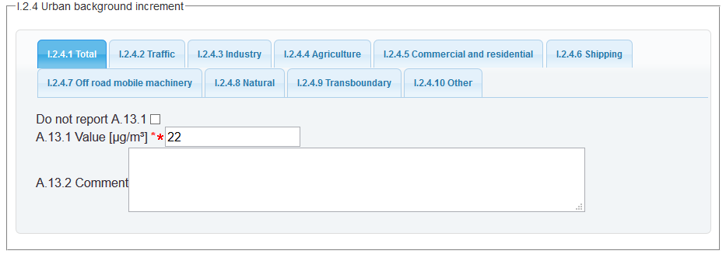

|  |  |
| --- | --- |
| Urban background – aqd:total | |
| Minimum occurrence: | 1 |
| Maximum occurrence: | 1 |
| IPR data specifications found: | I.2.4.1 (A.13.1, A.12.1, A.12.2, A.13.2) |
| Code list constraints: | n/a |
| Formats Allowed: | Datatype quantity commented |
| XPath to schema location: | /AQD_SourceApportionment/aqd:urbanBackground/aqd:UrbanBackground/aqd:total  /AQD_SourceApportionment/aqd:urbanBackground/aqd:UrbanBackground/aqd:total/aqd:QuantityCommented  /AQD_SourceApportionment/aqd:urbanBackground/aqd:UrbanBackground/aqd:total/aqd:QuantityCommented/quantity  /AQD_SourceApportionment/aqd:urbanBackground/aqd:UrbanBackground/aqd:total/aqd:QuantityCommented/comment |
| Voidable: | Quantity is voidable |

XML

**aqd:total**

|  |
| --- |
| <aqd:total>  <aqd:QuantityCommented>  <aqd:quantity uom="http://dd.eionet.europa.eu/vocabulary/uom/concentration/ug.m-3" xsi:nil="false">22</aqd:quantity>  </aqd:QuantityCommented>  </aqd:total> |

|  |  |
| --- | --- |
| Urban background – aqd:traffic | |
| Minimum occurrence: | 1 |
| Maximum occurrence: | 1 |
| IPR data specifications found: | I.2.4.2 (A.13.1, A.12.1, A.12.2, A.13.2) |
| Code list constraints: | n/a |
| Formats Allowed: | Datatype quantity commented |
| XPath to schema location: | /AQD_SourceApportionment/aqd:urbanBackground/aqd:UrbanBackground/aqd:traffic  /AQD_SourceApportionment/aqd:urbanBackground/aqd:UrbanBackground/aqd:traffic/aqd:QuantityCommented  /AQD_SourceApportionment/aqd:urbanBackground/aqd:UrbanBackground/aqd:traffic/aqd:QuantityCommented/quantity  /AQD_SourceApportionment/aqd:urbanBackground/aqd:UrbanBackground/aqd:traffic/aqd:QuantityCommented/comment |
| Voidable: | Quantity is voidable |

XML

**aqd:traffic**

|  |
| --- |
| <aqd:traffic>  <aqd:QuantityCommented>  <aqd:quantity uom="http://dd.eionet.europa.eu/vocabulary/uom/concentration/ug.m-3" xsi:nil="false">6</aqd:quantity>  </aqd:QuantityCommented>  </aqd:traffic |

|  |  |
| --- | --- |
| Urban background – aqd:heatAndPowerProduction | |
| Minimum occurrence: | 1 |
| Maximum occurrence: | 1 |
| IPR data specifications found: | I.2.4.3 (A.13.1, A.12.1, A.12.2, A.13.2) |
| Code list constraints: | n/a |
| Formats Allowed: | Datatype quantity commented |
| XPath to schema location: | /AQD_SourceApportionment/aqd:urbanBackground/aqd:UrbanBackground/aqd:heatAndProduction  /AQD_SourceApportionment/aqd:urbanBackground/aqd:UrbanBackground/aqd:heatAndPowerProduction/aqd:QuantityCommented  /AQD_SourceApportionment/aqd:urbanBackground/aqd:UrbanBackground/aqd:heatAndPowerProduction/aqd:QuantityCommented/quantity  /AQD_SourceApportionment/aqd:urbanBackground/aqd:UrbanBackground/aqd:heatAndPowerProduction/aqd:QuantityCommented/comment |
| Voidable: | Quantity is voidable |

XML

**aqd:heatAndPowerProduction**

|  |
| --- |
| <aqd:heatAndPowerProduction>  <aqd:QuantityCommented>  <aqd:quantity uom="http://dd.eionet.europa.eu/vocabulary/uom/concentration/ug.m-3" xsi:nil="false">1</aqd:quantity>  </aqd:QuantityCommented>  </aqd:heatAndPowerProduction> |

|  |  |
| --- | --- |
| Urban background – aqd:agriculture | |
| Minimum occurrence: | 1 |
| Maximum occurrence: | 1 |
| IPR data specifications found: | I.2.4.4 (A.13.1, A.12.1, A.12.2, A.13.2) |
| Code list constraints: | n/a |
| Formats Allowed: | Datatype quantity commented |
| XPath to schema location: | /AQD_SourceApportionment/aqd:urbanBackground/aqd:UrbanBackground/aqd:agriculture  /AQD_SourceApportionment/aqd:urbanBackground/aqd:UrbanBackground/aqd:agriculture/aqd:QuantityCommented  /AQD_SourceApportionment/aqd:urbanBackground/aqd:UrbanBackground/aqd:agriculture/aqd:QuantityCommented/quantity  /AQD_SourceApportionment/aqd:urbanBackground/aqd:UrbanBackground/aqd:agriculture/aqd:QuantityCommented/comment |
| Voidable: | Quantity is voidable |

XML

**aqd:agriculture**

|  |
| --- |
| <aqd:agriculture>  <aqd:QuantityCommented>  <aqd:quantity uom="http://dd.eionet.europa.eu/vocabulary/uom/concentration/ug.m-3" xsi:nil="false">1</aqd:quantity>  </aqd:QuantityCommented>  </aqd:agriculture> |

|  |  |
| --- | --- |
| Urban background – aqd:commercialAndResidential | |
| Minimum occurrence: | 1 |
| Maximum occurrence: | 1 |
| IPR data specifications found: | I.2.4.5 (A.13.1, A.12.1, A.12.2, A.13.2) |
| Code list constraints: | n/a |
| Formats Allowed: | Datatype quantity commented |
| XPath to schema location: | /AQD_SourceApportionment/aqd:urbanBackground/aqd:UrbanBackground/aqd:commercialAndResidential  /AQD_SourceApportionment/aqd:urbanBackground/aqd:UrbanBackground/aqd:commercialAndResidential/aqd:QuantityCommented  /AQD_SourceApportionment/aqd:urbanBackground/aqd:UrbanBackground/aqd:commercialAndResidential/aqd:QuantityCommented/quantity  /AQD_SourceApportionment/aqd:urbanBackground/aqd:UrbanBackground/aqd:commercialAndResidential/aqd:QuantityCommented/comment |
| Voidable: | Quantity is voidable |

XML

**aqd:commercialAndResidential**

|  |
| --- |
| <aqd:commercialAndResidential>  <aqd:QuantityCommented>  <aqd:quantity uom="http://dd.eionet.europa.eu/vocabulary/uom/concentration/ug.m-3" xsi:nil="false">9</aqd:quantity>  </aqd:QuantityCommented>  </aqd:commercialAndResidential> |

|  |  |
| --- | --- |
| Urban background – aqd:shipping | |
| Minimum occurrence: | 1 |
| Maximum occurrence: | 1 |
| IPR data specifications found: | I.2.4.6 (A.13.1, A.12.1, A.12.2, A.13.2) |
| Code list constraints: | n/a |
| Formats Allowed: | Datatype quantity commented |
| XPath to schema location: | /AQD_SourceApportionment/aqd:urbanBackground/aqd:UrbanBackground/aqd:shipping  /AQD_SourceApportionment/aqd:urbanBackground/aqd:UrbanBackground/aqd:shipping/aqd:QuantityCommented  /AQD_SourceApportionment/aqd:urbanBackground/aqd:UrbanBackground/aqd:shipping/aqd:QuantityCommented/quantity  /AQD_SourceApportionment/aqd:urbanBackground/aqd:UrbanBackground/aqd:shipping/aqd:QuantityCommented/comment |
| Voidable: | Quantity is voidable |

XML

**aqd:shipping**

|  |
| --- |
| <aqd:shipping>  <aqd:QuantityCommented>  <aqd:quantity uom="http://dd.eionet.europa.eu/vocabulary/uom/concentration/ug.m-3" xsi:nil="false">0</aqd:quantity>  </aqd:QuantityCommented>  </aqd:shipping> |

|  |  |
| --- | --- |
| Urban background – aqd:offRoadMobileMachinery | |
| Minimum occurrence: | 1 |
| Maximum occurrence: | 1 |
| IPR data specifications found: | I.2.4.7 (A.13.1, A.12.1, A.12.2, A.13.2) |
| Code list constraints: | n/a |
| Formats Allowed: | Datatype quantity commented |
| XPath to schema location: | /AQD_SourceApportionment/aqd:urbanBackground/aqd:UrbanBackground/aqd:offRoadMobileMachinery  /AQD_SourceApportionment/aqd:urbanBackground/aqd:UrbanBackground/aqd:offRoadMobileMachinery/aqd:QuantityCommented  /AQD_SourceApportionment/aqd:urbanBackground/aqd:UrbanBackground/aqd:offRoadMobileMachinery/aqd:QuantityCommented/quantity  /AQD_SourceApportionment/aqd:urbanBackground/aqd:UrbanBackground/aqd:offRoadMobileMachinery/aqd:QuantityCommented/comment |
| Voidable: | Quantity is voidable |

XML

**aqd:offRoadMobileMachinery**

|  |
| --- |
| <aqd:offRoadMobileMachinery>  <aqd:QuantityCommented>  <aqd:quantity uom="http://dd.eionet.europa.eu/vocabulary/uom/concentration/ug.m-3" xsi:nil="false">2</aqd:quantity>  </aqd:QuantityCommented>  </aqd:offRoadMobileMachinery> |

|  |  |
| --- | --- |
| Urban background – aqd:natural | |
| Minimum occurrence: | 1 |
| Maximum occurrence: | 1 |
| IPR data specifications found: | I.2.4.8 (A.13.1, A.12.1, A.12.2, A.13.2) |
| Code list constraints: | n/a |
| Formats Allowed: | Datatype quantity commented |
| XPath to schema location: | /AQD_SourceApportionment/aqd:urbanBackground/aqd:UrbanBackground/aqd:natural  /AQD_SourceApportionment/aqd:urbanBackground/aqd:UrbanBackground/aqd:natural/aqd:QuantityCommented  /AQD_SourceApportionment/aqd:urbanBackground/aqd:UrbanBackground/aqd:natural/aqd:QuantityCommented/quantity  /AQD_SourceApportionment/aqd:urbanBackground/aqd:UrbanBackground/aqd:natural/aqd:QuantityCommented/comment |
| Voidable: | Quantity is voidable |

XML

**aqd:natural**

|  |
| --- |
| <aqd:natural>  <aqd:QuantityCommented>  <aqd:quantity uom="http://dd.eionet.europa.eu/vocabulary/uom/concentration/ug.m-3" xsi:nil="false">0</aqd:quantity>  </aqd:QuantityCommented>  </aqd:natural> |

|  |  |
| --- | --- |
| Urban background – aqd:transboundary | |
| Minimum occurrence: | 1 |
| Maximum occurrence: | 1 |
| IPR data specifications found: | I.2.4.9 (A.13.1, A.12.1, A.12.2, A.13.2) |
| Code list constraints: | n/a |
| Formats Allowed: | Datatype quantity commented |
| XPath to schema location: | /AQD_SourceApportionment/aqd:urbanBackground/aqd:UrbanBackground/aqd:transboundary  /AQD_SourceApportionment/aqd:urbanBackground/aqd:UrbanBackground/aqd:transboundary/aqd:QuantityCommented  /AQD_SourceApportionment/aqd:urbanBackground/aqd:UrbanBackground/aqd:transboundary/aqd:QuantityCommented/quantity  /AQD_SourceApportionment/aqd:urbanBackground/aqd:UrbanBackground/aqd:transboundary/aqd:QuantityCommented/comment |
| Voidable: | Quantity is voidable |

XML

**aqd:transboundary**

|  |
| --- |
| <aqd:transboundary>  <aqd:QuantityCommented>  <aqd:quantity uom="http://dd.eionet.europa.eu/vocabulary/uom/concentration/ug.m-3" xsi:nil="false">0</aqd:quantity>  </aqd:QuantityCommented>  </aqd:transboundary> |

|  |  |
| --- | --- |
| Urban background – aqd:other | |
| Minimum occurrence: | 1 |
| Maximum occurrence: | 1 |
| IPR data specifications found: | I.2.4.10 (A.13.1, A.12.1, A.12.2, A.13.2) |
| Code list constraints: | n/a |
| Formats Allowed: | Datatype quantity commented |
| XPath to schema location: | /AQD_SourceApportionment/aqd:urbanBackground/aqd:UrbanBackground/aqd:other  /AQD_SourceApportionment/aqd:urbanBackground/aqd:UrbanBackground/aqd:other/aqd:QuantityCommented  /AQD_SourceApportionment/aqd:urbanBackground/aqd:UrbanBackground/aqd:other/aqd:QuantityCommented/quantity  /AQD_SourceApportionment/aqd:urbanBackground/aqd:UrbanBackground/aqd:other/aqd:QuantityCommented/comment |
| Voidable: | Quantity is voidable |

XML

**aqd:other**

|  |
| --- |
| <aqd:other>  <aqd:QuantityCommented>  <aqd:quantity xsi:nil="true" nilReason="Unpopulated" uom=”Unknown”/>  </aqd:QuantityCommented>  </aqd:other> |

Local Increment - <aqd:localIncrement>

This information class specifies the estimated split of contributions in µg/m³ from the local emissions i.e local contributions from emissions sources immediately adjacent to the location of the exceedance situation excluding the regional background and local increment contributions. The local increment can be estimated as the observed exceedance concentration at the location of exceedance minus regional and urban background contributions. Local increment contributions are grouped into the following source types (i) road traffic, (ii) industry,(iii) agriculture, (iv) commercial and residential, (v) shipping, (vi) off road mobile machinery, (vii) natural, (viii) transboundary and (ix) other.

The child class of each type of contribution to the local increment is aqd:quantityCommented which allows the quantification of the contribution (a number and unit of measurement, always given in μ/m³) and a voluntary comment in text form. Textual comment is needed when the quantification cannot be provided or may be used to provide additional context on the validity of the quantification provided.

aqd:quantityCommented includes;

* quantity 0..1 Conditional, mandatory if not voided and no comment
  + quantification numerical 1 Mandatory
  + units of measurement 1 Mandatory
* comment 0..1 Conditional, mandatory if quantity not available

**NOTE:** The total local increment contribution value must equal the sum of all composite contributions from the sources i-ix

.

PaPeRS

**Local Increment: total, traffic, industry, agriculture, commercial, shipping, off road machinery, natural, transboundary, other**

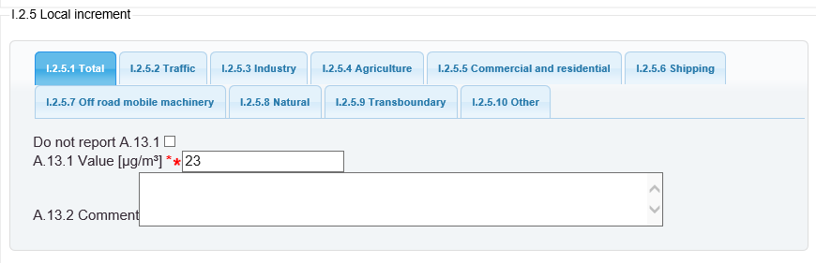

|  |  |
| --- | --- |
| Local increment– aqd:total | |
| Minimum occurrence: | 1 |
| Maximum occurrence: | 1 |
| IPR data specifications found: | I.2.5.1 (A.13.1, A.12.1, A.12.2, A.13.2) |
| Code list constraints: | n/a |
| Formats Allowed: | Datatype quantity commented |
| XPath to schema location: | /AQD_SourceApportionment/aqd:localIncrement/aqd:LocalIncrement/aqd:total  /AQD_SourceApportionment/aqd:localIncrement/aqd:LocalIncrement/aqd:total/aqd:QuantityCommented  /AQD_SourceApportionment/aqd:localIncrement/aqd:LocalIncrement/aqd:total/aqd:QuantityCommented/quantity  /AQD_SourceApportionment/aqd:localIncrement/aqd:LocalIncrement/aqd:total/aqd:QuantityCommented/comment |
| Voidable: | Quantity is voidable |

XML

**aqd:total**

|  |
| --- |
| <aqd:total>  <aqd:QuantityCommented>  <aqd:quantity uom="http://dd.eionet.europa.eu/vocabulary/uom/concentration/ug.m-3" xsi:nil="false">11</aqd:quantity>  </aqd:QuantityCommented>  </aqd:total> |

|  |  |
| --- | --- |
| Local increment– aqd:traffic | |
| Minimum occurrence: | 1 |
| Maximum occurrence: | 1 |
| IPR data specifications found: | I.2.5.2 (A.13.1, A.12.1, A.12.2, A.13.2) |
| Code list constraints: | n/a |
| Formats Allowed: | Datatype quantity commented |
| XPath to schema location: | /AQD_SourceApportionment/aqd:localIncrement/aqd:LocalIncrement/aqd:traffic  /AQD_SourceApportionment/aqd:localIncrement/aqd:LocalIncrement/aqd:traffic/aqd:QuantityCommented  /AQD_SourceApportionment/aqd:localIncrement/aqd:LocalIncrement/aqd:traffic/aqd:QuantityCommented/quantity  /AQD_SourceApportionment/aqd:localIncrement/aqd:LocalIncrement/aqd:traffic/aqd:QuantityCommented/comment |
| Voidable: | Quantity is voidable |

XML

**aqd:traffic**

|  |
| --- |
| <aqd:traffic>  <aqd:QuantityCommented>  <aqd:quantity uom="http://dd.eionet.europa.eu/vocabulary/uom/concentration/ug.m-3" xsi:nil="false">10</aqd:quantity>  </aqd:QuantityCommented>  </aqd:traffic> |

|  |  |
| --- | --- |
| Local increment– aqd:heatAndProduction | |
| Minimum occurrence: | 1 |
| Maximum occurrence: | 1 |
| IPR data specifications found: | I.2.5.3 (A.13.1, A.12.1, A.12.2, A.13.2) |
| Code list constraints: | n/a |
| Formats Allowed: | Datatype quantity commented |
| XPath to schema location: | /AQD_SourceApportionment/aqd:localIncrement/aqd:LocalIncrement/aqd:heatAndProduction  /AQD_SourceApportionment/aqd:localIncrement/aqd:LocalIncrement/aqd:heatAndProduction/aqd:QuantityCommented  /AQD_SourceApportionment/aqd:localIncrement/aqd:LocalIncrement/aqd:heatAndProduction/aqd:QuantityCommented/quantity  /AQD_SourceApportionment/aqd:localIncrement/aqd:LocalIncrement/aqd:heatAndProduction/aqd:QuantityCommented/comment |
| Voidable: | Quantity is voidable |

XML

**aqd:heatAndProduction**

|  |
| --- |
| <aqd:heatAndPowerProduction>  <aqd:QuantityCommented>  <aqd:quantity uom="http://dd.eionet.europa.eu/vocabulary/uom/concentration/ug.m-3" xsi:nil="false">0</aqd:quantity>  </aqd:QuantityCommented>  </aqd:heatAndPowerProduction> |

|  |  |
| --- | --- |
| Local increment– aqd:agriculture | |
| Minimum occurrence: | 1 |
| Maximum occurrence: | 1 |
| IPR data specifications found: | I.2.5.4 (A.13.1, A.12.1, A.12.2, A.13.2) |
| Code list constraints: | n/a |
| Formats Allowed: | Datatype quantity commented |
| XPath to schema location: | /AQD_SourceApportionment/aqd:localIncrement/aqd:LocalIncrement/aqd:agriculture  /AQD_SourceApportionment/aqd:localIncrement/aqd:LocalIncrement/aqd:agriculture/aqd:QuantityCommented  /AQD_SourceApportionment/aqd:localIncrement/aqd:LocalIncrement/aqd:agriculture/aqd:QuantityCommented/quantity  /AQD_SourceApportionment/aqd:localIncrement/aqd:LocalIncrement/aqd:agriculture/aqd:QuantityCommented/comment |
| Voidable: | Quantity is voidable |

XML

**aqd:agriculture**

|  |
| --- |
| <aqd:agriculture>  <aqd:QuantityCommented>  <aqd:quantity uom="http://dd.eionet.europa.eu/vocabulary/uom/concentration/ug.m-3" xsi:nil="false">0</aqd:quantity>  </aqd:QuantityCommented>  </aqd:agriculture> |

|  |  |
| --- | --- |
| Local increment– aqd:commercialAndResidential | |
| Minimum occurrence: | 1 | |
| Maximum occurrence: | 1 | |
| IPR data specifications found: | I.2.5.5 (A.13.1, A.12.1, A.12.2, A.13.2) | |
| Code list constraints: | n/a | |
| Formats Allowed: | Datatype quantity commented | |
| XPath to schema location: | /AQD_SourceApportionment/aqd:localIncrement/aqd:LocalIncrement/aqd:commercialAndResidential  /AQD_SourceApportionment/aqd:localIncrement/aqd:LocalIncrement/aqd:commercialAndResidential/aqd:QuantityCommented  /AQD_SourceApportionment/aqd:localIncrement/aqd:LocalIncrement/aqd:commercialAndResidential/aqd:QuantityCommented/quantity  /AQD_SourceApportionment/aqd:localIncrement/aqd:LocalIncrement/aqd:commercialAndResidential/aqd:QuantityCommented/comment | |
| Voidable: | Quantity is voidable | |

XML

**aqd:commercialAndResidential**

|  |
| --- |
| <aqd:commercialAndResidential>  <aqd:QuantityCommented>  <aqd:quantity uom="http://dd.eionet.europa.eu/vocabulary/uom/concentration/ug.m-3" xsi:nil="false">1</aqd:quantity>  </aqd:QuantityCommented>  </aqd:commercialAndResidential> |

|  |  |
| --- | --- |
| Local increment– aqd:shipping | |
| Minimum occurrence: | 1 |
| Maximum occurrence: | 1 |
| IPR data specifications found: | I.2.5.6 (A.13.1, A.12.1, A.12.2, A.13.2) |
| Code list constraints: | n/a |
| Formats Allowed: | Datatype quantity commented |
| XPath to schema location: | /AQD_SourceApportionment/aqd:localIncrement/aqd:LocalIncrement/aqd:shipping  /AQD_SourceApportionment/aqd:localIncrement/aqd:LocalIncrement/aqd:shipping/aqd:QuantityCommented  /AQD_SourceApportionment/aqd:localIncrement/aqd:LocalIncrement/aqd:shipping/aqd:QuantityCommented/quantity  /AQD_SourceApportionment/aqd:localIncrement/aqd:LocalIncrement/aqd:shipping/aqd:QuantityCommented/comment |
| Voidable: | Quantity is voidable |

XML

**aqd:shipping**

|  |
| --- |
| <aqd:shipping>  <aqd:QuantityCommented>  <aqd:quantity uom="http://dd.eionet.europa.eu/vocabulary/uom/concentration/ug.m-3" xsi:nil="false">0</aqd:quantity>  </aqd:QuantityCommented>  </aqd:shipping> |

|  |  |
| --- | --- |
| Local increment– aqd:offRoadMobileMachinery | |
| Minimum occurrence: | 1 |
| Maximum occurrence: | 1 |
| IPR data specifications found: | I.2.5.7 (A.13.1, A.12.1, A.12.2, A.13.2) |
| Code list constraints: | n/a |
| Formats Allowed: | Datatype quantity commented |
| XPath to schema location: | /AQD_SourceApportionment/aqd:localIncrement/aqd:LocalIncrement/aqd:offRoadMobileMachinery  /AQD_SourceApportionment/aqd:localIncrement/aqd:LocalIncrement/aqd:offRoadMobileMachinery/aqd:QuantityCommented  /AQD_SourceApportionment/aqd:localIncrement/aqd:LocalIncrement/aqd:offRoadMobileMachinery/aqd:QuantityCommented/quantity  /AQD_SourceApportionment/aqd:localIncrement/aqd:LocalIncrement/aqd:offRoadMobileMachinery/aqd:QuantityCommented/comment |
| Voidable: | Quantity is voidable |

XML

**aqd:offRoadMobileMachinery**

|  |
| --- |
| <aqd:offRoadMobileMachinery>  <aqd:QuantityCommented>  <aqd:quantity uom="http://dd.eionet.europa.eu/vocabulary/uom/concentration/ug.m-3" xsi:nil="false">0</aqd:quantity>  </aqd:QuantityCommented>  </aqd:offRoadMobileMachinery> |

|  |  |
| --- | --- |
| Local increment– aqd:natural | |
| Minimum occurrence: | 1 |
| Maximum occurrence: | 1 |
| IPR data specifications found: | I.2.5.8 (A.13.1, A.12.1, A.12.2, A.13.2) |
| Code list constraints: | n/a |
| Formats Allowed: | Datatype quantity commented |
| XPath to schema location: | /AQD_SourceApportionment/aqd:localIncrement/aqd:LocalIncrement/aqd:natural  /AQD_SourceApportionment/aqd:localIncrement/aqd:LocalIncrement/aqd:natural/aqd:QuantityCommented  /AQD_SourceApportionment/aqd:localIncrement/aqd:LocalIncrement/aqd:natural/aqd:QuantityCommented/quantity  /AQD_SourceApportionment/aqd:localIncrement/aqd:LocalIncrement/aqd:natural/aqd:QuantityCommented/comment |
| Voidable: | Quantity is voidable |

XML

**aqd:natural**

|  |
| --- |
| <aqd:natural>  <aqd:QuantityCommented>  <aqd:quantity uom="http://dd.eionet.europa.eu/vocabulary/uom/concentration/ug.m-3" xsi:nil="false">0</aqd:quantity>  </aqd:QuantityCommented>  </aqd:natural> |

|  |  |
| --- | --- |
| Local increment– aqd:transboundary | |
| Minimum occurrence: | 1 |
| Maximum occurrence: | 1 |
| IPR data specifications found: | I.2.5.9 (A.13.1, A.12.1, A.12.2, A.13.2) |
| Code list constraints: | n/a |
| Formats Allowed: | Datatype quantity commented |
| XPath to schema location: | /AQD_SourceApportionment/aqd:localIncrement/aqd:LocalIncrement/aqd:transboundary  /AQD_SourceApportionment/aqd:localIncrement/aqd:LocalIncrement/aqd:transboundary/aqd:QuantityCommented  /AQD_SourceApportionment/aqd:localIncrement/aqd:LocalIncrement/aqd:transboundary/aqd:QuantityCommented/quantity  /AQD_SourceApportionment/aqd:localIncrement/aqd:LocalIncrement/aqd:transboundary/aqd:QuantityCommented/comment |
| Voidable: | Quantity is voidable |

XML

**aqd:transboundary**

|  |
| --- |
| <aqd:transboundary>  <aqd:QuantityCommented>  <aqd:quantity uom="http://dd.eionet.europa.eu/vocabulary/uom/concentration/ug.m-3" xsi:nil="false">0</aqd:quantity>  </aqd:QuantityCommented>  </aqd:transboundary> |

|  |  |
| --- | --- |
| Local increment– aqd:other | |
| Minimum occurrence: | 1 |
| Maximum occurrence: | 1 |
| IPR data specifications found: | I.2.5.10 (A.13.1, A.12.1, A.12.2, A.13.2) |
| Code list constraints: | n/a |
| Formats Allowed: | Datatype quantity commented |
| XPath to schema location: | /AQD_SourceApportionment/aqd:localIncrement/aqd:LocalIncrement/aqd:other  /AQD_SourceApportionment/aqd:localIncrement/aqd:LocalIncrement/aqd:other/aqd:QuantityCommented  /AQD_SourceApportionment/aqd:localIncrement/aqd:LocalIncrement/aqd:other/aqd:QuantityCommented/quantity  /AQD_SourceApportionment/aqd:localIncrement/aqd:LocalIncrement/aqd:other/aqd:QuantityCommented/comment |
| Voidable: | Quantity is voidable |

XML

**aqd:other**

|  |
| --- |
| <aqd:other>  <aqd:QuantityCommented>  <aqd:quantity xsi:nil="true" nilReason="Unpopulated" uom=”Unknown”/>  </aqd:QuantityCommented>  </aqd:other> |

Macro Exceedance Situation

The macro exceedance situation concept describes the grouping of exceedance situations with similar source apportionment in a zone, into a larger aggreagted situation. A zone in exceedance may have one or more Macro Exceedance situations. The macro exceedance situation is described using the aqd:Exceedance Description class which is also used in the Attainment data flow to describe the parent exccedance situation.

**aqd:exceedanceDescription** (I2.6) include:

* aqd:exceedance Mandatory
* aqd:numericalExceedance Conditional (M if environmental objective is an average, percentile or AOT)
* aqd:numberExceedances Conditional (M if environmental objective threshold is given as a number of exceedances per year)
* aqd:deductionAssessmentMethod Mandatory (required to clearly declare that adjustments have not been applied)
* aqd:exceedanceArea Conditional (M if available)
* aqd:exceedanceExposure Conditional (M if available)
* aqd:reason Mandatory
* aqd:reasonOther Voluntary
* aqd:comment Voluntary

Detailed information on the constraints and content for this complex class is provided below. Figure 8 illustrates the core information classes that constitute aqd:exceedanceDescription.

|  |
| --- |
|  |
| Figure 8 – Exceedance description |

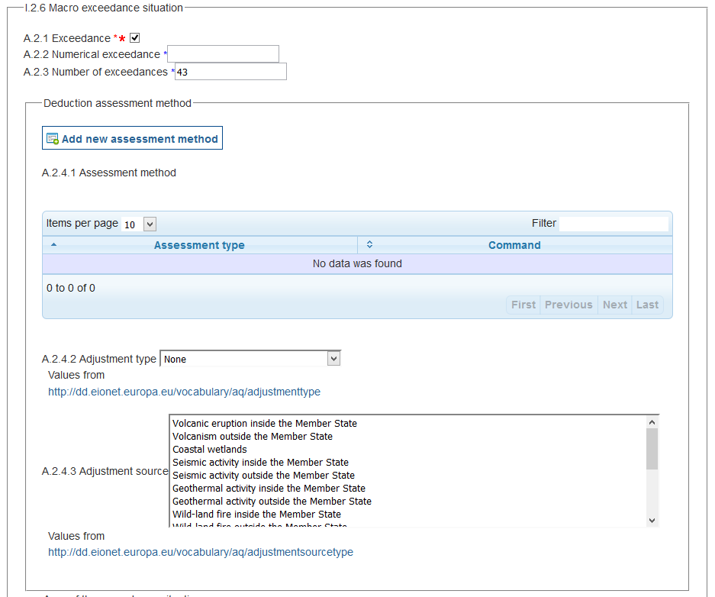

PaPeRS

**Macro Exceedance situation**

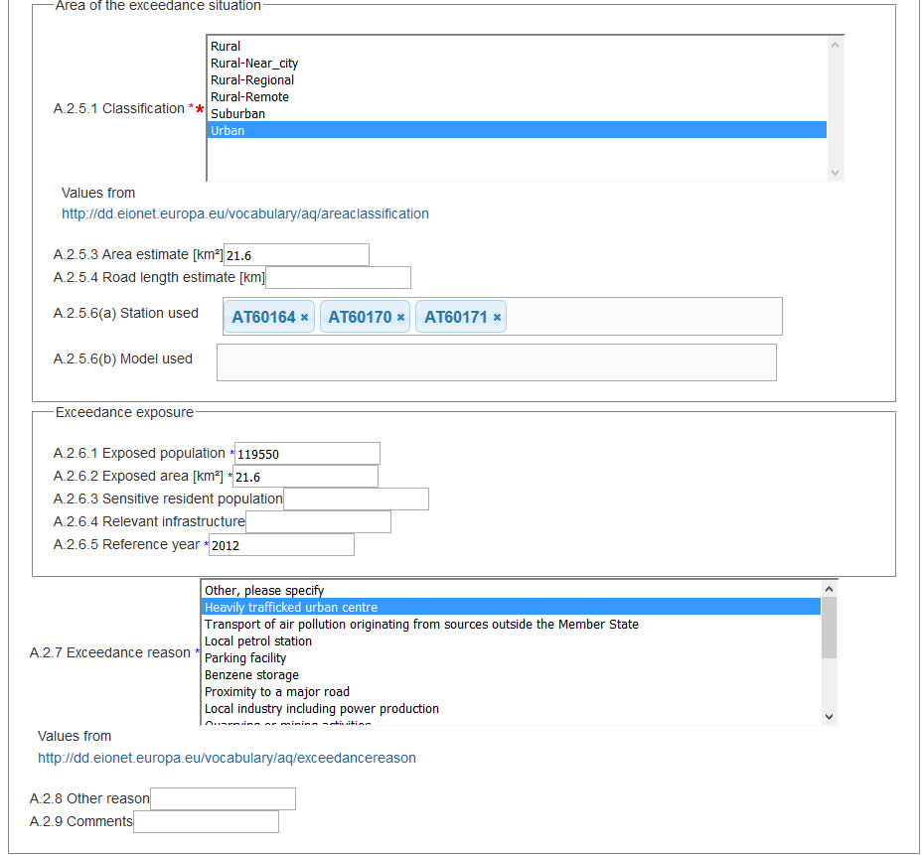

AQD exceedance statement - <aqd:exceedance>

AQD exceedance allows for a boolean statement to be declared in relation to whether levels are above or below the environmental objective. For source apportionment this will will always be ‘true’.

|  |  |
| --- | --- |
| <aqd:exceedances> |  |
| Minimum occurrence: | 1 (mandatory) |
| Maximum occurrence: | 1 (1 occurrence per <aqd:exceedanceDescriptionFinal>) |
| IPR data specifications found at: | I.2.6 (A.2.1) |
| Code list constraints: | None |
| QA/QC constraints: | None |
| Allowed formats: | True / false |
| XPath to schema location: | /aqd:AQD_Source Apportionment/aqd:exceedanceDescriptionFinal/aqd:ExceedanceDescription/aqd:exceedance |

Example

aqd:exceedance

|  |
| --- |
| <aqd:exceedance>true</aqd:exceedance> |

Numerical exceedances - <aqd:numericalExceedance>

AQD numerical exceedance allows for the description of the highest concentration value observed or predicted in the zone for the pollutant and environmental objective specified. The AQD numerical exceedance class is applicable to environmental objectives using average, percentile or AOT reporting metrics. For other short term reporting metrics use <aqd:numberExceedance>.The rounding rules stipulated by the Commissions’ guidance apply.

|  |  |
| --- | --- |
| <aqd:numericalExceedance> |  |
| Minimum occurrence: | 0 (conditional, mandatory if environmental objective is an average, percentile or AOT) |
| Maximum occurrence: | 1 (1 occurrence per <aqd:exceedanceDescription>) |
| IPR data specifications found at: | I.2.6 (A.2.2) |
| Code list constraints: | None |
| QA/QC constraints: | None |
| Allowed formats: | Numerical value |
| XPath to schema location: | /aqd:AQD_SourceApportionment/aqd:exceedanceDescriptionFinal/aqd:ExceedanceDescription/aqd:numericalExceedance |

Example

aqd:numericalExceedance

|  |
| --- |
| <aqd:numericalExceedance>59.0</aqd:numericalExceedance> |

Number of short term exceedances - <aqd:numberExceedances>

The number of short term exceedances element allows for the description of the highest number of exceedances of short term reporting metrics observed or predicted in the zone for the pollutant and environmental objective specified. The number of exceedances element is applicable to environmental objectives based on the number of daily or hourly exceedances.

|  |  |
| --- | --- |
| <aqd:numberExceedance> |  |
| Minimum occurrence: | C (conditional, mandatory if environmental objective threshold is given as a number of exceedances per year) |
| Maximum occurrence: | 1 (1 occurrence per <aqd:exceedanceDescriptionFinal>) |
| IPR data specifications found at: | I.5.2 (A.2.3) |
| Code list constraints: | None |
| QA/QC constraints: | None |
| Allowed formats: | Numerical value |
| XPath to schema location: | /aqd:AQD_SourceApportionment/aqd:exceedanceDescriptionFinal/aqd:ExceedanceDescription/aqd:numberExceedances |

Example

aqd:numberExceedance

|  |
| --- |
| <aqd:numberExceedances>37</aqd:numberExceedances> |

Adjustment Assessment Method - <aqd:deductionAssessmentMethod>

AQD adjusment assessment methods element exists for linking an Adjustment Description to an adjustment method used to adjust for Natural Sources or Winter-sanding or –salting. For source apportionmentt, this class is only used to re-assure that adjustment is not applicable or has been applied. Declaration of adjustment applicable are made within child elements of <aqd:AdjustmentMethod>.

|  |  |
| --- | --- |
| <aqd:deductionAssessmentMethod> |  |
| Minimum occurrence: | Mandatory |
| Maximum occurrence: | 1 (1 occurrence per <aqd:exceedanceDescriptionFinal>) |
| IPR data specifications : | I.2.6 (A.2.4.2) |
| Code list constraints: | http://dd.eionet.europa.eu/vocabulary/aq/adjustmenttype/ |
| QA/QC constraints: | None |
| XPath to schema location: | /aqd:AQD_SourceApportionment/aqd:exceedanceDescriptionFinal/aqd:ExceedanceDescription/aqd:numberExceedances |

Example

aqd:adjustmentMethod – example for source apportionment

|  |
| --- |
| None applicable  <aqd:deductionAssessmentMethod>  <aqd:AdjustmentMethod>  <aqd:adjustmentType xlink:href="http://dd.eionet.europa.eu/vocabulary/aq/adjustmenttype/noneApplicable/"/>  </aqd:AdjustmentMethod>  </aqd: deductionAssessmentMethod>  None applied  <aqd:deductionAssessmentMethod>  <aqd:AdjustmentMethod>  <aqd:adjustmentType xlink:href="http://dd.eionet.europa.eu/vocabulary/aq/adjustmenttype/noneApplied/"/>  </aqd:AdjustmentMethod>  </aqd: deductionAssessmentMethod>  Fully corrected  <aqd:deductionAssessmentMethod>  <aqd:AdjustmentMethod>  <aqd:adjustmentType xlink:href="http://dd.eionet.europa.eu/vocabulary/aq/adjustmenttype/fullyCorrected/"/>  </aqd:AdjustmentMethod>  </aqd: deductionAssessmentMethod> |

Area of the exceedance situation - <aqd:exceedanceArea>

The exceedance area information class allows for declaration of the area exceeding the environmental objective specified.

The area of exceedance situation class contains the child elements listed below.:

* aqd:areaClassification Mandatory
* aqd:spatialExtent Conditional (M, if available)
* aqd:surfaceArea Mandatory (Conditional if exceedance is on a road link only)
* aqd:roadLength Conditional (M if exceedance on a road link)
* aqd:stationUsed Conditional (M if exceedance measured at SamplingPoint)
* aqd:administrativeUnit Voluntary
* aqd:modelUsed Conditional (M if exceedance modeled using Model or ExpertJudgment)

It is a child element of aqd:exceedanceDescription (and therefore aqd:exceedanceDescriptionBase, aqd:exceedanceDescriptionAdjustment and aqd:exceedanceDescriptionFinal). The class is not required if levels are below the environmental objective, i.e. if aqd:exceedance has been set to false. If levels are above the environmental objective, the class is mandatory within aqd:exceedanceDescriptionFinal. If Member States have the information calculated for the aqd:exceedanceDescriptionBase and aqd:exceedanceDescriptionAdjustment classes, these data may be provided on a voluntary basis.

Example

aqd:exceedanceArea

|  |
| --- |
| <aqd:exceedanceArea>  <aqd:ExceedanceArea>  <aqd:areaClassification xlink:href="http://dd.eionet.europa.eu/vocabulary/aq/areaclassification/suburban"/>  <aqd:areaClassification xlink:href="http://dd.eionet.europa.eu/vocabulary/aq/areaclassification/urban"/>  <aqd:areaClassification xlink:href="http://dd.eionet.europa.eu/vocabulary/aq/areaclassification/rural"/>  <aqd:spatialExtent>  <gml:Surface srsName="urn:ogc:def:crs:EPSG::4258" gml:id="UK0030">  <gml:patches>  <gml:PolygonPatch>  <gml:exterior>  <gml:LinearRing>  <gml:posList srsDimension="2">50.691955 -4.493191 50.691651 -4.507335 50.700636 -4.507814 50.700939 -4.493668 50.691955 -4.493191</gml:posList>  </gml:LinearRing>  </gml:exterior>  </gml:PolygonPatch>  </gml:patches>  </gml:Surface>  </aqd:spatialExtent>  <aqd:surfaceArea uom="http://dd.eionet.europa.eu/vocabularyconcept/uom/area/km2">5008.0  </aqd:surfaceArea>  </aqd:ExceedanceArea>  </aqd:exceedanceArea> |

**Area classification - <aqd:areaClassification>**

The area classification element allows for the description of type of area covered by the exceedance situation. Area classification is mandatory when an exceedance situation has been observed. Multiple area classification types are allowable where the extent of the exceedance situation is large e.g. urban, suburban and rural area classifications are valid descriptions of widespread exceedance problem. The content of area classification is constrained by the code list indicated

|  |  |
| --- | --- |
| aqd:areaClassification |  |
| Minimum occurrence: | M (mandatory) |
| Maximum occurrence: | Unbounded |
| IPR data specifications: | I.2.6 (A.2.5.1) |
| Code list constraints: | http://dd.eionet.europa.eu/vocabulary/aq/areaclassification/view code |
| Formats Allowed: | codelist |
| XPath to schema location: | /aqd:AQD_SourceApportionment/aqd:exceedanceDescriptionFinal/aqd:ExceedanceDescription/aqd:exceedanceArea/aqd:ExceedanceArea/aqd:areaClassification |

**Spatial extent of exceedance situation - <aqd:spatialExtent>**

The spatial extent of exceedance situation element should be used to provide a geometry description of the extent of the exceedance area. The element may be generated by EEA central resources or if the Member State possesses the information as (i) a valid gml:polygon encoding of the extent of the exceedance situation if this is known, (ii) a gml:point encoding if exceedance situation is known as a point (e.g. sampling point or multiple sampling points) or (iii) a valid gml:linestring encoding if exceedance situation is known as a vector object (e.g. road centre line). Alternatively the Member State may encode this information as a list of administrative units coincident with the exceedance situation area, see <aqd:administrativeUnit>. One or other of <aqd:spatialExtent> and <aqd:administrativeUnit> must be provided, not both.

|  |  |
| --- | --- |
| aqd:spatialExtent |  |
| Minimum occurrence: | C (conditional, mandatory if aqd:administrativeUnit not supplied) |
| Maximum occurrence: | 1 |
| IPR data specifications: | I.2.6 (A.2.5.2) |
| Code list constraints: | None |
| Formats Allowed: | Valid gml:polygon, gml:point, gml:linestring |
| XPath to schema location: | /aqd:AQD_SourceApportionment/aqd:exceedanceDescriptionFinal/aqd:ExceedanceDescription/ aqd:exceedanceArea/aqd:ExceedanceArea/aqd:spatialExtent |

**Area of exceedance situation - <aqd:surfaceArea>**

The area of exceedance situation element allows for the reporting of a numerical estimate of the area of the exceedance situation above the environmental objective. It is identified as a mandatory requirement in the IPR guidance although it is noted that the area of exceedance may not be know if the exceedance is only associated with a road link. In this event the aqd:surfaceArea should be omitted and aqd:roadLength provided. It is recommended to keep the number of decimal places to one.

|  |  |
| --- | --- |
| aqd:surfaceArea |  |
| Minimum occurrence: | C (conditional, mandatory if exceedance estimated to be background / non-roadside) |
| Maximum occurrence: | 1 |
| IPR data specifications: | I.2.6 (A.2.5.3) |
| Code list constraints: | http://dd.eionet.europa.eu/vocabulary/uom/area/ |
| Formats Allowed: | Numeric value in square kilometres to 1 decimal place |
| XPath to schema location: | /aqd:AQD_SourceApportionment/aqd:exceedanceDescriptionFinal/aqd:ExceedanceDescription/ aqd:exceedanceArea/aqd:ExceedanceArea/aqd:surfaceArea |

**Length of road exceeding - <aqd:roadLength>**

The length of road exceeding element allows for the reporting of a numerical estimate of the length of road where the level was above the environmental objective in kilometers. It is mandatory when there is an exccedance situation linked to a road. It is recommended to keep the number of decimal places to one.

|  |  |
| --- | --- |
| aqd:roadLength |  |
| Minimum occurrence: | C (conditional, mandatory if exceedance estimated on a road link) |
| Maximum occurrence: | 1 |
| IPR data specifications: | I.2.6 (A.2.5.4) |
| Code list constraints: | http://dd.eionet.europa.eu/vocabulary/uom/length/ |
| Formats Allowed: | Numeric value in kilometres to 1 decimal place |
| XPath to schema location: | /aqd:AQD_SourceApportionment/aqd:exceedanceDescriptionFinal/aqd:ExceedanceDescription/ aqd:exceedanceArea/aqd:ExceedanceArea/aqd:roadLength |

**Administrative units covered by exceedance area - <aqd:administrativeUnit>**

The administrative units element should be used to provide an estimate of the geometry description for the extent of the exceedance area. It is an alternative method to providing detailed geographic information via the aqd:spatialExtent element. The element may be generated by EEA central resources or if the Member State, if the Member State possesses the information as list of LAU / NUTS administrative codes which coincide with the estimate are of exceedance. The list of codes to be used shall be constrained to EEA’s codelist described below.

|  |  |
| --- | --- |
| aqd:administrativeUnit |  |
| Minimum occurrence: | X (EEA generated), 0 (voluntary), |
| Maximum occurrence: | Unbounded |
| IPR data specifications: | I.2.6 (A.2.5.5) |
| Code list constraints: | http://dd.eionet.europa.eu/vocabulary/lau2  <http://dd.eionet.europa.eu/vocabulary/lau1>  <http://dd.eionet.europa.eu/vocabulary/common/nuts/> |
| Formats Allowed: | Codelist |
| XPath to schema location: | /aqd:AQD_SourceApportionment/aqd:exceedanceDescriptionFinal/aqd:ExceedanceDescription/ aqd:exceedanceArea/aqd:ExceedanceArea/ aqd:administrativeUnit |

Example

**aqd:administrativeUnit**

|  |
| --- |
| Use of a single LAU code <aqd:administrativeUnit xlink:href="http://dd.eionet.europa.eu/vocabulary/lau2/uk/38UDGW"/>  or  <aqd:administrativeUnit xlink:href="http://dd.eionet.europa.eu/vocabulary/lau2/es/17079"/>  Use of several LAU codes <aqd:administrativeUnit xlink:href="http://dd.eionet.europa.eu/vocabulary/lau2/uk/38UDGW"/>  <aqd:administrativeUnit xlink:href="http://dd.eionet.europa.eu/vocabulary/lau2/uk/38UDGW"/>  Use of single NUTS code <aqd:administrativeUnit xlink:href="http://dd.eionet.europa.eu/vocabulary/common/nuts/UKJ14”/>  Use of several NUTS codes <aqd:administrativeUnit xlink:href="http://dd.eionet.europa.eu/vocabulary/common/nuts/UKJ13”/>  <aqd:administrativeUnit xlink:href="http://dd.eionet.europa.eu/vocabulary/common/nuts/UKJ14”/>  Use of an entire AQ zone <aqd:administrativeUnit xlink:href=" [http://environment.data.gov.uk/air-quality/so/Zone_UK0036”/](http://environment.data.gov.uk/air-quality/so/Zone_UK0036)> |

**Sampling points observing the exceedance - <aqd:stationUsed>**

The <aqd:stationUsed> element allows for the reporting of a list of the sampling points observing the exceedence situation. The list of sampling points are provided by a xlink href reference to the sampling point declared in data flow D.

|  |  |
| --- | --- |
| aqd:stationUsed |  |
| Minimum occurrence: | C (conditional, mandatory if exceedance predicted by sampling point) |
| Maximum occurrence: | unbounded |
| IPR data specifications: | I.2.6 (A.2.5.6) |
| Code list constraints: | None |
| Formats Allowed: | Valid xlink href to method in data flow D |
| XPath to schema location: | /aqd:AQD_SourceApportionment/aqd:exceedanceDescriptionFinal/aqd:ExceedanceDescription/ aqd:exceedanceArea/aqd:ExceedanceArea/aqd:stationUsed |

**Focus On**

**aqd:stationUsed – provide link to all exceeding SamplingPoints**

|  |
| --- |
| This element is key to provide a link to ALL the SamplingPoints within each zone that have exceeded the Environmental Objective |

**Models / objective estimation methods predicting exceedance - <aqd:modelUsed>**

The models / objective estimation methods predicting exceedance allows for the reporting of a list of the models / objective estimation methods predicting the exceedence situation. The list of models / objective estimation methods are provided by a xlink href reference to the assessment methods declared in data flow D.

|  |  |
| --- | --- |
| aqd:modelUsed |  |
| Minimum occurrence: | C (conditional, mandatory if exceedance predicted by model / objective estimation) |
| Maximum occurrence: | unbounded |
| IPR data specifications: | I.2.6 (A.2.5.6) |
| Code list constraints: | None |
| Formats Allowed: | Valid xlink href to method in data flow D |
| XPath to schema location: | /aqd:AQD_SourceApportionment/aqd:exceedanceDescriptionFinal/aqd:ExceedanceDescription/ aqd:exceedanceArea/aqd:ExceedanceArea/aqd:modelUsed |

**Exceedance exposure information - <aqd:exceedanceExposure>**

The exceedance exposure complex information class allows for the declaration of an estimate of the population and vegetation areas exposed to levels above the environmental objective specified. It is a child element of aqd:exceedanceDescription (and therefore aqd:exceedanceDescriptionBase, aqd:exceedanceDescriptionAdjustment and aqd:exceedanceDescriptionFinal). If Member State have the information calculated for the aqd:exceedanceDescription, these data may be provided on a voluntary basis; if they are not provided, they may be generated by the EEA.

The exceedance exposure information class contains the child elements listed below:

* aqd:populationExposed Voluntary (or generated by EEA)
* aqd:ecosystemAreaExposed Voluntary (or generated by EEA)
* aqd:sensitivePopulation Voluntary (or generated by EEA)
* aqd:infrastructureServices Voluntary (or generated by EEA)
* aqd:referenceYear Voluntary

Example

aqd:exceedanceExposure

|  |
| --- |
| <aqd:exceedanceExposure>  <aqd:ExceedanceExposure>  <aqd:populationExposed>2640</aqd:populationExposed>  <aqd:referenceYear>  <gml:TimeInstant gml:id="ReferenceYear_9505">  <gml:timePosition>2011</gml:timePosition>  </gml:TimeInstant>  </aqd:referenceYear>  </aqd:ExceedanceExposure>  </aqd:exceedanceExposure> |

**Population exposure - <aqd:populationExposed>**

The population exposure element provides an estimate of the total resident population exposed to levels above the environmental objective. The element is mandatory for health related protection targets when there is an exceedance. The EEA may generate population statistics based on central data sources. Member State Mamber States are encouraged to provide detailed information if they have this available. Population is to be reported in integer format.

|  |  |
| --- | --- |
| aqd:populationExposed |  |
| Minimum occurrence: | X (EEA generated), 0 (voluntary), |
| Maximum occurrence: | 1 |
| IPR data specifications: | I.2.6 (A.2.6.1) |
| Code list constraints: | [None](http://dd.eionet.europa.eu/vocabulary/aq/individualexceedances/view) |
| Formats Allowed: | Integer |
| XPath to schema location: | /aqd:AQD_SourceApportionment/aqd:exceedanceDescriptionFinal/aqd:ExceedanceDescription/ aqd:exceedanceExposure/aqd:ExceedanceExposure/aqd:populationExposed |

**Area of ecosystem / vegetation area exposed - <aqd:ecosystemAreaExposed>**

The area of ecosystem/vegetation area exposed element provides an estimate of the area of this sensitive receptor type to levels above the environmental objective. The element is mandatory for vegetation related protection targets when there is an exceedance. The EEA may generate the estimates based on central data sources. Member State Member States are encouraged to provide detailed information if they have this available. Area exposed is to be reported in integer format in square kilometers.

|  |  |
| --- | --- |
| aqd:ecosystemAreaExposed |  |
| Minimum occurrence: | X (EEA generated), 0 (voluntary), |
| Maximum occurrence: | 1 |
| IPR data specifications found: | I.2.6 (A.2.6.2) |
| Code list constraints: | http://dd.eionet.europa.eu/vocabulary/uom/area/ |
| Formats Allowed: | Area in square kilometres to 1 decimal place maximum |
| XPath to schema location: | /aqd:AQD_SourceApportionment/aqd:exceedanceDescriptionFinal/aqd:ExceedanceDescription/aqd:exceedanceExposure/aqd:ExceedanceExposure/aqd:ecosystemAreaExposed  /aqd:AQD_SourceApportionment/aqd:exceedanceDescriptionFinal/aqd:ExceedanceDescription/aqd:exceedanceExposure/aqd:ExceedanceExposure/aqd:ecosystemAreaExposed/text()  /aqd:AQD_SourceApportionment/aqd:exceedanceDescriptionFinal/aqd:ExceedanceDescription/aqd:exceedanceExposure/aqd:ExceedanceExposure/aqd:ecosystemAreaExposed/@uom |

**Sensitive population exposure <aqd:sensitivePopulation>**

The sensitive population exposure element provides an estimate of the percentage of sensitive population in the exceedance area, defined as sum of percentage under 18 and over 60 years of age. This information is voluntary. The EEA may generate the estimates based on central data sources. Member State Member States are encouraged to provide detailed information if they have this available.

|  |  |
| --- | --- |
| <aqd:sensitivePopulation> |  |
| Minimum occurrence: | X (EEA generated), 0 (voluntary), |
| Maximum occurrence: | 1 |
| IPR data specifications: | I.2.6 (A.2.6.3) |
| Code list constraints: | [None](http://dd.eionet.europa.eu/vocabulary/aq/individualexceedances/view) |
| Formats Allowed: | Percentage (%) of total population exposed |
| XPath to schema location: | /aqd:AQD_SourceApportionment/aqd:exceedanceDescriptionFinal/aqd:ExceedanceDescription/ aqd:exceedanceExposure/aqd:ExceedanceExposure/aqd:sensitivePopulation |

**Sensitive infrastructure services exposed <aqd:infrastructureServices>**

The Sensitive infrastructure services exposed provides an estimate of the total number of infrastructure services for sensitive population groups in the exceedance area (hospitals, kindergardens, schools etc.). This information is voluntary. The EEA may generate the estimates based on central data sources. Member States are encouraged to provide detailed information if they have this available.

|  |  |
| --- | --- |
| <aqd:infrastructureServices> |  |
| Minimum occurrence: | X (EEA generated), 0 (voluntary), |
| Maximum occurrence: | 1 |
| IPR data specifications found: | I.2.6 (A.2.6.4) |
| Code list constraints: | [None](http://dd.eionet.europa.eu/vocabulary/aq/individualexceedances/view) |
| Formats Allowed: | Integer |
| XPath to schema location: | /aqd:AQD_SourceApportionment/aqd:exceedanceDescriptionFinal/aqd:ExceedanceDescription/ aqd:exceedanceExposure/aqd:ExceedanceExposure/aqd:infrastructureServices |

**Reference year <aqd:referenceYear>**

The reference year element provides a time position for the year in which the population estimates declared in aqd:populationExposed were collected. If the Member States has generated the estimates in aqd:populationExposed they are responsible for providing the reference year. If the EEA have generated the estimates in aqd:populationExposed, the EEA shall generate the reference year information.

|  |  |
| --- | --- |
| <aqd:referenceYear> |  |
| Minimum occurrence: | 0 (voluntary) |
| Maximum occurrence: | 1 |
| IPR data specifications: | I.2.6 (A.2.6.5) |
| Formats Allowed: | YYYY format |
| XPath to schema location: | /aqd:AQD_SourceApportionment/aqd:exceedanceDescriptionFinal/aqd:ExceedanceDescription/ aqd:exceedanceExposure/aqd:ExceedanceExposure/aqd:refenceYear |

**Exceedance reason - <aqd:reason> & <aqd:reasonOther>**

Allows for the declaration of the reason for exceedance using the 461-Air Quality Questionnaire reason codes. The content of this element is constrained by a code list as indicated below. The code list includes all reason codes previously used for declaring reason of exceedance within the 461-Air Quality Questionnaire. Multiple reason codes are allowed where more than one sector is responsible. In such a case multiple elements and xlink:href citations are allowed.

|  |  |
| --- | --- |
| aqd:reason |  |
| Minimum occurrence: | 0 (voluntary) |
| Maximum occurrence: | unbounded |
| IPR data specifications: | I.2.6 (A.2.7 & A.2.8) |
| Code list constraints: | http://dd.eionet.europa.eu/vocabulary/aq/exceedancereason |
| XPath to schema location: | /aqd:AQD_SourceApportionment/aqd:exceedanceDescriptionFinal/aqd:ExceedanceDescription/aqd:reason  /aqd:AQD_SourceApportionment/aqd:exceedanceDescriptionFinal/aqd:ExceedanceDescription/aqd:reasonOther |

Example

aqd:reason

|  |
| --- |
| <aqd:reason xlink:href=" [http://dd.eionet.europa.eu/vocabulary/aq/exceedancereason/S8"/](http://dd.eionet.europa.eu/vocabulary/aq/exceedancereason/S8%22/)> |

XML

**aqd:macroExceedanceSituation**

<aqd:macroExceedanceSituation>

<aqd:ExceedanceDescription>

<aqd:exceedance>true</aqd:exceedance>

<aqd:numberExceedances>43</aqd:numberExceedances>

<aqd:deductionAssessmentMethod>

<aqd:AdjustmentMethod>

<aqd:adjustmentType/>

</aqd:AdjustmentMethod>

</aqd:deductionAssessmentMethod>

<aqd:exceedanceArea>

<aqd:ExceedanceArea>

<aqd:areaClassification xlink:href="http://dd.eionet.europa.eu/vocabulary/aq/areaclassification/urban"/>

<aqd:surfaceArea uom="http://dd.eionet.europa.eu/vocabulary/uom/area/km2">21.6</aqd:surfaceArea>

<aqd:stationUsed xlink:href="http://www.gisaustria.at/AT.0008.20.AQ/AT60164"/>

<aqd:stationUsed xlink:href="http://www.gisaustria.at/AT.0008.20.AQ/AT60170"/>

<aqd:stationUsed xlink:href="http://www.gisaustria.at/AT.0008.20.AQ/AT60171"/>

</aqd:ExceedanceArea>

</aqd:exceedanceArea>

<aqd:exceedanceExposure>

<aqd:ExceedanceExposure>

<aqd:populationExposed>119550</aqd:populationExposed>

<aqd:ecosystemAreaExposed uom="http://dd.eionet.europa.eu/vocabulary/uom/area/km2">21.6</aqd:ecosystemAreaExposed>

<aqd:referenceYear>

<gml:TimeInstant gml:id="EXCEEDANCE_EXPOSURE_REFERENCE_YEAR_8bf4863cca4411269150c86705f9241b">

<gml:timePosition>2012</gml:timePosition>

</gml:TimeInstant>

</aqd:referenceYear>

</aqd:ExceedanceExposure>

</aqd:exceedanceExposure>

<aqd:reason xlink:href="http://dd.eionet.europa.eu/vocabulary/aq/exceedancereason/S1"/>

<aqd:reasonOther></aqd:reasonOther>

<aqd:comment></aqd:comment>

</aqd:ExceedanceDescription>

</aqd:macroExceedanceSituation>

Comments - <aqd:comments>

Comments on clarification, e.g. information on primary NO2.

|  |  |
| --- | --- |
| aqd:comment |  |
| Minimum occurrence: | 0 |
| Maximum occurrence: | 1 |
| IPR data specifications found: | I.2.7 |
| Code list constraints: | n/a |
| Formats Allowed: | Alphanumeric |
| XPath to schema location: | /aqd:AQD_SourceApportionment/aqd:comment |
| Voidable: | Yes |

PaPeRS

**Comments**

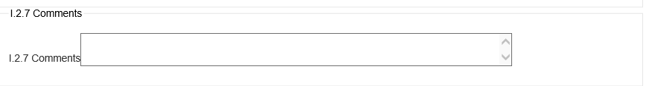

XML

**aqd:comments**

|  |
| --- |
| <aqd:comment></aqd:comment> |

AQD Plan - <aqd:usedInPlan xlink:href>

Link to H.2

|  |  |
| --- | --- |
| Aqd:usedInPlan |  |
| Minimum occurrence: | 1 |
| Maximum occurrence: | 1 |
| IPR data specifications found: | I.2.8 |
| Code list constraints: | n/a |
| Formats Allowed: | Alphanumeric |
| XPath to schema location: | /aqd:AQD_SourceApportionment/aqd:usedInPlan xlink:href |
| Voidable: | No |

PaPeRS

**AQD Plan**



XML

**aqd:usedInPlan**

|  |
| --- |
| <aqd:usedInPlan xlink:href="AT.0008.20.AQ/Draft_2015-10-28.08.18.904"/> |

Parent exceedance situation - <aqd:parentExceedanceSituation xlink:href>

Information of Assessment Attainment with the relevant parent Exceedances Situation (s). If the exceedance refers to a limit value or target value described as a number of values above a threshold, the quantitative source apportionment shall refer to the corresponding percentile. Link to G.5

|  |  |
| --- | --- |
| aqd:parentExceedanceSituation |  |
| Minimum occurrence: | 1 |
| Maximum occurrence: | 1 |
| IPR data specifications found: | I.2.9 |
| Code list constraints: | n/a |
| Formats Allowed: | Alphanumeric |
| XPath to schema location: | /aqd:AQD_SourceApportionment/aqd:parentExceedanceSituation xlink:href |
| Voidable: | No |

PaPeRS

**Parent Exceedance Situation**



XML

**aqd:parentExceedanceSituation**

|  |
| --- |
| <aqd:parentExceedanceSituation xlink:href="AT.0008.20.AQ/ATT-AT_60_00008_LV_aMean_2013"/> |

**J – Baseline and Evaluation Scenarios -** <aqd:AQD_EvaluationScenario>

The AQD_EvaluationScenario information class is the parent to the following child classes which hold information on the baseline projections scenario (which presents concentrations for a future date based on a business as usual emsissions scenario) and evaluation scenario (which presents concentrations for a future date with additional emissions abtement measures applied alongside relevant business as usual measure). The AQD_EvaluationScenario information class aims to presenting the expected outcome in the future if current air quality management practices continue (in terms of ambient concentrations) and the effect of additional measures to control air pollution. Core to the data flow is the presentation of the date by which the environmental objectives will be met and the evidence that this date is achievable with the measures identified.The reporting XML contains both the air quality reporting header information class and the AQD_EvaluationScenario classes. The AQD_EvaluationScenario class is comprised of the child classes out lined below. Further details on An indication of their cardinality is provided and references the location of the relevant data specification in the Commission’s IPR guidance documentation for air quality classes.

aqd:AQD_EvaluationScenario (J.2) includes:

* aqd:inspireId Mandatory (J.2.1)
* aqd:codeOfScenario Mandatory (J.2.2)
* aqd:publication Mandatory (J.2.3)
* aqd: description Mandatory
* aqd: title Mandatory
* aqd:author Voluntary
* aqd:publicationDate Mandatory
* aqd: publisher Mandatory
* aqd: webLink Voluntary
* aqd:attainmentYear Mandatory (J.2.4)
* aqd:startYear Mandatory (J.2.5)
* aqd:baselineScenario Mandatory (J.2.6)
  + aqd:scenario
    - aqd:description Mandatory
    - aqd:totalEmissions Mandatory
    - aqd:expectedConcentration Voluntary
  + aqd:expectedExceedances Voluntary
  + aqd:comment Voluntary
  + aqd:measuresApplied Mandatory
* aqd:projectionScenario Mandatory (J.2.7)
  + aqd:scenario
    - aqd:description Mandatory
  + aqd:totalEmissions Mandatory
  + aqd:expectedConcentration Voluntary
  + aqd:expectedExceedances Voluntary
  + aqd:comment Voluntary
  + aqd:measuresApplied Mandatory
* aqd:usedInPlan Mandatory (J.2.8)
* aqd:sourceApportionment Mandatory (J.2.9)

Detailed information on the constraints and content requirements for these e-Reporting classes is provided below. Figure 9 provides a high-level illustration of the core information classes that constitute AQD_EvaluationScenario.

**Focus On**

**AQD_EvaluationScenario – external links**

|  |
| --- |
| HTML based documentation for the element AQD_EvaluationScenario:  <http://www.eionet.europa.eu/aqportal/doc/xsd/AirQualityReporting.html#LinkB>  Latest UML for AQD_ EvaluationScenario at:  <http://www.eionet.europa.eu/aqportal/doc/UML_AQDmodel_bmp/Plans_Programmes.pdf> |

|  |
| --- |
|  |
| Figure 9 – AQD_EvaluationScenario |

AQD Evaluation Scenario identifier- <aqd:inspireId>

The identifier provides for the unique identification of the source apportionment information. The data provider is responsible for ensuring the identifier is unique and managing its lifecycle. An explanation of the identifier class can be found in [Part 1 - USER GUIDE TO XML & DATA MODEL - Common elements & B-G](http://www.eionet.europa.eu/aqportal/toolbox/guidance/doc/UserGuide2_AQD_XML_v3.2.0.pdf). **The Inspire identifier for the air quality evaluation scenario may be built by concatenating prefix (EVS.), the zone code (e.g. AT01), the pollutant code of notation (e.g. 1 or so2), the protection target (e.g. H – for health protection), reporting metric (e.g. daysAbove), and the reporting year of reference year (e.g. 2014), see example below.**

|  |  |
| --- | --- |
| aqd:inspireId |  |
| Minimum occurrence: | 1 (mandatory) |
| Maximum occurrence: | 1 (1 occurrence per XML document) |
| IPR data specifications found at: | J.2.1 (A.8.1, A.8.2, A.8.3) |
| QA/QC constraints: | See http://dd.eionet.europa.eu/vocabulary/aq/cdrqaqc/view, otherwise none other than the multiplicity and formats specified here. |
| Allowed formats: | Alphanumeric |
| XPath to schema location: | /aqd:AQD_EvaluationScenario/aqd:inspireId/base:Identifier  /aqd:AQD_ EvaluationScenario /aqd:inspireId/base:Identifier/base:localId  /aqd:AQD_ EvaluationScenario /aqd inspireId/base:Identifier/base:namespace  /aqd:AQD_ EvaluationScenario /aqd:inspireId/base:Identifier/base:versionId |
| Further information found @ | <http://inspire.jrc.ec.europa.eu/documents/Data_Specifications/D2.5_v3.4rc2.pdf> |
| Voidable: | No |

XML

aqd:inspireId

|  |
| --- |
| <aqd:AQD_EvaluationScenario gml:id="EVS_AT01_PM10_daysAbove_2014">  <aqd:inspireId>  <base:Identifier>  <base:localId> EVS_AT01_PM10_daysAbove_2014</base:localId>  <base:namespace>AT.0008.20.AQ</base:namespace>  <base:versionId>2015-10-28.09.17.373</base:versionId>  </base:Identifier> |

Code of scenario - <aqd:codeOfScenario>

This simple class presents a unique local code for the the evaluation scenario. Member States are responsible for managing the life cycle of the code and ensuring it is unque within their systems.

|  |  |
| --- | --- |
| <aqd:codeOfScenario> |  |
| Minimum occurrence: | 1 (mandatory for e-Reporting) |
| Maximum occurrence: | 1 |
| IPR data specifications found: | J.2.2 |
| Code list constraints: | None |
| Formats Allowed: | Alphanumeric |
| XPath to schema location: | /aqd:AQD_EvaluationScenario/aqd:codeOfScenario |
| Voidable: | No |

PaPeRS

**AQD codeOfScenario**



XML

aqd:codeOfScenario

|  |
| --- |
| <aqd:codeOfScenario>AT_60_2013_PM10</aqd:codeOfScenario> |

Relevant Publication - <aqd:publication>

. The information class provides for documentating a technical or policy focused publication on the Scenario (this publication may be identical to that of the AQ Plan referenced in H.2.12). See also data type Publication described in section H.2.12

|  |  |
| --- | --- |
| <aqd:publication> |  |
| Minimum occurrence: | 1 (mandatory for e-Reporting) |
| Maximum occurrence: | unbounded |
| IPR data specifications found: | J.2.3 |
| Code list constraints: | None |
| Formats Allowed: | Alphanumeric |
| XPath to schema location: | aqd:AQD_EvaluationScenario/aqd:publication  /aqd:AQD_EvaluationScenario/aqd:publication/aqd:Publication  /aqd:AQD_EvaluationScenario/aqd:publication/aqd:Publication/aqd:description  /aqd:AQD_EvaluationScenario/aqd:publication/aqd:Publication/aqd:title  /aqd:AQD_EvaluationScenario/aqd:publication/aqd:Publication/aqd:author  /aqd:AQD_EvaluationScenario/aqd:publication/aqd:Publication/aqd:publicationDate  /aqd:AQD_EvaluationScenario/aqd:publication/aqd:Publication/aqd:publicationDate/gml:TimeInstant gml:id  /aqd:AQD_EvaluationScenario/aqd:publication/Publication/publicationDate/ gml:TimeInstant/gml:TimePosition  /aqd:AQD_EvaluationScenario/aqd:publication/aqd:Publication/aqd:publicationDate/gml:TimeInstant  /aqd:AQD_EvaluationScenario/aqd:publication/aqd:Publication/aqd:publicationDate/gml:TimeInstant/gml:timePosition  /aqd:AQD_EvaluationScenario/aqd:publication/aqd:Publication/aqd:publisher  /aqd:AQD_EvaluationScenario/aqd:publication/aqd:Publication/aqd:webLink |
| Voidable: | No |

PaPeRS

**Publication**

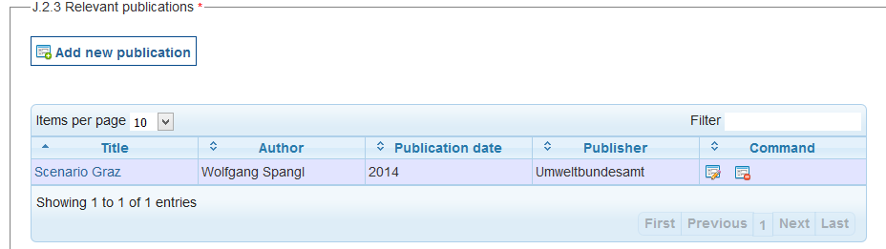

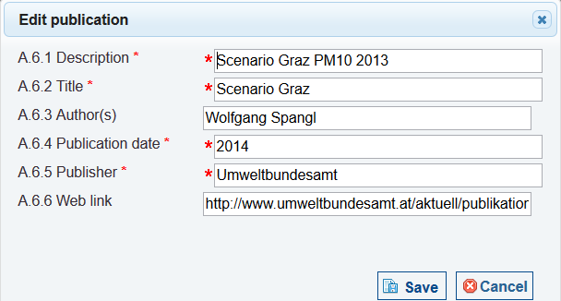

XML

aqd:publication

|  |
| --- |
| <aqd:publication>  <aqd:Publication>  <aqd:description>Scenario Graz PM10 2013</aqd:description>  <aqd:title>Scenario Graz</aqd:title>  <aqd:author>Wolfgang Spangl</aqd:author>  <aqd:publicationDate>  <gml:TimeInstant gml:id="PUBLICATION_DATE_d5b6610e119d9c8fc433e596bd527193">  <gml:timePosition>2014</gml:timePosition>  </gml:TimeInstant>  </aqd:publicationDate>  <aqd:publisher>Umweltbundesamt</aqd:publisher> <aqd:webLink>http://www.umweltbundesamt.at/aktuell/publikationen/publikationssuche/publikationsdetail/?pub_id=2138</aqd:webLink>  </aqd:Publication>  </aqd:publication> |

Attainment year for which the projections are calculated - <aqd:attainmentYear>

This simple information class specifies the calendar year for which the projections have been calculated. The format allowed is yyyy.

|  |  |
| --- | --- |
| <aqd:attainmentYear> |  |
| Minimum occurrence: | 1 (mandatory for e-Reporting) |
| Maximum occurrence: | 1 |
| IPR data specifications found: | J.2.4 |
| Code list constraints: | None |
| Formats Allowed: | Date (YYYY) |
| XPath to schema location: | /aqd:AQD_EvaluationScenario/aqd:firstExceedanceYear  /aqd:AQD_EvaluationScenario/aqd:firstExceedanceYear/gml:Instant gml:id  /aqd:AQD_EvaluationScenario/aqd:firstExceedanceYear/gml:Instant/gml:timePosition |
| Voidable: | No |

PaPeRS

**Attainment Year**



XML

aqd:attainmentYear

|  |
| --- |
| <aqd:attainmentYear>  <gml:TimeInstant gml:id="ATTAINMENT_YEAR_1e734bb05d6c865a07ae3763c7e2c8cb">  <gml:timePosition>2015</gml:timePosition>  </gml:TimeInstant>  </aqd:attainmentYear> |

Reference year - <aqd:startYear>

This simple information class specifies the reference year from which the projections are have been calculated. It define base year from which modelling of future projection is based will effect the emissions inventory used, atmospheric conditions and implemented measures within the base year. The format allowed is yyyy. The reference year may be different to the source apportionment base year although countries are recommended to use the same referenece year for both source apportionment and the evaluation scenario.

|  |  |
| --- | --- |
| <aqd:startYear> |  |
| Minimum occurrence: | 1 (mandatory for e-Reporting) |
| Maximum occurrence: | 1 |
| IPR data specifications found: | J.2.5 |
| Code list constraints: | None |
| Formats Allowed: | Date (YYYY) |
| XPath to schema location: | /aqd:AQD_EvaluationScenario/aqd:startYear  /aqd:AQD_EvaluationScenario/aqd:firstExceedanceYear/gml:Instant gml:id  /aqd:AQD_EvaluationScenario/aqd:firstExceedanceYear/gml:Instant/gml:timePosition |
| Voidable: | No |

PaPeRS

**Start Year**



XML

aqd:startYear

|  |
| --- |
| <aqd:startYear>  <gml:TimeInstant gml:id="START_YEAR_1e734bb05d6c865a07ae3763c7e2c8cb">  <gml:timePosition>2012</gml:timePosition>  </gml:TimeInstant>  </aqd:startYear> |

Baseline Scenario - <aqd:baselineScenario>

This information class describes the emissions scenario applied in the baseline analysis (without additional measures). It uses the complex datatype aqd:baselineScenario with the following elements.

aqd:baselineScenario includes;

* aqd:description Mandatory
* aqd:totalEmissions Mandatory
* aqd:expectedConcentration Conditional/Mandatory
* aqd:expectedExceedances Conditional/Mandatory
* aqd:comment Voluntary
* aqd:measuresApplied Mandatory

Description of the baseline scenario - <aqd:description>

This simple class provides a description of the emission scenario in free text form. It should briefly document assumptions regarding the emission scenarios, meterology, chemical schemes etc preferably with reference to background material.

|  |  |
| --- | --- |
| <aqd:description> |  |
| Minimum occurrence: | 1 (mandatory for e-Reporting) |
| Maximum occurrence: | 1 |
| IPR data specifications found: | J.2.6.1 |
| Code list constraints: | None |
| Formats Allowed: | Alphanumeric |
| XPath to schema location: | /aqd:AQD_EvaluationScenario/aqd:BaselineScenario/aqd:Scenario/aqd:descripion |
| Voidable: | No |

PaPeRS

**Baseline Scenario - description**

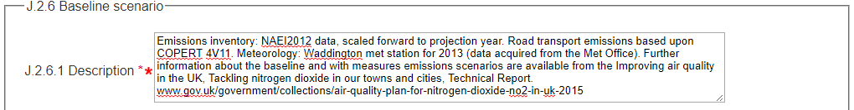

XML

aqd:description

|  |
| --- |
| <aqd:baselineScenario>  <aqd:Scenario>  <aqd:description>Emissions inventory: NAEI2012 data, scaled forward to projection year. Road transport emissions based upon COPERT 4V11. Meteorology: Waddington met station for 2013 (data acquired from the Met Office). Further information about the baseline and with measures emissions scenarios are available from the Improving air quality in the UK, Tackling nitrogen dioxide in our towns and cities, Technical Report. www.gov.uk/government/collections/air-quality-plan-for-nitrogen-dioxide-no2-in-uk-2015</aqd:description> |

Total emissions in the area addressed by the evaluation scenario - <aqd:totalEmissions>

This simple class documents the total emissions in the base year for the area addressed by the evaluation scenario. The base line emissions for the reference year should not include any additional measures that are planned in order to achieve the projection scenario. Total emissions are given in kt/yr.

|  |  |
| --- | --- |
| <aqd:totalEmissions> |  |
| Minimum occurrence: | 1 (mandatory for e-Reporting) |
| Maximum occurrence: | 1 |
| IPR data specifications found: | J.2.6.2 |
| Code list constraints: | None |
| Formats Allowed: | Alphanumeric |
| XPath to schema location: | /aqd:AQD_EvaluationScenario/aqd:BaselineScenario/aqd:Scenario/aqd:totalEmissions uom |
| Voidable: | No |

PaPeRS

**Baseline Scenario – total emissions**



XML

aqd:totalEmissions

|  |
| --- |
| <aqd:totalEmissions uom="http://dd.eionet.europa.eu/vocabulary/uom/emission/kt.year-1">2.2</aqd:totalEmissions> |

Expected concentration for the evaluation scenario - <aqd:expectedConcentration>

This simple class documents the expected concentrations in the base year for the area addressed by the evaluation scenario and the baseline emissions scenario describe in J.2.6.. Annual mean value and percentile concentrations (in µg/m³) are documented in J2.6.2.

|  |  |
| --- | --- |
| <aqd:expectedConcentration> |  |
| Minimum occurrence: | 0 |
| Maximum occurrence: | 1 |
| IPR data specifications found: | J.2.6.3 |
| Code list constraints: | None |
| Formats Allowed: | Numeric |
| XPath to schema location: | /aqd:AQD_EvaluationScenario/aqd:BaselineScenario/aqd:Scenario/aqd:expectedConcentration |
| Voidable: | No |

PaPeRS

**Baseline Scenario – expected Concentration levels**



XML

aqd:expectedConcentration

|  |
| --- |
| <aqd:expectedConcentration></aqd:expectedConcentration> |

Expected number of exceedances for the evaluation scenario - <aqd:expectedExceedances>

This simple class documents the expected number of exceedances in the base year for the area addressed by the evaluation scenario and the baseline emissions scenario describe in J.2.6. J2.6.3 is applicable to short-term reporting metrics only i.e. number of days or hours above threshold.

|  |  |
| --- | --- |
| <aqd:expectedExceedances> |  |
| Minimum occurrence: | 0 |
| Maximum occurrence: | 1 |
| IPR data specifications found: | J.2.6.4 |
| Code list constraints: | None |
| Formats Allowed: | Numeric |
| XPath to schema location: | /aqd:AQD_EvaluationScenario/aqd:BaselineScenario/aqd:Scenario/aqd:expectedExceedances |
| Voidable: | No |

PaPeRS

**Baseline Scenario – expected Exceedances**



XML

aqd:expectedExceedances

|  |
| --- |
| <aqd:expectedExceedances>37</aqd:expectedExceedances> |

Comments - <aqd:comment>

A simple class providing for a short description or notes for clarification in relation to the baseline evaluation scenario.

|  |  |
| --- | --- |
| <aqd:comments> |  |
| Minimum occurrence: | 0 |
| Maximum occurrence: | 1 |
| IPR data specifications found: | J.2.6.5 |
| Code list constraints: | None |
| Formats Allowed: | Alphanumeric |
| XPath to schema location: | /aqd:AQD_EvaluationScenario/aqd:BaselineScenario/aqd:Scenario/aqd:comments |
| Voidable: | Yes |

PaPeRS

**Baseline Scenario – comments**



XML

aqd:comments

|  |
| --- |
| <aqd:comments></aqd:comments> |

Measures applied in the baseline emissions scenario - <aqd:measuresApplied>

A simple element providing a list of the measures applied in the baseline emissions scenario via a link to K.2.

|  |  |
| --- | --- |
| <aqd:measuresApplied> |  |
| Minimum occurrence: | 1 |
| Maximum occurrence: | unbounded |
| IPR data specifications found: | J.2.6.6 |
| Code list constraints: | None |
| Formats Allowed: | Alphanumeric |
| XPath to schema location: | /aqd:AQD_EvaluationScenario/aqd:BaselineScenario/aqd:Scenario/aqd:measuresApplied |
| Voidable: | No |

PaPeRS

**Baseline Scenario – measures applied**

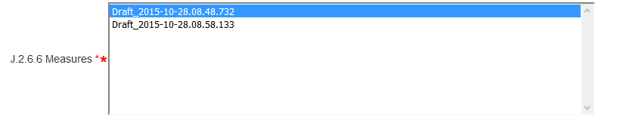

XML

aqd:measuresApplied

|  |
| --- |
| <aqd:measuresApplied xlink:href="http://www.gisaustria.at/AT.0008.20.AQ/Draft_2015-10-28.08.48.732"/> |

Projection Scenario - <aqd:projectionScenario>

This information class describes the emissions scenario applied in the projection year (with additional measures included). It uses the complex datatype aqd:projectionScenario with the following elements.

aqd:projectionScenario includes;

* aqd:description Mandatory
* aqd:totalEmissions Mandatory
* aqd:expectedConcentration Conditional/Mandatory
* aqd:expectedExceedances Conditional/Mandatory
* aqd:comment Voluntary
* aqd:measuresApplied Mandatory

The information requirements for projection scenario are the same as baseline scenario but updated to include the effects of the new new / additional measures.

Description of the projection scenario - <aqd:description>

This simple class provides a description of the emission scenario in free text form. It should briefly document assumptions regarding the emission scenarios, meterology, chemical schemes etc preferably with reference to background material.

|  |  |
| --- | --- |
| <aqd:description> |  |
| Minimum occurrence: | 1 (mandatory for e-Reporting) |
| Maximum occurrence: | 1 |
| IPR data specifications found: | J.2.7.1 |
| Code list constraints: | None |
| Formats Allowed: | Alphanumeric |
| XPath to schema location: | /aqd:AQD_EvaluationScenario/aqd:ProjectionScenario/aqd:Scenario/aqd:descripion |
| Voidable: | No |

PaPeRS

**Projection Scenario - description**

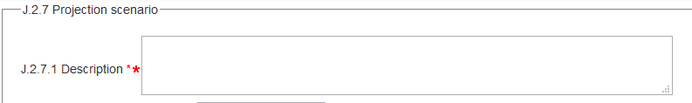

XML

aqd:description

|  |
| --- |
| <aqd:projectionScenario>  <aqd:Scenario>  <aqd:description></aqd:description> |

Total emissions in the area addressed by the evaluation scenario - <aqd:totalEmissions>

This simple class documents the total emissions in the attainment year (J.2.4) for the area addressed by the evaluation scenario. The emissions for the attainment year should include any additional measures that are planned in order to achieve the projection scenario by the . Total emissions are given in kt/yr.

|  |  |
| --- | --- |
| <aqd:totalEmissions> |  |
| Minimum occurrence: | 1 (mandatory for e-Reporting) |
| Maximum occurrence: | 1 |
| IPR data specifications found: | J.2.7.2 |
| Code list constraints: | None |
| Formats Allowed: | Alphanumeric |
| XPath to schema location: | /aqd:AQD_EvaluationScenario/aqd:ProjectionScenario/aqd:Scenario/aqd:totalEmissions uom |
| Voidable: | No |

PaPeRS

**Projection Scenario – total emissions**



XML

aqd:totalEmissions

|  |
| --- |
| <aqd:totalEmissions uom="http://dd.eionet.europa.eu/vocabulary/uom/emission/kt.year-1">1.9</aqd:totalEmissions> |

Expected concentration for the evaluation scenario - <aqd:expectedConcentration>

This simple class documents the expected concentrations in the attainment year for the area addressed by the evaluation scenario and the projected emissions scenario describe in J.2.7. Annual mean value and percentile concentrations (in µg/m³) are documented in J2.7.2.

|  |  |
| --- | --- |
| <aqd:expectedConcentration> |  |
| Minimum occurrence: | 0 |
| Maximum occurrence: | 1 |
| IPR data specifications found: | J.2.7.3 |
| Code list constraints: | None |
| Formats Allowed: | Numeric |
| XPath to schema location: | /aqd:AQD_EvaluationScenario/aqd:ProjectionScenario/aqd:Scenario/aqd:expectedConcentration |
| Voidable: | No |

PaPeRS

**Projection Scenario – expected Concentration levels**



XML

aqd:expectedConcentration

|  |
| --- |
| <aqd:expectedConcentration></aqd:expectedConcentration> |

Expected number of exceedances for the evaluation scenario - <aqd:expectedExceedances>

This simple class documents the expected number of exceedances in the attainment year for the area addressed by the evaluation scenario and the projected emissions scenario describe in J.2.7. J2.7.3 is applicable to short-term reporting metrics only i.e. number of days or hours above threshold.

|  |  |
| --- | --- |
| <aqd:expectedExceedances> |  |
| Minimum occurrence: | 0 |
| Maximum occurrence: | 1 |
| IPR data specifications found: | J.2.7.4 |
| Code list constraints: | None |
| Formats Allowed: | Numeric |
| XPath to schema location: | /aqd:AQD_EvaluationScenario/aqd:ProjectionScenario/aqd:Scenario/aqd:expectedExceedances |
| Voidable: | No |

PaPeRS

**Projection Scenario – expected Exceedances**



XML

aqd:expectedExceedances

|  |
| --- |
| <aqd:expectedExceedances>34</aqd:expectedExceedances> |

Comments - <aqd:comment>

A simple class providing for a short description or notes for clarification in relation to the projection evaluation scenario.

|  |  |
| --- | --- |
| <aqd:comments> |  |
| Minimum occurrence: | 0 |
| Maximum occurrence: | 1 |
| IPR data specifications found: | J.2.7.5 |
| Code list constraints: | None |
| Formats Allowed: | Alphanumeric |
| XPath to schema location: | /aqd:AQD_EvaluationScenario/aqd:ProjectionScenario/aqd:Scenario/aqd:comments |
| Voidable: | Yes |

PaPeRS

**Projection Scenario – comments**

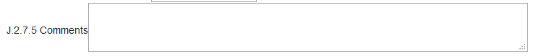

XML

aqd:comments

|  |
| --- |
| <aqd:comments></aqd:comments> |

Measures applied in the projected emissions scenario - <aqd:measuresApplied>

A simple element providing a list of the measures applied in the projected emissions scenario for the attainment year via a link to K.2.

|  |  |
| --- | --- |
| <aqd:measuresApplied> |  |
| Minimum occurrence: | 1 |
| Maximum occurrence: | unbounded |
| IPR data specifications found: | J.2.7.6 |
| Code list constraints: | None |
| Formats Allowed: | Alphanumeric |
| XPath to schema location: | /aqd:AQD_EvaluationScenario/aqd:ProjectionScenario/aqd:Scenario/aqd:measuresApplied xlink:href |
| Voidable: | No |

PaPeRS

**Projection Scenario – measures applied**

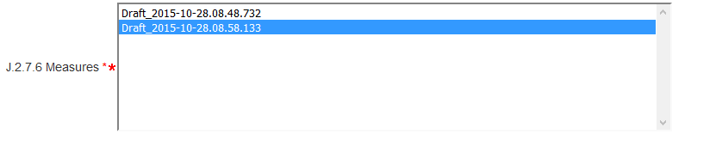

XML

aqd:measuresApplied

|  |
| --- |
| <aqd:measuresApplied xlink:href="AT.0008.20.AQ/Draft_2015-10-28.08.58.133"/> |

AQ Plan - <aqd:usedInPlan>

This simple information class links the evaluation scenario to an air quality plan document via an xlink href reference to the localId of the relevant plan in H.2.

|  |  |
| --- | --- |
| <aqd:usedInPlan> |  |
| Minimum occurrence: | 1 |
| Maximum occurrence: | 1 |
| IPR data specifications found: | J.2.8 |
| Code list constraints: | None |
| Formats Allowed: | Alphanumeric |
| XPath to schema location: | /aqd:AQD_EvaluationScenario/aqd:usedInPlan xlink:href |
| Voidable: | No |

PaPeRS

**Used in AQ Plan**



XML

aqd:usedInPlan

|  |
| --- |
| <aqd:usedInPlan xlink:href="AT.0008.20.AQ/Draft_2015-10-28.08.18.904"/> |

AQ Source Apportionment - <aqd:sourceApportionment>

This simple information class links the evaluation scenario to a source apportionment record / description via an xlink href reference to the localId of the relevant source apportionment in I.2.

|  |  |
| --- | --- |
| <aqd:sourceApportionment> |  |
| Minimum occurrence: | 1 |
| Maximum occurrence: | 1 |
| IPR data specifications found: | J.2.9 |
| Code list constraints: | None |
| Formats Allowed: | Alphanumeric |
| XPath to schema location: | /aqd:AQD_EvaluationScenario/aqd:sourceApportionment xlink:href |
| Voidable: | No |

PaPeRS

**Source Apportionment**



XML

aqd:sourceApportionment

|  |
| --- |
| <aqd:sourceApportionment xlink:href="AT.0008.20.AQ/Draft_2015-10-28.08.36.612"/> |

K - Documentation of measures

The AQD_Measures information class is the parent to the following child classes which hold information on the air quality management measures (policies) which have been applied in the baseline evalusation scenario or are planned to be applied within the projection scenario. The measures are designed manage and reduce air pollution in the exccedance areas identified by the air quality plan.

The reporting XML contains both the air quality reporting headerinformation class and the AQD_Measures class.

Reporting header <aqd:AQD_ReportingHeader>

An explanation of the air quality reporting header information class can be found in  [Part 1 - USER GUIDE TO XML & DATA MODEL - Common elements & B-G](http://www.eionet.europa.eu/aqportal/toolbox/guidelines) This is mandatory for all reporting data flows.

aqd:AQD_Measures (K.2) includes:

* aqd:inspireId Mandatory (K.2.1)
* aqd:code Mandatory (K.2.2)
* aqd:name Mandatory (K.2.3)
* aqd:description Mandatory (K.2.4)
* aqd:classification Mandatory (K.2.5)
* aqd:type Mandatory (K.2.6)
* aqd:administrativeLevel Mandatory (K.2.7)
* aqd:timescale Mandatory (K.2.8)
* aqd:costs Conditional, mandatory if available (K.2.9)
* aqd:estimatedImplementationCosts Conditional, mandatory if available (K.2.9.1)
* aqd:finalImplementationCosts Voluntary (K.2.9.2)
* aqd:currency Conditional, mandatory if available (K.2.9.3)
* aqd:comment Conditional, mandatory if no costs are available (K.2.9.4)
* aqd:sourceSectors Mandatory (K.2.10)
* aqd:spatialScale Mandatory (K.2.11)
* aqd:plannedImplementation Mandatory (K.2.12)
  + aqd:plannedImplementationStatus Voluntary (K.2.12.1)
  + aqd:implementationPlannedTimePeriod Mandatory (K.2.12.2)
    - gml:TimePosition/beginPosition Mandatory (K.2.12.2.1)
    - gml:TimePosition/endPosition Mandatory (K.2.12.2.2)
    - aqd:implementationAcutalTimePeriod Voluntary (K.2.12.2.3)
      * gml:TimePosition/beginPosition Mandatory (K.2.12.2.3.1)
      * gml:TimePosition/endPosition Mandatory (K.2.12.2.3.2)
    - aqd:plannedFullEffectDate Conditional, mandatory if available (K.2.12.2.4)
    - aqd:otherDates Voluntary (K.2.12.2.5)
  + aqd:monitoringProgressIndicators Conditional, mandatory if available (K.2.12.6)
  + aqd:comment Conditional, mandatory if available (K.2.12.7
* aqd:reductionOfEmissions Mandatory (K.2.13)
  + aqd:quantityCommented Conditional, mandatory if not voided and no comment
  + aqd:quantity@UoM Mandatory
  + aqd:comment Conditional, mandatory if quantity not available
* aqd:expectedImpact Conditional, mandatory if available (K.2.14)
  + aqd:levelOfConcentration Conditional, mandatory if available (K.2.14.1)
  + aqd:quantity@UoM Mandatory
  + aqd:numberOfExceedances Conditional, mandatory if available (K.2.14.2)
  + aqd.specificationOfHours Conditional, mandatory (K.2.14.3)
  + aqd:comment Voidable (K.2.14.4)
* aqd:comment Vodable (K.2.15)
* aqd:exceedanceAffected@xlink:href Mandatory (K.2.16)
* aqd:usedForScenario@xlink:href Voluntary (K.2.17)

Detailed information on the constraints and content for these e-Reporting classes is provided below in Figure 10

**Focus On**

**AQD_Measures**

|  |
| --- |
| HTML based documentation for the element AQD_Measures:  <http://www.eionet.europa.eu/aqportal/doc/xsd/AirQualityReporting.html#LinkD>  Latest UML for AQD_Measures:  <http://www.eionet.europa.eu/aqportal/doc/UML_AQDmodel_bmp/Plans_Programmes.pdf> |

|  |
| --- |
|  |
| Figure – Ilustration of AQD_Measures |

Air quality mdentifier - <aqd:inspireId>

The identifier provides for the unique identification of the source apportionment. The data provider is responsible for ensuring the identifier is unique and managing its lifecycle. An explanation of the identifier class can be found in  [Part 1 - USER GUIDE TO XML & DATA MODEL - Common elements & B-G](http://www.eionet.europa.eu/aqportal/guidelines) .

|  |  |
| --- | --- |
| aqd:inspireId |  |
| Minimum occurrence: | 1 (Mandatory) |
| Maximum occurrence: | 1 |
| IPR data specifications found: | K.2.1 |
| Code list constraints: | [none](http://dd.eionet.europa.eu/vocabulary/aq/stationclassification) |
| QA/QC constraints: |  |
| Allowed formats: | alphanumeric |
| XPath to schema location: | /aqd:AQD_Measures/aqd:inspireId |
| Further information @ |  |
| Voidable: | No |

XML

aqd:inspireId

|  |
| --- |
| <aqd:AQD_Measures gml:id="ATTR_ AT_60_PM10_2014_traffic">  <aqd:inspireId>  <base:Identifier>  <base:localId>AT_60_PM10_2014_traffic</base:localId>  <base:namespace>AT.0008.20.AQ</base:namespace>  <base:versionId>2015-10-28.08.57.38</base:versionId>  </base:Identifier>  </aqd:inspireId> |

Air quality measures code - <aqd:code>

This simple class presents a unique local code for the measure. Member States are responsible for managing the life cycle of the code and ensuring it is unque within their systems.The code may be identical to the unique identifier used in K2.1.

|  |  |
| --- | --- |
| aqd:code |  |
| Minimum occurrence: | 1 (Mandatory) |
| Maximum occurrence: | 1 |
| IPR data specifications found: | K.2.2 |
| Code list constraints: | [none](http://dd.eionet.europa.eu/vocabulary/aq/stationclassification) |
| QA/QC constraints: | See http://dd.eionet.europa.eu/vocabulary/aq/cdrqaqc/view, otherwise none other than the multiplicity and formats specified here. |
| Allowed formats: | alphanumeric |
| XPath to schema location: | /aqd:AQD_Measures/aqd:code |
| Further information @ |  |
| Voidable: | No |

PaPeRS

**Measure code**



XML

aqd:code

|  |
| --- |
| <aqd:code>AT_60_PM10_2014_traffic</aqd:code> |

Air quality measure name - <aqd:name>

This simple information class stores a short title of the pollution abatement measure.

|  |  |
| --- | --- |
| aqd:name |  |
| Minimum occurrence: | 1 (Mandatory) |
| Maximum occurrence: | 1 |
| IPR data specifications found: | K.2.3 |
| Code list constraints: | [none](http://dd.eionet.europa.eu/vocabulary/aq/stationclassification) |
| QA/QC constraints: |  |
| Allowed formats: | alphanumeric |
| XPath to schema location: | /aqd:AQD_Measures/aqd:name |
| Further information @ |  |
| Voidable: | No |

PaPeRS

**Measure name**



XML

aqd:name

|  |
| --- |
| <aqd:name>Graz PM10 traffic</aqd:name> |

AQ Measure description - <aqd:description>

This simple information class holds descriptive information on the measure as free text. The description should provide brief information on the sources covered, type of measure e.g. introduction of new technology(s), incentivisation of modal shifts, economic insentivisation, physical mamangament pollution dispersion etc.

|  |  |
| --- | --- |
| aqd:description |  |
| Minimum occurrence: | 1 (Mandatory) |
| Maximum occurrence: | 1 |
| IPR data specifications found: | K.2.4 |
| Code list constraints: | [none](http://dd.eionet.europa.eu/vocabulary/aq/stationclassification) |
| QA/QC constraints: |  |
| Allowed formats: | alphanumeric |
| XPath to schema location: | /aqd:AQD_Measures/aqd:description |
| Further information @ |  |
| Voidable: | No |

PaPeRS

**Measure description**

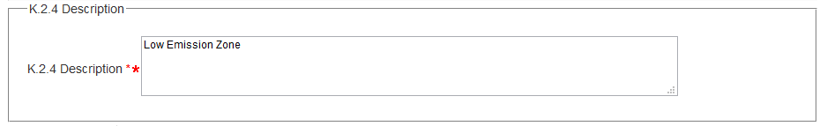

XML

aqd:description

|  |
| --- |
| <aqd:description>Low Emission Zone</aqd:description> |

Air quality measure classification - <aqd:classification>

The aqd:classification information class identifies the measure using one of a series measure tyoes. The measure classifications type available to countries are controlled by codelist, see <http://dd.eionet.europa.eu/vocabulary/aq/measureclassification>. Additions to this codelist may be requested via email to aqipr.helpdesk@eionet.europa.eu.

|  |  |
| --- | --- |
| aqd:classification |  |
| Minimum occurrence: | 1 (Mandatory) |
| Maximum occurrence: | unbounded |
| IPR data specifications found: | K.2.5 |
| Code list constraints: | http://dd.eionet.europa.eu/vocabulary/aq/measureclassification |
| QA/QC constraints: |  |
| Allowed formats: | Code list |
| XPath to schema location: | /aqd:AQD_Measures/aqd:classification |
| Further information @ |  |
| Voidable: | No |

PaPeRS

**Measure classification**

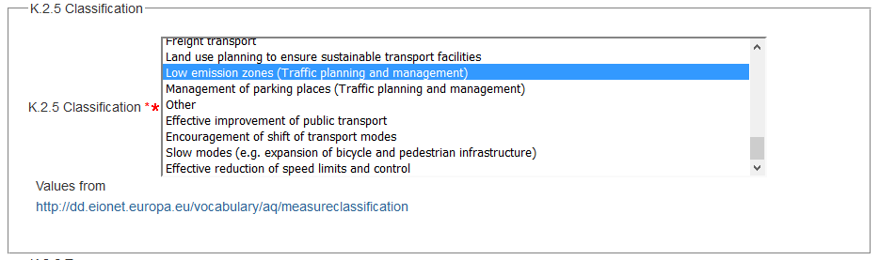

XML

aqd:classification

|  |
| --- |
| <aqd:classification xlink:href="http://dd.eionet.europa.eu/vocabulary/aq/measureclassification/traffic-LEZ"/> |

Air quality measure type - <aqd:type>

The aqd:measureType information class groups the measure into 1 of more ‘types’ which describe the high-level implementation mechanism or scope of the measure. The measure types available to countries are controlled by codelist, see <http://dd.eionet.europa.eu/vocabulary/aq/measuretype>. Additions to this codelist may be requested via email to aqipr.helpdesk@eionet.europa.eu.

See codelist Measure Types.

|  |  |
| --- | --- |
| aqd:type |  |
| Minimum occurrence: | 1 (Mandatory) |
| Maximum occurrence: | 1 |
| IPR data specifications found: | K.2.6 |
| Code list constraints: | http://dd.eionet.europa.eu/vocabulary/aq/measuretype |
| QA/QC constraints: |  |
| Allowed formats: | See code list |
| XPath to schema location: | /aqd:AQD_Measures/aqd:type |
| Further information @ |  |
| Voidable: | No |

PaPeRS

**Measure type**

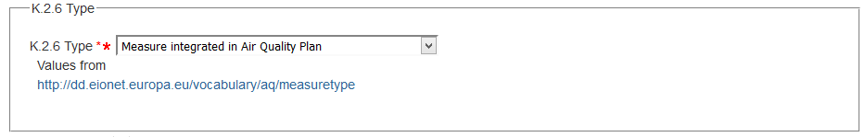

XML

aqd:type

|  |
| --- |
| <aqd:measureType xlink:href="http://dd.eionet.europa.eu/vocabulary/aq/measuretype/integrated"/> |

Administrative level - <aqd:administrativeLevel>

The aqd:administrationLevel information class specifies the administrative level responsible for implementation of the measure. Additions to this codelist may be requested via email to aqipr.helpdesk@eionet.europa.eu.

|  |  |
| --- | --- |
| aqd:administrativeLevel |  |
| Minimum occurrence: | 1 (Mandatory) |
| Maximum occurrence: | 1 |
| IPR data specifications found: | K.2.7 |
| Code list constraints: | <http://dd.eionet.europa.eu/vocabulary/aq/measuretype> |
| QA/QC constraints: |  |
| Allowed formats: | Code list |
| XPath to schema location: | /aqd:AQD_Measures/aqd:administrativeLevel |
| Further information @ |  |
| Voidable: | No |

PaPeRS

**Administrative level**

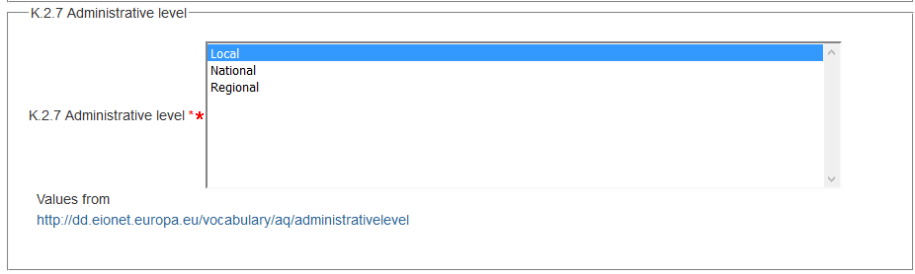

XML

aqd:administrativeLevel

|  |
| --- |
| <aqd:administrativeLevel xlink:href="http://dd.eionet.europa.eu/vocabulary/aq/administrativelevel/local"/> |

Time scale - <aqd:timeScale>

The aqd:timeScale information class specifies the timescale for the implementation of the measure using a codelist of controlled vocabularies. Additions to this codelist may be requested via email to aqipr.helpdesk@eionet.europa.eu.

|  |  |
| --- | --- |
| aqd:timeScale |  |
| Minimum occurrence: | 1 (Mandatory) |
| Maximum occurrence: | 1 |
| IPR data specifications found: | K.2.8 |
| Code list constraints: | <http://dd.eionet.europa.eu/vocabulary/aq/timeScale> |
| QA/QC constraints: |  |
| Allowed formats: | See code list |
| XPath to schema location: | /aqd:AQD_Measures/aqd:timescale |
| Further information @ |  |
| Voidable: | No |

PaPeRS

**Time scale**

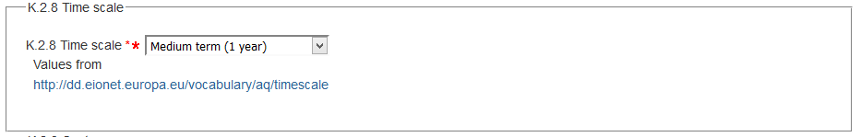

XML

aqd:timeScale

|  |
| --- |
| <aqd:timeScale xlink:href="http://dd.eionet.europa.eu/vocabulary/aq/timescale/medium"/> |

Costs - <aqd:costs>

The aqd:costs complex information class provides information on estimated costs for the implementation of the measure over its implementation life time. This parent class includes the following child information classes;

* aqd:Costs conditional, mandatory if available
* aqd:estimatedImplementationCosts conditional, mandatory if available
* aqd:finalImplementationCosts voluntary
* aqd:currency conditional, mandatory if available
* aqd:comment conditional, mandatory if no costs available

|  |  |
| --- | --- |
| aqd:costs |  |
| Minimum occurrence: | 0 (Conditional, mandatory if available) |
| Maximum occurrence: | 1 |
| IPR data specifications found: | K.2.9 |
| Code list constraints: |  |
| QA/QC constraints: |  |
| Allowed formats: |  |
| XPath to schema location: | /aqd:AQD_Measures/aqd:costs |
| Further information @ |  |
| Voidable: | No |

PaPeRS

**Costs**

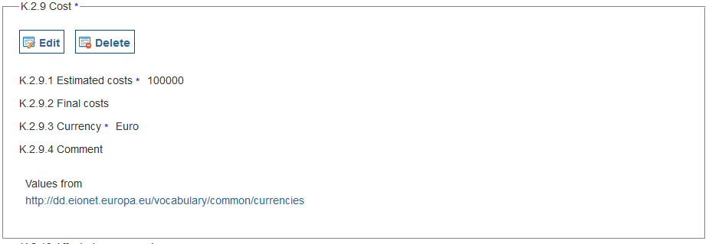

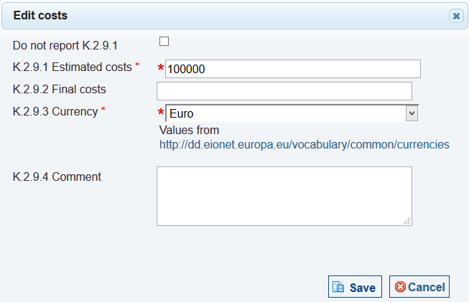

XML

aqd:costs

|  |
| --- |
| <aqd:costs>  <aqd:Costs>  <aqd:estimatedImplementationCosts xsi:nil="false">100000</aqd:estimatedImplementationCosts>  <aqd:currency xlink:href="http://dd.eionet.europa.eu/vocabulary/common/currencies/EUR" xsi:nil="false"/>  </aqd:Costs> |

aqd:estimatedImplementationCosts

This simple information class specifies the estimated costs of implementing the measure prior to its implemention. Note that the implementing costs of a generic measure type may have different costs when implemented at varying spatial scales e.g. congestion charging or a LEZ in a small town may be expected to have lower costs associated with it when compared with a similar scheme in a large agglomeration. In such a case multiple measures reflecting the differing costs are required.

In the event that information on costs is unavailable, the cost information class my be voided with an appropriate descriptor from the controlled vocabulary – missing, not available, not populated. In addition, in such a case a brief description of the reason for this information being unvailable is required.

|  |  |
| --- | --- |
| aqd:estimatedImplementationCosts |  |
| Minimum occurrence: | 0 (Conditional, mandatory if available. If not, justification in void reason is necessary and the comment field must be filled) |
| Maximum occurrence: | 1 |
| IPR data specifications found: | K.2.9.1 |
| Code list constraints: | none |
| QA/QC constraints: |  |
| Allowed formats: | Numeric integer value |
| XPath to schema location: | /aqd:AQD_Measures/aqd:costs/aqd:Costs/aqd:estimatedImplementationCosts |
| Further information @ |  |
| Voidable: | Yes |

XML

aqd:estimatedImplementationCosts

|  |
| --- |
| If estimated costs are available  <aqd:estimatedImplementationCosts xsi:nil="false">100000</aqd:estimatedImplementationCosts>  If estimated costs are unavailable  <aqd:estimatedImplementationCosts nilReason="Unpopulated" xsi:nil="true"/>  <aqd:estimatedImplementationCosts nilReason="Unkown" xsi:nil="true"/>  <aqd:estimatedImplementationCosts nilReason="Withheld" xsi:nil="true"/> |

aqd:finalImplementationCosts

This simple information class specifies the actual costs of implementing the measure. Note that the implementing costs of a generic measure type may have different costs when implemented at varying spatial scales e.g. congestion charging or a LEZ in a small town may be expected to have lower costs associated with it when compared with a similar scheme in a large agglomeration. In such a case multiple measures reflecting the differing costs are required.

In the event that information on costs is unavailable, the cost information class my be voided with an appropriate descriptor from the controlled vocabulary – missing, not available, not populated. In addition, in such a case a brief description of the reason for this information being unvailable is required.

|  |  |
| --- | --- |
| aqd:finalImplementationCosts |  |
| Minimum occurrence: | 0 (voluntary) |
| Maximum occurrence: | 1 |
| IPR data specifications found: | K.2.9.2 |
| Code list constraints: | none |
| QA/QC constraints: |  |
| Allowed formats: | Numeric integer value |
| XPath to schema location: | /aqd:AQD_Measures/aqd:costs/aqd:Costs/aqd:finalImplementationCosts |
| Further information @ |  |
| Voidable: | No |

XML

aqd:finalImplementationCosts

|  |
| --- |
| <aqd:finalImplementationCosts xsi:nil="true"></aqd:finalImplementationCosts> |

aqd:currency

See codelist currencies.

|  |  |
| --- | --- |
| aqd:currency |  |
| Minimum occurrence: | 0 (Conditional, mandatory if available. If not, justification in void reason is necessary and the comment field must be filled) |
| Maximum occurrence: | 1 |
| IPR data specifications found: | K.2.9.3 |
| Code list constraints: | http://dd.eionet.europa.eu/vocabulary/common/currencies/view |
| QA/QC constraints: |  |
| Allowed formats: | Code list |
| XPath to schema location: | /aqd:AQD_Measures/aqd:costs/aqd:Costs/aqd:currency |
| Further information @ |  |
| Voidable: | Yes |

XML

aqd:currency

|  |
| --- |
| Currency declaration with costs  <aqd:currency xlink:href="http://dd.eionet.europa.eu/vocabulary/common/currencies/EUR" xsi:nil="false"/>  Currency declaration where no cost information is available  <aqd:currency nilReason="Unpopulated" xsi:nil="true"/> |

Comments / notes for clarification - <aqd:comment>

This information class allows for comments / notes for clarification to added to the costs information class e.g. any known limitation of the cost estimates / cost accounting methods or exclusions for the cost estimates. In the event of the costs class being voided because information is not available the K.2.9.4 class is mandatory in order to explain why this information is unavailable.

|  |  |
| --- | --- |
| aqd:comment |  |
| Minimum occurrence: | 0 (Conditional, mandatory if no costs are available) |
| Maximum occurrence: | 1 |
| IPR data specifications found: | K.2.9.4 |
| Code list constraints: |  |
| QA/QC constraints: |  |
| Allowed formats: | alphanumeric |
| XPath to schema location: | /aqd:AQD_Measures/aqd:costs/aqd:Costs/aqd:comment |
| Further information @ |  |
| Voidable: | No |

XML

aqd:comment

|  |
| --- |
| <aqd:comment>Not quantified. Cost information not always available from routinely collected data on national measures.</aqd:comment> |

Affected source - <aqd:sourceSectors>

The affected sector information class specifies the high-level activity sector targeted by the measure.The sectors allowed are controlled by a codelist. Multiple sectors are allowed using crtl-right click.

|  |  |
| --- | --- |
| aqd:sourceSectors |  |
| Minimum occurrence: | 1 (Mandatory) |
| Maximum occurrence: | unbounded |
| IPR data specifications found: | K.2.10 |
| Code list constraints: | [code](http://dd.eionet.europa.eu/vocabulary/aq/stationclassification) list |
| QA/QC constraints: | See http://dd.eionet.europa.eu/vocabulary/aq/cdrqaqc/view, otherwise none other than the multiplicity and formats specified here. |
| Allowed formats: | http://dd.eionet.europa.eu/vocabulary/aq/sourcesectors |
| XPath to schema location: | /aqd:AQD_Measures/aqd:sourceSectors |
| Further information @ |  |
| Voidable: | No |

PaPeRS

**Source Sectors**

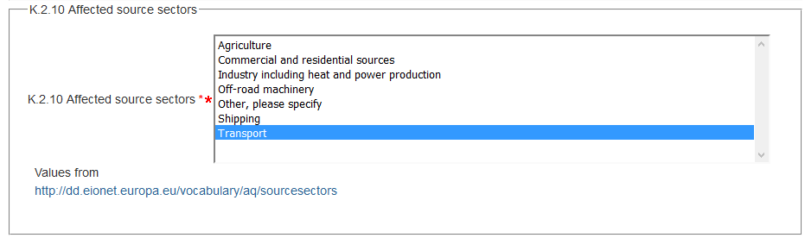

XML

aqd:sourceSectors

|  |
| --- |
| <aqd:sourceSectors xlink:href="http://dd.eionet.europa.eu/vocabulary/aq/sourcesectors/transport"/> |

Spatial scale - <aqd:spatialScale>

The spatial scale information class describe the geographical scope of the measure using a controlled vocabulary

|  |  |
| --- | --- |
| aqd:sourceSectors |  |
| Minimum occurrence: | 1 (Mandatory) |
| Maximum occurrence: | unbounded |
| IPR data specifications found: | K.2.11 |
| Code list constraints: | [code](http://dd.eionet.europa.eu/vocabulary/aq/stationclassification) list |
| QA/QC constraints: | See http://dd.eionet.europa.eu/vocabulary/aq/cdrqaqc/view, otherwise none other than the multiplicity and formats specified here. |
| Allowed formats: | http://dd.eionet.europa.eu/vocabulary/aq/spatialscale |
| XPath to schema location: | /aqd:AQD_Measures/aqd:spatialScale |
| Further information @ |  |
| Voidable: | No |

PaPeRS

**Spatial Scale**

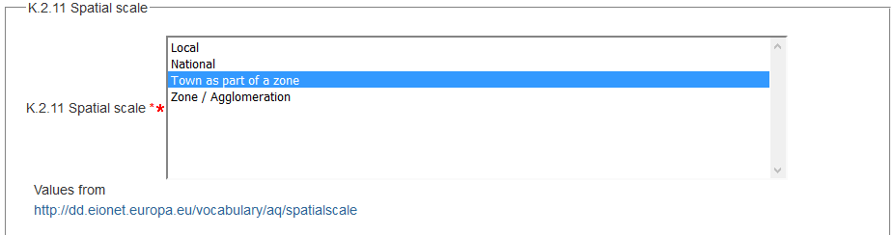

XML

aqd:spatialScale

|  |
| --- |
| <aqd:spatialScale xlink:href="http://dd.eionet.europa.eu/vocabulary/aq/spatialscale/town"/> |

Planned implementation - <aqd:plannedImplementation

Information on the time frame of the implementation of the measure may be specified in the adqplannedImplementation class. It is a complex class with the following child classes. The class as a whole is mandatory although some of the child elements are voidable as for K.2.9.1 and K.2.9.2 (costs), recognising the fact that some information may not be known yet.

aqd:PlannedImplementation Mandatory

* aqd:status Voluntary
* aqd:ImplemenationPlannedTimePeriod Mandatory
* gml:TimePeriod
* gml:beginPosition Mandatory
* gml:endPosition Mandatory
* aqd:ImplemenationActualTimePeriod Voluntary
* gml:TimePeriod
* gml:beginPosition Mandatory
* gml:endPosition Mandatory
* aqd:plannedFullEffectDate Conditional, mandatory if available
* aqd:otherDates Voluntary
* aqd:monitoringProgressIndicators Conditional, mandatory if available
* aqd:comment Conditional, mandatory

|  |  |
| --- | --- |
| aqd:plannedImplementation |  |
| Minimum occurrence: | 1 |
| Maximum occurrence: | 1 |
| IPR data specifications found: | K.2.12 |
| Code list constraints: |  |
| QA/QC constraints: |  |
| Allowed formats: |  |
| XPath to schema location: | /aqd:AQD_Measures/aqd:plannedImplementation |
| Further information @ |  |
| Voidable: | No |

PaPeRS

**PlannedImplementation**

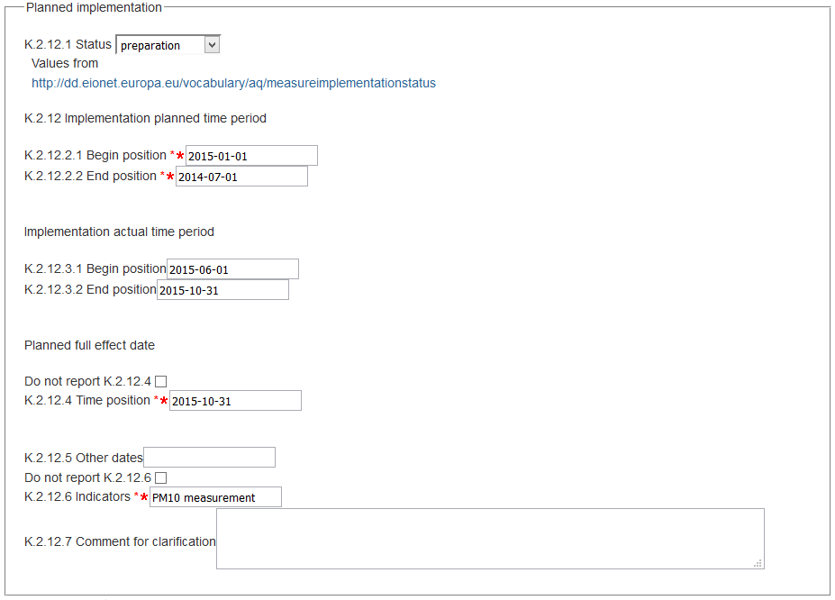

XML

aqd:plannedImplementation

|  |
| --- |
| <aqd:plannedImplementation>  <aqd:PlannedImplementation>  <aqd:status xlink:href="http://dd.eionet.europa.eu/vocabulary/aq/measureimplementationstatus/preparation"/>  <aqd:implementationPlannedTimePeriod>  <gml:TimePeriod gml:id="PLANNED_IMPLEMENTATION_TIME_PERIOD_6ad53e7bfa2ab530d8aa1e0292a37db3">  <gml:beginPosition>2015-01-01T00:00:00Z</gml:beginPosition>  <gml:endPosition>2014-07-01T00:00:00Z</gml:endPosition>  </gml:TimePeriod>  </aqd:implementationPlannedTimePeriod>  <aqd:implementationActualTimePeriod>  <gml:TimePeriod gml:id="ACTUAL_IMPLEMENTATION_TIME_PERIOD_6ad53e7bfa2ab530d8aa1e0292a37db3">  <gml:beginPosition>2015-06-01T00:00:00Z</gml:beginPosition>  <gml:endPosition>2015-10-31T00:00:00Z</gml:endPosition>  </gml:TimePeriod>  </aqd:implementationActualTimePeriod>  <aqd:plannedFullEffectDate>  <gml:TimeInstant gml:id="PLANNED_FULL_EFFECT_DATE_6ad53e7bfa2ab530d8aa1e0292a37db3">  <gml:timePosition>2015-10-31</gml:timePosition>  </gml:TimeInstant>  </aqd:plannedFullEffectDate>  <aqd:monitoringProgressIndicators xsi:nil="false">PM10 measurement</aqd:monitoringProgressIndicators>  </aqd:PlannedImplementation>  </aqd:plannedImplement |

Implementation status - <aqd:Implementation status>

Measure Implementation Status class specifies the status of implementation using a controlled vocabulary. It is a mandatory information requirement.

|  |  |
| --- | --- |
| aqd:status |  |
| Minimum occurrence: | 0 (Voluntary) |
| Maximum occurrence: | 1 |
| IPR data specifications found: | K.2.12.1 |
| Code list constraints: | http://dd.eionet.europa.eu/vocabulary/aq/measureimplementationstatus |
| QA/QC constraints: |  |
| Allowed formats: | Code list |
| XPath to schema location: | /aqd:AQD_Measures/aqd:plannedImplementation/aqd:PlannedImplementation/aqd:status |
| Further information @ |  |
| Voidable: | No |

XML

aqd:status

|  |
| --- |
| <aqd:status xlink:href="http://dd.eionet.europa.eu/vocabulary/aq/measureimplementationstatus/preparation"/> |

Planned implementation time period - < aqd:implementationPlannedTimePeriod>

The planned implementation time period class specifies the start and end of the time period over which the measure is expected to operate ot take effect. An estimate of the start date in yyyy-mm-dd format is a mandatory information requirement. If the end date is not known the field may be left blank and the system will genmerate default code of 9999-01-01.

|  |  |
| --- | --- |
| .aqd:plannedImplementation |  |
| Minimum occurrence: | 1 |
| Maximum occurrence: | 1 |
| IPR data specifications found: | K.2.12.2, K.2.12.2.1, K.2.12.2.2 |
| Code list constraints: | none |
| QA/QC constraints: |  |
| Allowed formats: | Timestamp |
| XPath to schema location: | /aqd:AQD_Measures/aqd:plannedImplementation/aqd:PlannedImplementation/aqd:implementationPlannedTimePeriod  ……./gml:TimePeriod/gml:beginPosition  ….…/gml:TimePeriod/gml:endPosition |
| Further information @ |  |
| Voidable: | No |

XML

aqd:plannedImplementation

|  |
| --- |
| With defined end date  <aqd:implementationPlannedTimePeriod>  <gml:TimePeriod gml:id="PLANNED_IMPLEMENTATION_TIME_PERIOD_6ad53e7bfa2ab530d8aa1e0292a37db3">  <gml:beginPosition>2015-01-01T00:00:00Z</gml:beginPosition>  <gml:endPosition>2014-07-01T00:00:00Z</gml:endPosition>  </gml:TimePeriod>  </aqd:implementationPlannedTimePeriod>  With undefined end date  <aqd:implementationPlannedTimePeriod>  <gml:TimePeriod gml:id="PLANNED_IMPLEMENTATION_TIME_PERIOD_6ad53e7bfa2ab530d8aa1e0292a37db3">  <gml:beginPosition>2015-01-01T00:00:00Z</gml:beginPosition>  <gml:endPosition indeterminatePosition="unknown"/>  </gml:TimePeriod>  </aqd:implementationPlannedTimePeriod> |

Actual implementation time period - <aqd: aqd:PlannedImplementationActualTimePeriod>

The planned implementation time period class specifies the start and end of the time period over which the measure is actually operational. An estimate of the start date in yyyy-mm-dd format is a mandatory information requirement. If the end date is not known e.g. no end date has been set, the field may be left blank and the system will generate default code of 9999-01-01. The dates may be identical to those in the aqd:plannedImplementation class if no better information is available.

|  |  |  |
| --- | --- | --- |
| aqd: implementationActualTimePeriod | |  |
| Minimum occurrence: | 0 (voluntary) | |
| Maximum occurrence: | 1 | |
| IPR data specifications found: | K.2.12.3, K.2.12.3.1, K.2.12.3.2 | |
| Code list constraints: | none | |
| QA/QC constraints: |  | |
| Allowed formats: | Time Period | |
| XPath to schema location: | /aqd:AQD_Measures/aqd:plannedImplementation/aqd:PlannedImplementation/aqd:PlannedImplementationActualTimePeriod/aqd:implementationPlannedTimePeriod  ……./gml:TimePeriod/gml:beginPosition (mandatory)  ….…/gml:TimePeriod/gml:endPosition (mandatory) | |
| Further information @ |  | |
| Voidable: | No | |

XML

aqd:ImplementationActualTimePeriod

|  |
| --- |
| With defined end date  <aqd:implementationActualTimePeriod>  <gml:TimePeriod gml:id="ACTUAL_IMPLEMENTATION_TIME_PERIOD_6ad53e7bfa2ab530d8aa1e0292a37db3">  <gml:beginPosition>2015-06-01T00:00:00Z</gml:beginPosition>  <gml:endPosition>2015-10-31T00:00:00Z</gml:endPosition>  </gml:TimePeriod>  </aqd:implementationActualTimePeriod  With undefined end date  <aqd:implementationActualTimePeriod>  <gml:TimePeriod gml:id="ACTUAL_IMPLEMENTATION_TIME_PERIOD_6ad53e7bfa2ab530d8aa1e0292a37db3">  <gml:beginPosition>2015-06-01T00:00:00Z</gml:beginPosition>  <gml:endPosition indeterminatePosition="unknown"/>  </gml:TimePeriod>  </aqd:implementationActualTimePeriod |

aqd:plannedFullEffectDate

The planned full effect date information class specifies the date when the measure is planned to take full effect. This class is a mandatory requirement. In the event that information on the planned full effect date is unavailable, the cost information class my be voided with an appropriate descriptor from the controlled vocabulary – missing, not available, not populated. In addition, in such a case a brief description of the reason for this information being unvailable is required.

|  |  |  |
| --- | --- | --- |
| aqd: plannedFullEffectDate | |  |
| Minimum occurrence: | 0 (conditional, mandatory if available) | |
| Maximum occurrence: | 1 | |
| IPR data specifications found: | K.2.12.4 | |
| Code list constraints: | none | |
| QA/QC constraints: |  | |
| Allowed formats: | Timestamp | |
| XPath to schema location: | /aqd:AQD_Measures/aqd:plannedImplementation/aqd:PlannedImplementation/aqd:PlannedImplementationActualTimePeriod/  aqd:plannedFullEffectDate  ../gml:TimeInstant gml:id  ../gml:TimeInstant/gml:TimePosition | |
| Further information @ |  | |
| Voidable: | Yes | |

XML

aqd:plannedFullEffectDate

|  |
| --- |
| If information is available  <aqd:plannedFullEffectDate>  <gml:TimeInstant gml:id="PLANNED_FULL_EFFECT_DATE_6ad53e7bfa2ab530d8aa1e0292a37db3">  <gml:timePosition>2015-10-31</gml:timePosition>  </gml:TimeInstant>  </aqd:plannedFullEffectDate>  If information is unavailable  <aqd:plannedFullEffectDate nilReason="Unpopulated" xsi:nil="true"/>  <aqd:plannedFullEffectDate nilReason="Unkown" xsi:nil="true"/>  <aqd:plannedFullEffectDate nilReason="Withheld" xsi:nil="true"/> |

Key adoption/implementation dates with short description.

aqd:otherDates (other key implementation dates)

The other key implementation dates class allows for other important dates to be reported in yyyy-mm-dd format.

|  |  |  |
| --- | --- | --- |
| aqd:otherDates | |  |
| Minimum occurrence: | 0 (Voluntary) | |
| Maximum occurrence: | 1 | |
| IPR data specifications found: | K.2.12.5 | |
| Code list constraints: | none | |
| QA/QC constraints: |  | |
| Allowed formats: | Alphanumeric | |
| XPath to schema location: | /aqd:AQD_Measures/aqd:plannedImplementation/aqd:PlannedImplementation/aqd:otherDates | |
| Further information @ |  | |
| Voidable: | No | |

XML

aqd:otherDates

|  |
| --- |
| <aqd:otherDates></aqd:otherDates> |

Indicators on progress - <aqd:monitoringProgressIndicators>

The aqd:monitoringProgressIndicators class allows for a free text description on the indicators a Member State may use to track progress towards implementation / full affect i.e. monitoring the effectiveness of a measure. It is usually not sufficient to just follow how concentration level change, as the change may be due to other causes. Hence, it is important to follow the progress of the measures with suitable indicators that relate more directly to the measure e.g.

* have the planned parking fees been implemented [y/n] and to what extent [number of parking places affected];
* has the planned permit revision been implemented [y/n];
* how much has the traffic volume on a road gone down [% heavy duty vehicles].

If such information is not available or cannot be generated, the information class my be voided with an appropriate descriptor from the controlled vocabulary – missing, not available, not populated. In addition, in such a case a brief description of the reason for this information being unvailable is required.

|  |  |  |
| --- | --- | --- |
| aqd:monitoringProgressIndicators | |  |
| Minimum occurrence: | 0 (conditional, mandatory if available) | |
| Maximum occurrence: | 1 | |
| IPR data specifications found: | K.2.12.6 | |
| Code list constraints: | none | |
| QA/QC constraints: |  | |
| Allowed formats: | Timestamp | |
| XPath to schema location: | /aqd:AQD_Measures/aqd:plannedImplementation/ aqd:PlannedImplementation/aqd:monitoringProgressIndicators | |
| Further information @ |  | |
| Voidable: | Yes | |

XML

aqd:monitoringProgressIndicators

|  |
| --- |
| <aqd:monitoringProgressIndicators xsi:nil="false">PM10 measurement</aqd:monitoringProgressIndicators> |

Textual description of why the quantification could not be provided or to provide additional context on the validity of the value provided.

Comments / notes for clarification - <aqd:comment>

This information class allows for comments / notes for clarification to added to the implemtation information class. In the event of any classes being voided because information is not available the K.2.21.7 class is mandatory in order to explain why this information is unavailable.

|  |  |  |
| --- | --- | --- |
| aqd:comment | |  |
| Minimum occurrence: | 0 (Voluntary) | |
| Maximum occurrence: | 1 | |
| IPR data specifications found: | K.2.12.7 | |
| Code list constraints: | none | |
| QA/QC constraints: |  | |
| Allowed formats: | Alphanumeric | |
| XPath to schema location: | /aqd:AQD_Measures/aqd:plannedImplementation/aqd:PlannedImplementation/aqd:comment | |
| Further information @ |  | |
| Voidable: | No | |

XML

aqd:comment

|  |
| --- |
| <aqd:monitoringProgressIndicators xsi:nil="false">No suitable indicator can be determined</aqd:monitoringProgressIndicators>  <aqd:comment>Full effect date: Not all dates available from routinely collected data on local measures. </aqd:comment> |

Reduction in emissions due to applied measure - <aqd:reductionOfEmissions

This information class specifies the reduction in total annual emissions attributable to the measure kt/yr Emissions in the area addressed by the measure for the year for which the projections are developed.

This information class is parent to the following child elments that allow the specification of the reduction in emissions, its units of measure and additional comments;

* quantity 0..1 Conditional, mandatory if not voided and no comment
  + quantification numerical 1 Mandatory
  + units of measurement 1 Mandatory
  + comment 0..1 Conditional, mandatory if quantity not available

In the event of the information not being available, the class may be voided in which case the K.13.2 class is mandatory in order to explain why this information is unavailable.

|  |  |
| --- | --- |
| aqd:reductionOfEmissions |  |
| Minimum occurrence: | 1 (mandatory) |
| Maximum occurrence: | 1 |
| IPR data specifications found: | K.2.13 |
| Code list constraints: | http://dd.eionet.europa.eu/vocabulary/uom/emission |
| QA/QC constraints: |  |
| Allowed formats: | Quantification |
| XPath to schema location: | /aqd:AQD_Measures/aqd:reductionOfEmissions  /aqd:AQD_Measures/aqd:reductionOfEmissions/aqd:quantityCommented  /aqd:AQD_Measures/aqd:reductionOfEmissions/aqd:quantityCommented/aqd:quantity uom  /aqd:AQD_Measures/aqd:reductionOfEmissions/aqd:quantityCommented/aqd:comment |
| Further information @ |  |
| Voidable: | No |

PaPeRS

**Reduction of emissions**

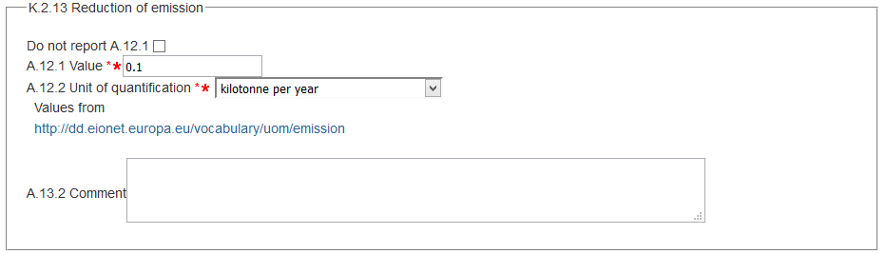

XML

aqd:reductionOfEmissions

|  |
| --- |
| If information is available  <aqd:reductionOfEmissions>  <aqd:QuantityCommented>  <aqd:quantity uom="http://dd.eionet.europa.eu/vocabulary/uom/emission/kt.year-1" xsi:nil="false">0.1</aqd:quantity>  </aqd:QuantityCommented>  </aqd:reductionOfEmissions>  If information is not available  <aqd:reductionOfEmissions>  <aqd:QuantityCommented>  <aqd:quantity uom="Unknown" nilReason="Unpopulated" xsi:nil="true"/>  <aqd:comment>Target annual emissions reduction - No suitable target annual emission reduction can be determined for this measure</aqd:comment>  </aqd:QuantityCommented>  </aqd:reductionOfEmissions> |

Expected impact on ambient concentrations - <aqd:expectedImpact

This information class specifies the expected impact on ambient concentrations attributable to the measure. The reduction in levels shall be given a positive numerical value (for long-term reporting metrics) or positive number (for short-term reporting metrics). This reduction should be calculated at the location where the highest levels are observed. Where there is an exceedance situation without a monitoring station (i.e. derived from modelling) the point of highest modelled concentrations should be used. Deviation from this rule has to be indicated and explained in comments.aqd:expectedImpact

* aqd:levelOfConcentration
* aqd:numberOfExceedances
* aqd:specificationOfHours
* aqd:comment

PaPeRS

**Expected impact**

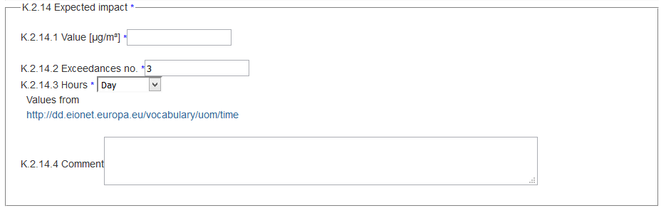

XML

aqd:expectedImpact

|  |
| --- |
| <aqd:expectedImpact>  <aqd:ExpectedImpact>  <aqd:numberOfExceedances>3</aqd:numberOfExceedances>  <aqd:specificationOfHours xlink:href="http://dd.eionet.europa.eu/vocabulary/uom/time/day"/>  </aqd:ExpectedImpact>  </aqd:expectedImpact> |

Expected impact on average concentrations - <aqd:levelOfConcentration>

This information class specifies the reduction in average concentrations for the relevant long-term reporting metric as a numerical value with recommended units of µg/m³.

|  |  |  |
| --- | --- | --- |
| aqd:levelOfConcentraion | |  |
| Minimum occurrence: | 0 (conditional/mandatory if available) | |
| Maximum occurrence: | 1 | |
| IPR data specifications found: | K.2.14.1 (A.12.1, A.12.2) | |
| Code list constraints: | http://dd.eionet.europa.eu/vocabulary/uom | |
| QA/QC constraints: |  | |
| Allowed formats: | Quantitification | |
| XPath to schema location: | /aqd:AQD_Measures/aqd:expectedImpact/aqd:ExpectedImpact/aqd:levelOfConcentration  /aqd:AQD_Measures/aqd:expectedImpact/aqd:ExpectedImpact/aqd:levelOfConcentration/quantity uom | |
| Further information @ |  | |
| Voidable: | No | |

XML

aqd:levelOfConcentraion

|  |
| --- |
| <aqd:expectedImpact>  <aqd:ExpectedImpact>  <aqd:levelOfConcentration></aqd: levelOfConcentration> |

aqd:numberOfExceedances - Expected impact in number of exceedances in the Projection yearFor short-term reporting metrics values, this information class specifies the reduction in the number of exceedances for the relevant long-term reporting metric.

|  |  |
| --- | --- |
| aqd:numberOfExceedances |  |
| Minimum occurrence: | 0 (conditional, mandatory if available) |
| Maximum occurrence: | 1 |
| IPR data specifications found: | K.2.14.2 |
| Code list constraints: |  |
| QA/QC constraints: |  |
| Allowed formats: | Numeric |
| XPath to schema location: | /aqd:AQD_Measures/aqd:expectedImpact/aqd:numberOfExceedances |
| Further information @ |  |
| Voidable: | No |

XML

aqd:numberOfEmissions

|  |
| --- |
| <aqd:expectedImpact>  <aqd:ExpectedImpact>  <aqd:numberOfExceedances>3</aqd:numberOfExceedances> |

aqd:specificationOfHours – Specification of hours or days

For short-term reporting metrics values, this information class specifies the units of measure for the number of exceedances from a codelist. Allowed values are ‘days’ or ‘hours’, See code list Time unit.

|  |  |  |
| --- | --- | --- |
| aqd:specificationOfHours: | |  |
| Minimum occurrence: | 0 (conditional, mandatory if expected impact in number of exceedances in the Projection year is given) | |
| Maximum occurrence: | 1 | |
| IPR data specifications found: | K.2.14.3 | |
| Code list constraints: | http://dd.eionet.europa.eu/vocabulary/uom/time | |
| QA/QC constraints: |  | |
| Allowed formats: | Code list | |
| XPath to schema location: | /aqd:AQD_Measures/aqd:expectedImpact/aqd:ExpectedImpact/aqd:specificationOfHours | |
| Further information @ |  | |
| Voidable: | No | |

XML

aqd:specificationOfHours

|  |
| --- |
| <aqd:specificationOfHours xlink:href="http://dd.eionet.europa.eu/vocabulary/uom/time/day"/> |

Comments / notes for clarification - <aqd:comment>

This information class allows for comments / notes for clarification to added to the expected impact on concentration information class.

|  |  |  |
| --- | --- | --- |
| aqd:comment | |  |
| Minimum occurrence: | 0 (Voluntary) | |
| Maximum occurrence: | 1 | |
| IPR data specifications found: | K.2.14.4 | |
| Code list constraints: | none | |
| QA/QC constraints: |  | |
| Allowed formats: | Alphanumeric | |
| XPath to schema location: | /aqd:AQD_Measures/ aqd:expectedImpact/aqd:ExpectedImpact/aqd:comment | |
| Further information @ |  | |
| Voidable: | No | |

XML

aqd:comment

|  |
| --- |
| <aqd:comment></aqd:comment> |

Comment for clarification - <aqd:comment

This information class allows for comments / notes for clarification to added to the measure records as a whole.

|  |  |  |
| --- | --- | --- |
| aqd:comment | |  |
| Minimum occurrence: | 0 (Voluntary) | |
| Maximum occurrence: | 1 | |
| IPR data specifications found: | K.2.15 | |
| Code list constraints: | none | |
| QA/QC constraints: |  | |
| Allowed formats: | Alphanumeric | |
| XPath to schema location: | /aqd:AQD_Measures/aqd:comment | |
| Further information @ |  | |
| Voidable: | No | |

PaPeRS

**Comment for clarification**



XML

aqd:comment

|  |
| --- |
| <aqd:comment></aqd:comment> |

Code of source apportionment - <aqd:exceedanceAffected>

The aqd:exeedanceAffected information class provides a link to the source apportionment records to which the measure will be applied. Each measaure may be applied to 1 or many source apportionment records. The linkage is made via an xlink href reference to the localId(s) of the relevant source apportionment record(s) in I.2. To accommodate the reporting requirements for pollutants covered by Directive 107/204/EC (Arsenic, Nickle, Cadmium and BaP), where source apportionment information is not required, this reporting requirement may be omitted.

|  |  |  |  |
| --- | --- | --- | --- |
| aqd:exceedanceAffected | |  |  |
| Minimum occurrence: | 1 (mandatory) | |  |
| Maximum occurrence: | Unbounded | |  |
| IPR data specifications found: | K.2.16 | |  |
| Code list constraints: | none | |  |
| QA/QC constraints: |  | |  |
| Allowed formats: | Alphanumeric | |  |
| XPath to schema location: | /aqd:AQD_Measures/aqd:exceedanceAffected xlink:href | |  |
| Further information @ |  | |  |
| Voidable: | No | |  |

PaPeRS

**Link to Source apportionment**

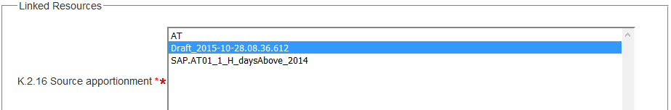

XML

aqd:exceedanceAffected

|  |
| --- |
| <aqd:exceedanceAffected xlink:href="AT.0008.20.AQ/Draft_2015-10-28.08.36.612"/> |

Code of evaluation scenario - <aqd:usedForScenario>

The aqd:usedForScenario information class provides a link to the evaluation scenario records to which the measure will be applied. Each measaure may be applied to 0 or many source apportionment records. The linkage is made via an xlink href reference to the localId(s) of the relevant evaluation scenario record(s) in I.2.

|  |  |  |
| --- | --- | --- |
| aqd:usedForScenario | |  |
| Minimum occurrence: | 0 (voluntary) | |
| Maximum occurrence: | unbounded | |
| IPR data specifications found: | K.2.17 | |
| Code list constraints: | none | |
| QA/QC constraints: |  | |
| Allowed formats: | Alphanumeric | |
| XPath to schema location: | /aqd:AQD_Measures/aqd:usedForScenario xlink:href | |
| Further information @ |  | |
| Voidable: | No | |

PaPeRS

**Link to evaluation scenario**

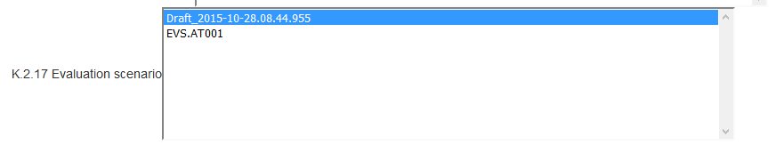

XML

aqd:usedForScenario

|  |
| --- |
| <aqd:usedForScenario xlink:href="AT.0008.20.AQ/Draft_2015-10-28.08.44.955"/> |

1. [Reporting of Air Quality Plans and Programs, JRC Technical Reports](http://www.eionet.europa.eu/aqportal/toolbox/papers/usermanual)