ETC Report template guidance - 2022

How to use the ETC Report template
The template guidance provides information on the structure and formatting to be used for ETC and Eionet reports. This set of knowledge products produced by ETCs is defined as targeting audience segment C. ETCs can also publish technical notes, which may accompany a product for audience segment B. For more information about report structure and style, please refer to the EEA Writing Manual 2017. The guidance relates to Word templates prepared for each ETC.

ETC report cover and meta information
descriptor | Contents guidance | location
Publication type | ETC report followed by year and report number ETC-XX Report 202X/XX (bibliographic reference short form). (alternative is ETC-XX technical note 202X/XX) | Cover Header and later page footer (Needed on cover for google scholar crawler)
Title | Title of report (Do not include year of publication and report numbers or use “ETC report” in the title as these are provided elsewhere in the report) The use of a year reference in the title could be for the baseline year covered by the report. | Cover  (Needed on top of cover for google scholar crawler)
authors | List of authors and organisations to which they are affiliated in the consortium. Can be for 1 or more ETCs | Cover (Needed on cover after title for google scholar crawler)
ETC logo |  | Cover footer
Cover design | EEA (unless report cover is redesigned) | Inside cover
Cover image | Name of copyright holder for cover image (individual or organisation) | Inside cover
Layout | organization responsible for report layout | Inside cover
Version | Optional. Include if relevant | Inside cover
Publication date |  | Inside cover
EEA activity/ areas of work | One or more of: Biodiversity and ecosystems; climate change mitigation and adaptation; human health and the environment; circular economy and resource use; sustainability trends, prospects and responses. | Inside cover
Legal notice | Standard | Inside cover
ETC-XX coordinator | Organisation responsible for coordination of the consortium and oversight of QA of the product | Inside cover
ETC-XX partners | List of consortium partners – to be amended by ETC mgt if the consortium changes | Inside cover
Copyright notice | © European Topic Centre on Climate change adaptation and LULUCF, 2022  Reproduction is authorized provided the source is acknowledged. [Creative Commons Attribution 4.0 (International)]  Or Creative commons attribution, non-commercial, share alike 4.0 (International) | Inside cover
ISBN / ISSN / DOI | Usually ISBN from ETC coordinator or DOI from Zenodo | Inside cover
ETC address | ETC Name and web url. Can be extended with an email and postal address if desired. | Inside cover
Acknowledgements | Acknowledgment of methodologies, imagery, data providers, contributions from other ETCs, reviewers, including from Eionet and EU bodies, specific inputs from EEA staff, etc | Page 3-4
Summary description | bibliographic summary of report to support discovery, cataloguing and indexing. Use title ”Summary” OR “Description” for this section. Useful to reference related policy framework, geographic and/or temporal coverage] – target length: 150 words = 1000 char. Max length: 300 words = 2000char | Page 3- 4

Styles and numbering
Predefined Word styles are used in the template for all headings, body text, feature (figures/maps/tables/boxes/photos) captions, notes and sources. These styles set fonts and font sizes. When writing your report, use the ETC Report template and replace the existing text with your own text (e.g., chapter titles, headings, subheadings) without altering the predefined styles.

The following styles are used in ETC reports:

Title of the report (Calibri, 24, bold, centre-aligned)

The report title takes the ‘Title’ style. The Title is 24 in size so that it is indexed by Google scholar.
Chapter titles, headings, sections, and sub-sections are styled as follows:

Chapter title = Heading 1 (Calibri, 14. Bold)
This is used to number chapters.

Sections = Heading 2 (Calibri, 12. Bold)
This is used to number sections and any subsections of the annexes.

Sub-sections = Heading 3 (Calibri, 11. Bold, italic)
This is used to number sub-sections.

Further level of sub-section = Heading 4 (Calibri Light (Headings), 10. Bold, italic)
This is used for a further level of sub-section. Note, no numbering is used so this level will not appear in the table of contents.

Note: Headings 1-4 are used for the main body of your report/assessment. The remaining headings are used to number annexes, and annex sections and sub-sections.

Heading 5 (Calibri, 14. Bold)

This is used to number annexes. Note that the style is set up to number annexes sequentially from Annex 1.

Heading 6 (Calibri, 12. Bold)

This is used to number sections of annexes.

Heading 7 (Calibri (Body), 11. Bold, italic)

This is used to number sub-sections of annexes.

Any further levels of sub-section in annexes use Heading 4 style.

The numbering of chapters, headings and sub-headings is automatic when these styles are used. Note that numbering only begins with the Introduction. Your foreword, preface, table of contents, acknowledgements and executive summary are not numbered. The last numbered chapter should be your conclusions. Lists of abbreviations, references and annexes are not numbered in this way.

The table of contents will be generated automatically if you respect the pre-defined styles for chapters, headings, sections and sub-sections. You should not need to adjust the table of contents manually.

The Styles gallery, found under the ‘Home’ tab displays all the styles used in this template:

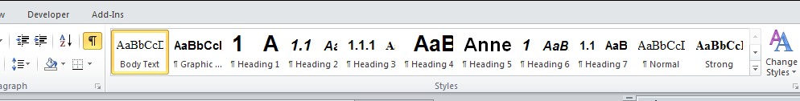

You should not need to use this as the styles are pre-set in the template, but to apply a style, just click on it in the Styles gallery. To view a style without applying it, just mouse over that style in the gallery.

Features
Features are boxes, figures, maps, photographs, and tables. These can appear in any chapter including the executive summary, introduction, and conclusions. Features should be numbered sequentially according to where they appear in the report, i.e., the executive, the chapters, or the annexes, and should include a caption.

To number features and add a caption, you should follow the following instructions:

Select the object (box, figure, map, photograph, table) that you want to add a caption to.
On the References tab, click Insert Caption.
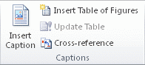
In the Label list, select the label that best describes the object, e.g. figure or map. If the list doesn't provide the label you want, click New Label, type the new label in the Label box, and then click OK.
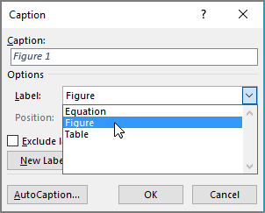
Type your caption text after the label.
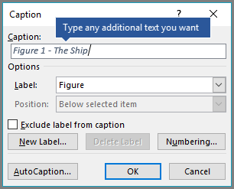
Click OK.

Note that the labels and captions are styled as using the ‘Style Caption, left’ style. For ETC reports, the numbering of features follows the ‘Chapter No, feature No’ convention, beginning at 1.1 (i.e., Figure 1.1, Map 1.1 etc.). Numbering in the executive summary and conclusions follow the same procedure, but labels will be as follows: Figure ES1, Figure A1.1. Numbering will continue sequentially. Note also, that for photographs, the caption will appear below rather than above the feature.

Notes should appear immediately after the feature. Notes use the ‘Graphic source/notes’ style:
Note: Note text

Sources appear after the notes and use the ‘Graphic source/notes’ style too:
Source: Source name (Surname, initial., (Year)).

References
Use the normal style and one line space between each reference. Do not use bullet points.

For print references use the following format:
Author’s surname, author’s initial(s)., year of publication, Title of reference work (where appropriate include edition number), publisher, place of publication, relevant page numbers if necessary.

For online references use the following format:
Author’s surname, author’s initial(s)., year of publication, Title of reference work (where appropriate include edition number), publisher, (URL) accessed ../../….

Annex 1 (repeat sequentially for subsequent annexes)
Text here
Figure/Map/ Table/Box A1.1 Caption
Insert feature here. For figures, maps and photos insert as .jpeg, .png file.
Photo A1.1 Caption (for photos only, the caption comes under the feature)

Figure/Map/ Table/Box A1.2 Caption
Insert feature here. For figures, maps and photos insert as .jpeg, .png file.
Photo A1.2 Caption (for photos only, the caption comes under the feature)

Audience segment C: Technical or highly informed audience (Technical personnel at the European Commission, ministries, local, regional level; academia. This audience category wants to have access to raw data, to exploratory data visualisations and they appreciate EEA’s longer assessments – the reports. They want the language used to be clear and understandable).
Audience Segment B: Non-technical audience with more time availability (Policymakers; advisers; journalists; NGOs; businesses. This audience category allocates more time to our products, but they still want the information to be focused, preferably in formats not longer than 3-4 Word pages. The infographics, charts and maps should be explanatory, but they can include a certain degree of interactivity. The language used should be non- technical.)

