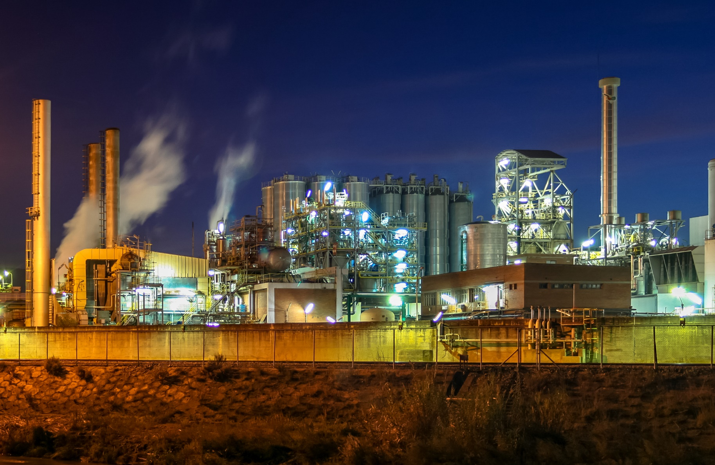

Guidance Document on Definitions and Use of Industrial Site, Facility and Installation for IEPR Reporters

Authors:
European Topic Centre – Human health and the environment, European Environment Agency

FIRST DRAFT FOR CONSULTATION – October 2024
Cover design: EEA
Cover image © Jorge Franganillo, Creative Commons Attribution 2.0 Generic (https://goo.gl/rqHYk6)
Layout: EEA / ETC HE (Aether Limited)

Legal notice
Preparation of this report has been co-funded by the European Environment Agency as part of a grant with the European Topic Centre on Human Health and the Environment (ETC HE) and expresses the views of the authors. The contents of this publication does not necessarily reflect the position or opinion of the European Commission or other institutions of the European Union. Neither the European Environment Agency nor the European Topic Centre on Human Health and the Environment is liable for any consequences stemming from the reuse of the information contained in this publication.

How to cite this report:
ETC-HE, EEA (2024). Guidance Document on Definitions and Use of Industrial Site, Facility and Installation for IEPR Reporters European Topic Centre on Human Health and the Environment. European Environment Agency

The document is available from: https://www.eionet.europa.eu/reportnet/industrial-reporting

Version: 1 [First draft for consultation]
EEA activity no. 3 Human health and the environment

ETC HE coordinator: Stiftelsen NILU
(https://www.nilu.com/)

ETC HE consortium partners: Federal Environment Agency/Umweltbundesamt (UBA), Aether Limited, Czech Hydrometeorological Institute (CHMI), Institut National de l’Environnement Industriel et des Risques (INERIS), Swiss Tropical and Public Health Institute (Swiss TPH), Universitat Autònoma de Barcelona (UAB),
Vlaamse Instelling voor Technologisch Onderzoek (VITO), 4sfera Innova S.L.U., klarFAKTe.U

Copyright notice
© European Topic Centre on Human Health and the Environment, 2024
Reproduction is authorized provided the source is acknowledged. [Creative Commons Attribution 4.0 (International)]

More information on the European Union is available on the Internet (http://europa.eu).

European Topic Centre on
Human Health and the Environment (ETC HE)
https://www.eionet.europa.eu/etcs/etc-he

Contents

Contents 3
Acknowledgements 4
Summary 5
1 Introduction 6
2 The geographic hierarchy 8
3 Definitions 10
3.1 Site 10
3.2 Facility 10
3.3 Installation 11
4 How to identify IEPR entities for reporting 13
4.1 How to identify an installation 13
4.1.1 Stationary technical unit 13
4.1.2 Technical connection between technical units 15
4.1.3 Directly Associated Activities 16
4.2 How to identify a facility 17
4.3 How to identify an industrial site 17
5 Sector examples 19
5.1 Power sector example 19
5.2 Waste sector example 19
5.3 Refinery and petrochemical site example 20
5.4 Pharmaceutical site example 21
5.5 Water discharges from multiple installations at the same site 22
5.6 Non-IED sectors 22
5.6.1 Medium combustion plants 22
5.6.2 Underground mining and related operations, including the extraction of crude oil or gas either onshore or offshore, where not covered by Annex I of the IED 23
5.6.3 Opencast mining and quarrying (where not covered by Annex I of the IED (here the surface of the area effectively under extractive operation equals 25 hectares) 23
5.6.4 Urban waste water treatment plants (above 100 000 population equivalents) 23
5.6.5 Feed-based aquaculture exceeding an annual production capacity of 500 tonnes 23
5.6.6 Installations for the building and/or dismantling of ships, and for the painting or removal of paint from ships with a capacity for ships 100 m long 24
5.6.7 Electrolysis of water for production of hydrogen Industrial scale production (not in Annex I of the IED) 24
6 Facility and installation relationships in the EU Registry on Industrial Sites 2022 dataset 25
6.1 Current numbers of reported facilities and installations 25
6.2 Ratios of facilities to installations 25
7 Summary 27
List of abbreviations 28

Acknowledgements
This report has been prepared by the EEA European Topic Centre on Environment and Health (ETC/HE) as part of the 2024 Action plan. The authors of the report were Bob Boyce and Mark Gibbs (Aether Limited).

The ETC task manager was Mark Gibbs (Aether Limited). The EEA task manager was Juan Calero.

Others that provided input were Federico Antognazza (EEA), Christophe Lescot (INERIS), Kenneth Pettersson (Naturvårdsverket), Tom Boonen (Vlaamse Overheid) and Malgorzata Kicia (European Commission).

Summary
This guidance document provides a framework for accurate and consistent environmental data reporting from industrial sites in the EU. It aims to help clarify the definitions of ‘site’, ‘facility’ and ‘installation’ under the INSPIRE Directive, aligning them with those in the Industrial Emissions Portal Regulation (IEPR) 2024/1244, as well as the definition of an ‘installation’ in the Industrial Emissions Directive (IED) 2010/75/EU. The document explains how these definitions fit in the hierarchical reporting structure required by the INSPIRE Directive's framework for spatial data sharing.

Key sections include guidance on identifying installations and facilities, describing the technical and operational connections between industrial units, and establishing when multiple installations should be considered a single facility. The document also discusses ‘directly associated activities’ which, while not requiring separate permits, should be included when reporting emissions from an installation.

EU Registry on Industrial Sites data from 2022 shows that most facilities have a one-to-one relationship with installations. This guidance aims to help harmonise reporting practices across the EU, supporting the integration of industrial emissions data for environmental regulation and policymaking.

Introduction
The Industrial Emissions Portal Regulation (IEPR) () was adopted on 24 April 2024 and replaces the European Pollutant Release and Transfer Register (E-PRTR) Regulation (). It establishes an integrated pollutant release and transfer register at EU level and thus implements the United Nations Economic Commission for Europe (UNECE) Protocol on Pollutant Release and Transfer Registers () (commonly known as the Kyiv Protocol). The first reporting under the revised Regulation will take place in 2028 when the Member States will report to the Commission data for releases and transfers, resource use and other contextual information from applicable industrial installations for the 2027 reporting year.

The IEPR brings in a change in the reporting level for releases from a facility, which may encompass one or more installations, to a single installation. By reporting releases at this more granular level, better alignment and coherence can be achieved with the Industrial and Livestock Rearing Emissions Directive (IED) () which regulates industrial emissions through the permitting of installations. The IEPR therefore can better support implementation of the IED and evaluation of the IED’s effectiveness. It must be noted that a compilation of Answers Given by DG Environment on the Implementation of the Industrial Emissions Directive – Chapter 1, dated 18 January 2019, has been taken into account here with regard to aligning with Commission’s guidance on installation boundaries, components, directly associated activities and aggregation rules.

Moving to installation-level reporting is expected to have limited impact for reporting of releases from most industrial entities where a single facility encompasses a single installation. In other, more complex situations, guidance and recommendations on responding to the change to the reporting structure and on how to apply in practice the definitions laid down in the IEPR for sites, facilities and installations will be required. The development by the beginning of 2025 of such guidance by the Commission assisted by the European Environment Agency (EEA) and in consultation with Member States, was mandated by Article 13(h) of the IEPR.

This guidance document aims to fulfil that requirement by providing examples and definitions of what is a site, what is facility and what is an installation; by giving sector-specific examples of relationships between facilities and installations; and by providing recommendations on how entities should be defined and handled for industrial emissions reporting. A key goal of this document is to ensure a common understanding among EU-level organisations and data providers (i.e. industrial operators, competent authorities and Member State reporters) and to ensure consistency and accuracy in data submissions. This document should further be of assistance to both thematic and IT experts.

This guidance document provides principles and guidelines with various examples, but it cannot be exhaustive and cover every possible case. The relevant competent authority in each reporting country must make their own decisions based on local and national circumstances.

This guidance document has the following structure:

- Section 2 describes the hierarchical reporting of industrial production sites
- Section 3 defines each of the hierarchical levels
- Section 4 provides complete details of technical units and technical connections
- Section 5 presents several examples of facility/installation relationships.
- Section 6 uses 2022 reporting to the EU Registry on Industrial Sites to present a summary of facility/installation relationships.
- Section 7 provides a summary of this guidance document

Commission Implementing Decision (CID) (EU) 2018/1135 () (the IED CID) established the EU Registry on Industrial Sites and this guidance is intended to complement the Manual for Reporters for the EU Registry on Industrial Sites (). That document contains all the essential information for describing the industrial entities to be reported in the relevant dataflows established by the IEPR and the revised IED. While this document can be used as a standalone document, it is intended to be used in conjunction with the EU Registry on Industrial Sites Manual for Reporters.

This guidance document will not cover the aggregation rules applicable to the rearing poultry and pigs as established by Article 70(b) of the recently revised IED. As noted in Article 70(b)(2) of that directive, the Commission will publish specific guidelines, after consultation with the EU Member States ‘on the criteria for considering different installations to be a single unit’ in this sector as per Article 70(b)(1) of the IED. Once these separate guidelines are ready, this guidance document will make reference to them.

The geographic hierarchy
The hierarchical reporting of industrial production sites required by the IEPR and the IED CID is based on the INSPIRE (Infrastructure for Spatial Information in Europe) Regulation () and involves organising and presenting information about industrial activities in a structured manner. This regulation aims to create a harmonised framework for spatial data sharing across Europe, including data related to environmental and industrial aspects. Industrial production sites are categorised based on their types, activities and environmental impacts. The hierarchical structure typically includes various levels that allows reporting of different types of information, such as site location, production processes, and emissions data. This approach facilitates the consistent integration of data from multiple sources, allowing for comprehensive spatial analysis, cross-border comparisons, and informed decision-making regarding environmental policies and industrial regulation.

The INSPIRE Regulation data structure defines layers of industrial production sites based on the geographical relationships between the various entities:

- Production sites
- Production facilities
- Production installations
- Production installation parts

The Kyiv Protocol also requires the reporting of industrial sites at the facility level and defines a facility in line with the INSPIRE Regulation. The IEPR requires reporting of the current operator of an installation which is tracked at the facility level and continuing to identify the parent facility of installations will provide continuity with historic time series containing information at the facility level. The IEPR also requires reporting of the parent site that contains the facility and installation(s). Therefore, whilst the IEPR now focuses on reporting emissions from installations there still remains an important requirement to report information at the facility and site level.

Figure 2.1 illustrates the proposed new data flows for reporting administrative, geographic and thematic information under the IEPR. Most facilities reported to the EU Registry on Industrial Sites in 2022 have a one-to-one relationship with an IED installation (Facility 1 - Installation 1); they may also have an installation part. There will be other facilities that have more than one installation.
Figure 2.1: Industrial emissions data flows
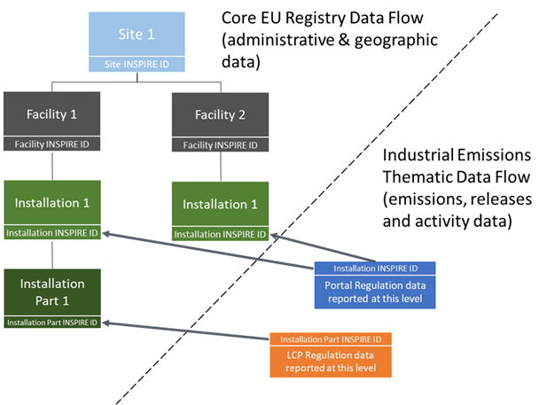

Definitions
The definitions of site, facility and installation are presented and explained in this section.

Site
The INSPIRE Regulation defines a Production Site as ‘All land at a distinct geographic location where the production facility was, is, or is intended to be located. This includes all infrastructure, equipment and materials.’ The IEPR states that site means ‘site means the geographical location of the installation and the facility’.

The Manual for Reporters for the EU Registry on Industrial sites clarifies that a site encompasses one or more industrial areas where activities are carried out by different operators or owners of related facilities and installations:

- Geographical proximity: The entities need to be physically in the same location. However, a site does not become two sites merely because two parcels of land are separated by a physical barrier such as a road, a railway or a river.
- Related activities: If more than one entity is to be included in the same site, all of them must either be joined by a technical connection or cooperate for a common purpose (e.g. a facility assembling cars and associated facilities in the car manufacturing supply chain on the same site).
- Disregard of ownership: Ownership does not play a role and a site can include multiple entities with different owners/operators.
- Beyond urban planning: Multiple industrial sites can be located on a single coherent lot zoned for industrial activity according to urban planning. Where necessary, they must be distinguished by using the third criterion above.

Facility
The INSPIRE Regulation refers to a ‘Production Facility’ as ‘one or more installations on the same site operated by the same natural or legal person, designed, built or installed to serve specific production or industrial purposes, comprehending all infrastructure, equipment and materials’ and covered by Regulation (EC) No 166/2006 (the E-PRTR Regulation).

A facility as defined in the IEPR means ‘… one or more installations, or parts thereof, that are on the same site and that are operated by the same natural or legal person’. A facility is a single physical entity within a site with one or more installations that are managed under a single operational unit.
It is still important to have the concept of facility even when the reporting of thematic data will be done at installation level. The main reasons are:

- Compliance with Article 5(1)(a) of the IEPR which requires the ability to search and download data by ‘facility’ from the European Industrial Emissions Portal website from 2028
- Compliance with the INSPIRE Regulation
- Compliance with the UNECE Protocol on Pollutant Release and Transfer Registers
- Coherence with historical time series of data previously reported under the E-PRTR

Each facility must be reported as a distinct entity under the IEPR, along with information on the current operator. Whether the site contains one facility with one installation, one facility with multiple installations (e.g. a chemical plant and a power generation unit with the same operator) or contains multiple facilities (with different operators) with one or more installations (e.g. three chemical plants with different owners, an independently operated waste water treatment plant (WWTP) and a power plant serving the whole site), each facility should be reported separately with its specific data along with the same parent site identifier.

The facility is defined by the owner or operator of the industrial site. It is the operator, who might lease the facility or the land from an owner or be the owner, that is responsible for the activities on the site that defines the boundary for a facility. The operator should be the entity listed in the relevant permit. For an IED installation that has multiple operators in one ‘framework’ permit, this definition splits the one permitted installation into multiple facilities and installations in line with the operators. Further details are provided in Section 4.2.

Installation
The INSPIRE Regulation refers to technical units, such as machinery, apparatus, devices or equipment placed in position or connected for use, as individual installations or production lines within an industrial facility where specific processes or activities are carried out. These units are typically part of a larger industrial site and are characterised by their functions, processes, and emissions.

In other words, an installation is a technical unit within a facility where a specific industrial activity is carried out. Installations may consist of one or more components (e.g. reactors, furnaces, or engines) that work together to perform a particular function. The IEPR definition of installation is now fully aligned with the one laid down by the IED. An installation is defined in the relevant legal instruments as follows:

- Regulation 2024/1244 (the IEPR) defines an installation as ‘a stationary technical unit within which one or more activities listed in Annex I are carried out, and any other directly associated activities on the same site which have a technical connection with the activities listed in that Annex and which could have an effect on emissions and pollution’.
- Directive 2010/75/EU (the IED) defines an installation as ‘a stationary technical unit within which one or more activities listed in Annex I, in Annex Ia or in Part 1 of Annex VII are carried out, and any other directly associated activities on the same site which have a technical connection with the activities listed in those Annexes and which could have an effect on emissions and pollution’.

The IEPR and IED definitions of an installation are now virtually identical. The only difference is that the IED refers to the IED Annexes I, Ia and VII, while the IEPR refers to the IEPR Annex I which in turn refers to the IED Annexes I and Ia.

Although all IED activities are now included in the IEPR, the IEPR’s scope includes the following additional activities:

- Medium combustion plants (MCPs) () (where not covered by Annex I of Directive 2010/75/EU) with a rated thermal input of at least 20 MW and below 50 MW
- Underground mining and related operations, including the extraction of crude oil or gas either onshore or offshore (where not covered by Annex I to Directive 2010/75/EU)
- Opencast mining and quarrying (where not covered by Annex I to Directive 2010/75/EU), where the surface of the area effectively under extractive operation equals 25 hectares
- Urban waste water treatment plants with a capacity of 100 000 population equivalents or more
- Feed-based aquaculture exceeding an annual production capacity of 500 tonnes
- Installations for the building and/or dismantling of ships, and for the painting or removal of paint from ships with a capacity for ships 100 m long
- Electrolysis of water for production of hydrogen Industrial scale production

From these activities, mining and quarrying operations, urban waste water treatment plants, aquaculture (albeit with a higher capacity threshold) and installations for building and dismantling ships, were already in the scope of the E-PRTR Regulation. These activities do not need to abide by the definition of ‘installation’ of the IED but a common understanding of what these definitions mean for them is necessary. In general, the same principles applied to other sectors should also apply to them, having in mind the avoidance of unnecessary administrative burden when reporting these entities. Section 5 on sector examples has a subsection dedicated to non-IED activities in the scope of the Regulation.

How to identify IEPR entities for reporting
This section helps reporting countries to identify the different geographical characteristics for industrial entities. Each element of the INSPIRE hierarchy is presented and analysed from bottom up to ensure an easy approach and a better understanding of each entity.

How to identify an installation
On 18 January 2019 DG Environment produced a compilation of Answers Given by DG Environment on the Implementation of the Industrial Emissions Directive – Chapter 1. These questions and answers cover definitions of an installation, operator, technical connection etc., and they have been taken into account throughout this section for consistency with definitions and interpretations of the IED and the IEPR.

To define the boundaries of an installation, the following points should be considered and assessed:

- Multiple Installations: A single IEPR facility can have multiple installations if they are operated by the same company or person.
- Permit Coverage:
- One permit can cover multiple installations operated by the same legal entities at the same site (Article 4(2) of the IED).
- A ‘framework’ permit can have more than one operator with separate responsibilities for specified activities listed in the same permit (Article 4(3) of the IED). In this case the IEPR dictates they are separate facilities (with associated installations) under IEPR and IED reporting because they have different operators.
- Identify the activity (or activities) listed in Annex I or Annex Ia of the IEPR
- Establish whether there are any Directly Associated Activities (DAAs) on the same site, which have a technical connection with these IEPR activities and which could have an effect on emissions and pollution
- Confirm that those activities are carried out in a stationary technical unit
Box 4.1:The importance of operator under the IEPR
Framework permits are often used for IED regulatory purposes for complex industrial sites. However, they do not align with the reporting obligations under the respective E-PRTR and IED CIDs as they allow more than one operator to be specified in a permitted installation. The IEPR facility definition, based on operator, therefore requires a framework-permitted installation to be split into two or more facilities, perhaps with one or more installations each, based on the different operators specified in the permit.

Stationary technical unit
The term ‘stationary technical unit’ is also not explicitly defined within INSPIRE, the IEPR or the IED. However, based on the concept of ‘technical unit’ and the requirement for installations to be stationary, this definition is provided for use in the IEPR and IER reporting:

- A stationary technical unit, in the context of the IEPR and IED, refers to an integrated entity specifically designed and equipped to carry out activities related to an installation, and which is permanently located at a fixed geographical site. Further, in the context of the IEPR, it refers to an integrated entity specifically designed and equipped to carry out activities related to an IEPR installation or a DAA on the same site.
Box 4.2:The importance of technical units
- The concept of technical units helps clarify the scope of an installation. By identifying the permanent and integrated entities carrying out specific activities, competent authorities can assess their environmental impact and determine the appropriate permitting and regulatory approach.
- While the IED regulates emissions from fixed facilities with technical units, it is important to remember that movable equipment can still be used within these installations. Additionally, the IED might consider certain mobile plants as ‘stationary’ if they operate at a fixed location for a significant period.

The following guidelines are suggested to help competent authorities and IEPR reporters to determine if a technical unit is stationary.

What constitutes a ‘stationary technical unit’ under the IEPR and IED?
A technical unit is considered ‘stationary’ if it is not intended to move from one location to another. This does not prevent the use of mobile equipment like forklifts and other machinery within the installation.

What about movable plants that operate in a single location for extended periods?
‘Mobile’ plants designed for relocation, such as tarmac production or incinerators for contaminated soil, can be considered stationary if they operate at a specific site for a significant time. Competent authorities will assess each case based on factors such as:
- Potential environmental impact of the activities
- Expected and actual duration of operation at the location
- Difficulty and resources needed to move and set up the plant: for example, a plant arriving on its own wheels is easier to relocate than one requiring significant construction at each site.

What ‘stationary technical unit’ does not mean:
- It does not refer to mobile equipment or plants designed to be relocated.
- It does not require all elements to be physically connected within a single building.

The determination of the stationary status of technical units ultimately lies with the competent authority. For the purposes of this document, ‘technical unit’ will refer to a stationary technical unit.

Some key aspects of technical unit include:

- Integrated Entity: A technical unit is not a single piece of equipment, but rather a collection of elements that work together as a whole. This could include:
- Equipment (reactors, filters etc.)
- Structures (buildings, tanks etc.)
- Infrastructure (pipelines, conveyors etc.)
- Tools and machinery
- Facilities for storage, handling, and pre-treatment of materials
- Monitoring and recording systems
- Specifically Designed and Equipped: The elements within a technical unit are chosen and configured to perform specific tasks related to the IEPR activity or the DAA. This excludes activities like open-air incineration, which lack dedicated equipment.
- Integrated Operations: The key point is that these elements function together in a coordinated manner to achieve a particular outcome within the IEPR installation or the DAA.

Examples of Technical Units:
- A chemical production line within a factory, consisting of interconnected reactors, distillation columns, and piping for processing raw materials.
- A dedicated waste water treatment plant permanently located on-site to handle waste water from an installation.
- A storage facility with tanks and pipelines for raw materials or finished products, permanently located and integrated with the main installation.
- A distillation unit in a chemical plant, consisting of reactors, columns, and piping for separating components of a mixture.

What ‘Technical Unit’ does not mean:
- It does not refer to a single piece of equipment.
- It does not imply a high level of technological complexity.
- It does not require all elements to be physically connected or within the same building.

The key aspects can be broken down as:

- Stationary: This is the crucial addition to the concept of a technical unit. The entire unit, with all its elements, must be permanently located at a specific site and not intended to move from one location to another.
- Integrated Entity: Similar to a technical unit, it is a collection of elements working together as a whole. Examples include equipment, structures, pipelines, and facilities.
- Specific Activities: The elements within the unit are designed and equipped to perform specific tasks related to the installation.

Technical connection between technical units
One or more technical units, as described above, can be considered as technically connected if there is a physical link or operational dependence between them. This strength and dependency of the connection helps determine if the units should therefore be considered as one installation or as separate installations under IEPR reporting.

The key aspects of a technical connection can be broken down as:

- Physical Link: This refers to a direct physical connection between the technical units. Examples include:
- Pipelines: Transporting raw materials, products, or waste streams between installations.
- Conveyors: Moving materials (solids) between the installations.
- Power lines: Supplying electricity from one installation directly to one or more other installations.
- Operational Dependence: This refers to how essential the installation is for the core operation of the other installation. Examples include:
- On-site waste water treatment plant: Treating waste water generated by the installation before discharge.
- Dedicated storage tanks: Holding raw materials or finished products specifically for the IED installation.

The strength of the technical connection is a crucial factor in determining if two or more technical units are considered part of the same IED installation. A strong technical connection suggests one technical unit directly supports the core activities and environmental impact of another technical unit. Here there are some examples of technical connections:

- Strong technical connection: storage tanks connected by pipelines directly to a chemical plant for feeding raw materials. This clear physical link indicates a strong technical connection although it remains crucial that a rigorous assessment is performed to ensure the technical unit is required for the activity to operate.
- Weaker technical connection: a separate warehouse storing finished products from a chemical plant, even if located on the same site. Without a direct physical link or operational dependence, the technical connection might be weaker.

In borderline cases, consideration of the specific details and operational setup will be crucial for determining if a technical connection exists. This assessment is carried out by the relevant competent authority and therefore the decision of whether more than one technical units qualify as an installation rests with the competent authority. They should consider the factors mentioned above to determine if the technical units should be included under the same IED installation. However, ultimately, the determination of the nature of an installation is a decision for the competent authority responsible for implementation of the IED and to some extent also the IEPR.

Directly Associated Activities
In the context of the IEPR and IED, ‘Directly Associated Activities’ (DAAs) refer to activities that are not themselves listed in the IEPR and IED annexes (meaning they would not require a separate IED permit) but are:

- Functionally connected to an installation on the same site. This means they support or complement the core activities of the installation.
- Likely to affect the overall environmental impact of the installation.

Key aspects of DAAs include:

- Supporting role: DAAs typically provide services or handle materials that are essential for the operation of the installation.
- Environmental impact: DAAs, though not IED activities themselves, can influence the emissions or environmental impact of the main installation.

Examples of Directly Associated Activities:

- Storage of raw materials or finished products directly connected to an installation, like tanks or silos with pipelines feeding the process.
- Waste water treatment plants specifically designed to handle waste water from an installation.
- On-site generation of power or heat used by the installation.

The key distinction between a DAA and a separate installation lies in the strength of the technical connection to the IED activity. Some factors to consider are:

- Physical connection: Are the activities physically linked through pipelines, conveyors, or similar infrastructure?
- Operational dependence: Does the installation rely on the DAA for its core operations?
- Environmental impact: Does the DAA significantly affect the overall emissions or environmental footprint of the installation?

Ultimately, as with the determination of installations, the determination of whether an activity qualifies as a DAA rests with the relevant competent authority. They should consider the factors mentioned above to determine if the activity should be included under the same permit as the IED installation.

The operator should be the entity listed in the relevant permit. For an IED installation that has multiple operators listed in one ‘framework’ permit, this definition splits the one permitted installation into multiple facilities and installations in line with the operators. Further details are provided in Section 4.2.

How to identify a facility
To define the boundaries of a facility the following steps should be considered:

- Ownership / Operator: The facility is defined by the owner or operator of the industrial site. It is the operator, who might lease the facility or the land from an owner or be the owner, that is responsible for the activities on the site that defines the boundary for a facility. The operator should be the entity listed in the relevant permit. For an IED installation that has multiple operators in one ‘framework’ permit, this definition splits the one permitted installation into multiple facilities and installations in line with the operators. Whereas in reality these are ‘parts of installations’ each having a different operator, the concept is translated into the reporting systems using this split.
- Multiple Installations: A single facility can have multiple installations if they are operated by the same company or person, functionally connected, and are in reasonable proximity. If one or more of the installations are not functionally connected, then they should be considered as separate facilities.
- Functionally connected: Functional connection means one or more activities, including IED and non-IED activities, e.g. an industrial WWTP treating leachate or sewage sludge (IED Activity 5.3(a) or 5.3(b)) and an urban WWTP treating domestic sewage (IEPR Activity 6, previously E-PRTR Activity 5(f)), operated by the same company, with varying degrees of dependency, but are not necessarily technically connected. An example would be an urban WWTP that also has a waste handling activity operated by the same company side by side at the same location. Therefore, two installations, in any combination of IED and NONIED, that are not technically connected but are functionally connected, can be part of the same facility if operated by the same company.

How to identify an industrial site
The following is a series of points to consider to help with reporting an industrial site containing one or more facilities and installations:

- Focus on location: The site refers to the physical location, not necessarily a single facility or installation.
- Ownership: Land ownership is irrelevant.
- Operators: Multiple unrelated operators can be considered as on the same site if there is a strong direct association between their operations.
- Site boundaries: Fences are not a reliable indicator.
- Brief physical separations: A road or right-of-way passing through the location might not create separate sites, as long as the areas are reasonably close.
- Importance of connection: Activities on separate areas can be considered part of the same site if they have a strong direct association of either an operational, economic or technical connection. These concepts can be described as:
- Operational connection: When different areas work together to achieve a common industrial goal, they should be seen as part of a single site. For instance, if one area processes raw materials and another assembles the final product, their interdependence makes them function as a cohesive industrial unit. Treating them as one site ensures a more accurate representation of how the industrial process operates as a whole.
- Economic connection: Separate areas can be considered part of the same site if they contribute to a unified economic activity, such as sharing financial resources, management, or economic objectives. This connection highlights the integrated nature of operations, making it easier to understand the economic footprint and performance of the entire industrial activity.
- Technical connection: If areas share technological infrastructure, utilities, or technical processes, they can be considered as part of the same site. Their interconnected operations contribute to a complete industrial process, and acknowledging these connections provides a clearer picture of the industrial network and resource flows.
The importance of the connection lies in providing a more holistic view of industrial activities, ensuring that data about these activities accurately reflects the interconnected nature of operations across different areas. This helps in understanding the scale, efficiency, and scope of industrial production more effectively.

Clear example for inclusion in a site: Storage tanks connected by pipelines to a chemical plant are clearly part of the same site.

Unclear example for inclusion in a site: Storage tanks at a distant harbour would require expert judgement to determine if they belong to the same site as the main installation. The level of technical connection (e.g. pipelines, transportation methods) and the overall impact on the environment should be considered.

Sector examples
This section presents several idealised examples for different sectors with increasing complexity that illustrate the concepts discussed above. Not all situations can be covered here. More complex or nuanced situations will require case-by-case consideration and may require consultation with permit writers at the competent authority, with the EEA or with the Commission. The EEA Industry Helpdesk can be contacted at industry.helpdesk@eea.europa.eu.

Power sector example
The example shown in Figure 5.1 represents an electricity generation location with three large combustion plants (LCPs). It includes three combined cycle gas turbines, each with a capacity of over 50 MW and its own stack, and an emergency diesel generator with a capacity of 10 MW. As such the one and only relevant IEPR activity in this example is 1.1 Combustion of fuels in installations with a total rated thermal input of 50 MW or more. While there are multiple installation parts, these would all be regarded as part of one installation, which in turn would be part of one facility and one site. See Section 2.2.3 of the Manual for Reporters for the E-PRTR and LCP Integrated Data Reporting for a description of how to implement the common stack principle (Article 29 of the IED) in the reporting.

The emergency generator in this example is a Directly Associated Activity. It has a clear technical connection with the IEPR activity because its only purpose is to provide emergency power. The emergency generator would be permitted separately as a small MCP, and its emissions would be reported along with the emissions for the installation, but not as part of the emissions reported separately by its LCPs. As noted in Annex I of the IEPR, MCPs do not need to be reported individually if they are part of an IED installation.
Figure 5.1: Example electricity generation site
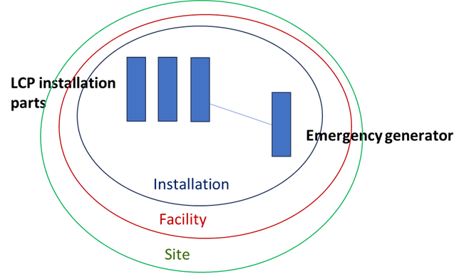

Waste sector example
The example shown in Figure 5.2 contains different waste management technical units.

The biogas plant directly consumes output from the waste processing plant. Therefore the waste processing plant (IED Activity 5.3(a) or 5.3(b)) and biogas plant (IED Activity 5.3(a)(i) or 5.3(b)(i)) are technically connected – they form one installation. The nearby landfill is not technically connected to the biogas plant or the waste processing plant, even if it receives waste from them as it is considered a final disposal site. It is therefore a separate installation (IED Activity 5.4).

The two installations may or may not be one facility; this will depend on whether they have separate operators. All of these entities could be considered to be part of one site.
Figure 5.2: Example waste management site
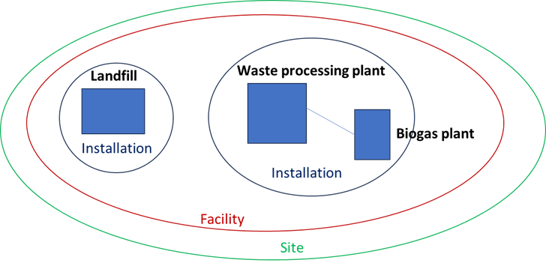

Refinery and petrochemical site example
In the example in Figure 5.3 a refinery is located next to a petrochemical plant.

Components of the refinery include a distillation unit which supplies product to the reformer and fluid catalytic cracker, which in turn supplies product to the alkylation plant. All of these technical units are technically connected and so form one installation. A power plant within the refinery provides power to each of the refining technical units. Although additional power is exported outside the refinery to the grid, the majority of the required power is necessary for the refinery’s operation. As such there is a strong technical connection and the power plant would also be part of the same installation.

As one of its activities, the refinery provides naphtha to the petrochemical plant, both of which have the same operator but different processes. The petrochemical plant which will further process the naphtha into a set of derivatives that are used downstream to produce rubber, plastics, fibres, resins etc. Because the naphtha produced by the refinery is also sent to other locations and customers and because the petrochemical plant could use naphtha produced elsewhere and this could be considered a weak technical connection, and the refinery and petrochemical plant should be regarded as separate installations. However, these installations have the same operator and so are part of one facility. With no other associated facilities this one facility makes up the site.
Figure 5.3: Example refinery and petrochemical site
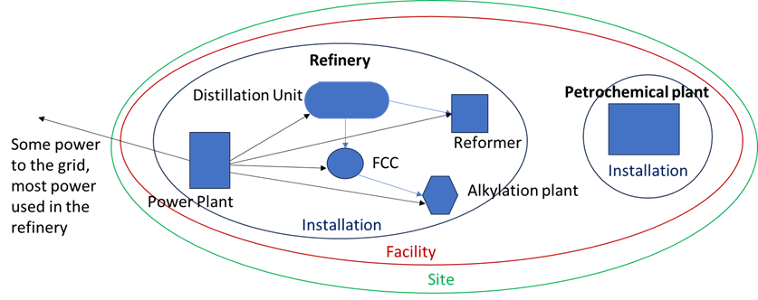

Pharmaceutical site example
The example in Figure 5.4 is intentionally complex so that multiple concepts can be illustrated. This particular example is discussed at further length in Annex I of the Manual for Reporters for the EU Registry on Industrial Sites.

ProductionFacility 1 performs a combustion process to generate heat and electricity. The heat is provided to the reactors of ProductionFacility 2. The whole of ProductionFacility 1 is owned by ‘Energy Ltd’. It contains three ProductionInstallationParts (1, 2 and 3) since each of them are independent boilers with independent stacks and are deemed separate by the competent authority as outlined in Article 29(2) of the IED. These installation parts all have a technical connection and so form one installation, ProductionInstallation 1.

ProductionFacility 2 is a purely pharmaceutical facility owned by ‘Pharma Ltd’. This facility contains four different sub-entities. ProductionInstallationPart 4 and ProductionInstallationPart 5 are the reactors producing the pharmaceutical product. ProductionInstallationPart 6 is a waste water treatment plant which is functionally connected to the reactors, while ProductionInstallationPart 7 is storage of raw materials. These entities are all technically connected and are essential to the functioning of the whole facility. Therefore, they all constitute a single installation, ProductionInstallation 2.

ProductionFacility 3, owned by ‘Supply Ltd’, performs a chemical activity producing biochemical and organic solvents. These are used in ProductionFacility 2 but also by other companies outside the site. This facility has two independent installations which do not have a technical connection and which use entirely different chemical processes. ProductionInstallation 3 is a biochemical reactor which produces a biochemical solvent; a single ProductionInstallationPart 8 belongs to this installation. ProductionInstallation 4 is a chemical reactor (ProductionInstallationPart 9) which refines an organic solvent.

The three facilities operated by Energy Ltd, Pharma Ltd and Supply Ltd constitute a single site since these three companies are performing activities with a common purpose and are related in nature, in this case the production of pharmaceuticals.

An important point is that although ProductionInstallation 1 and ProductionInstallation 2 have a technical connection, they are operated by two different legal entities (Energy Ltd and Pharma Ltd). This means that, although they could be considered as a single installation, they must be reported as separate installations within separate facilities. Similar principles apply to more complex chemical plants performing several IED activities.
Figure 5.4: Example pharmaceutical site
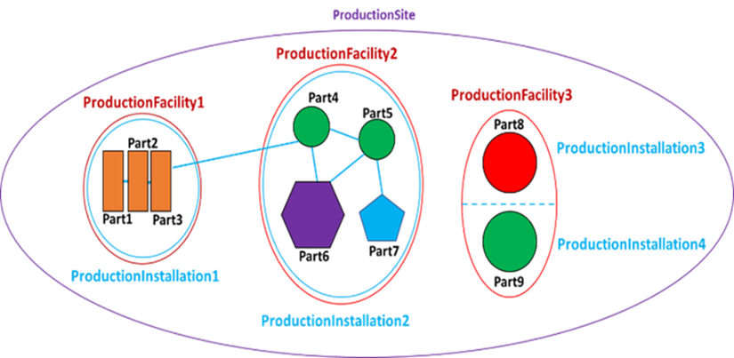

Water discharges from multiple installations at the same site
An example covering various scenarios of water discharges from multiple installations at the same site will be provided here in the next version of this document [to be developed].
It is worth noting that if the site owns an independently operated wastewater plant (activity 6.11 of the IED “Independently operated treatment of waste water not covered by Directive 91/271/EEC and discharged by an installation covered by Chapter II”), this would be considered a different facility (as it is independently operated) of the same site. Other facilities with their installations would report wastewater transfers if these are above the reporting thresholds. For activity 6.11, it should also be noted that the capacity threshold in the equivalent activity in the former E-PRTR Regulation (5g), was 10 000 m³ per day, but IED activity 6.11 does not have a capacity threshold. From 2028, the scope of 6.11 applies.
Figure 5.5: Example of water discharges from multiple installations at the same site
[Figure to be developed]

Non-IED sectors
The definition of facilities versus installations in non-IED sectors is not directly linked to the IED and its permitting process. However, the IED definition of installation is completely aligned with the definition of installation in the IEPR, which does apply to reporting entities in these sectors. Consequently, this guidance document aims at using the same principles as for IED activities without incurring an excessive administrative burden.

Medium combustion plants
The IEPR, the IED and the Medium Combustion Plant Directive (MCPD, Directive 2015/2193) have different and complex reporting requirements. The IEPR requirement applies specifically to larger MCPs with a thermal input between 20 MW and 50 MW. These plants, and the smaller MCPs, are subject to periodic reporting requirements under the MCPD, detailing actual emissions data, fuel types and quantities used, operational hours, among other parameters, at an aggregated level.

With respect to the IEPR reporting requirements, the larger MCPs (20-50 MW) forming one MCP installation, are only to be reported when not part of an IED installation (i.e. when not meeting the activity definition for combustion plans in Annex 1 of the IED). All individual MCP technical units should be reported as installation parts. Emissions will be reported at installation level. The number of installations to be reported on an IEPR MCP facility will depend on the technical connections discussed in Section 4.1.2. In the case of several MCPs which together form an installation with over 50 MW rated thermal input, these would fall under IED Activity 1.1, and the installation should be reported as such, and not as MCPs.

Considering reporting to the EU Registry on Industrial Sites, MCPs sharing a common stack will form an installation part. The definition of combustion plants in the MCPD is that they are to be aggregated if connected to a common stack. This approach aligns somewhat with definition and reporting of LCP installation parts but note the capacity thresholds that define each activity (i.e. above or below 50 MW thermal input). There is no definition of an ‘installation’ provided in the MCPD, however, the same definition of an operator defined in the IEPR is given. Therefore, the operator, as used above in this document to define a facility, should be used to define facilities and will, therefore, define installations.

Typically, there will be a one-to-one relationship between facility and installation for MCPs for IEPR reporting. However, an MCP can have multiple installation parts for EU Industrial Emissions Registry reporting.

Underground mining and related operations, including the extraction of crude oil or gas either onshore or offshore, where not covered by Annex I of the IED
Typically, there will be a one-to-one relationship between facility and installation for underground mining and related operations. The only possible exception would be if there is more than one well, e.g. one for gas and one for oil in close proximity and the wells are operated by the same company. This situation could potentially be considered as one facility covering two installations. A similar situation for underground mining is highly unlikely but the same principle would apply.

Opencast mining and quarrying (where not covered by Annex I of the IED (here the surface of the area effectively under extractive operation equals 25 hectares)
Typically, there will be a one-to-one relationship between facility and installation for mining and other operations. The only possible exception would be if there is more than one working face covering different types of material or if the facility originally covered one area of exploitation of a type of material, e.g. a quarry, and another exploitation area of another mineral. Note that the new IED activity 3.6 is defined as ‘Extraction including on-site treatment operations, such as comminution, size control, beneficiation and upgrading, of the following ores on an industrial scale: bauxite, chromium, cobalt, copper, gold, iron, lead, lithium, manganese, nickel, palladium, platinum, tin, tungsten and zinc’. If competent authorities develop a definition of installation for these cases that can be applicable to underground mining and opencast mining that are not part of Annex I, they may be applied to non-IED mines as well for consistency.

Urban waste water treatment plants (above 100 000 population equivalents)
Typically, there will be a one-to-one relationship between facility and installation for urban WWTPs. However, it is possible that a separate but related waste operation receiving and treating sludge or landfill leachate is operated by the same company and located on the same facility.

Feed-based aquaculture exceeding an annual production capacity of 500 tonnes
Aquaculture was already a sector covered by the E-PRTR Regulation, although the capacity threshold of that Regulation was 1 000 tonnes per year. With the decreased threshold it is likely that smaller family-owned businesses will be in the scope. Although competent authorities will have the opportunity to report on their behalf if they opt to use the top-down reporting defined in Article 6(9) of the IEPR, it is still relevant to establish the concepts of facility and installation to report the best possible point-source emissions data.

For the definition of facilities, the same principle as with the E-PRTR Regulation applies (see Section 4.2) including how the concept of operator defines the boundaries of each facility.

If the aquaculture activity has cages or tanks owned by the same operator, a certain geographical proximity is expected for it to be considered the same facility. For example, this could be a number of cages located in a gulf off the same island. It could also make sense to report various separate locations along the coast of various small islands of an archipelago that converge in the single location as the same facility if they have the same operator.
When defining this activity, it is important to note that the capacity threshold applies at the installation level. Therefore, if splitting a facility in several locations that are otherwise very close to each other means not meeting the capacity threshold, this is not a suitable approach.

Although they could cause different environmental issues, the presence of different aquatic species is in principle not a good reason, on its own, to separate installations of the same facility. The main reason is that the capacity threshold applies at the installation level regardless of the species. If separating by species means not meeting the capacity threshold of 500 tonnes per year, this would not be a suitable approach since the IEPR says nothing about different species in the description of the threshold for this activity.

[Note to Member States experienced in the aquaculture sector: Please provide feedback on the characteristics of the sector in your country, including how installations or sites are defined for permitting purposes.]

Installations for the building and/or dismantling of ships, and for the painting or removal of paint from ships with a capacity for ships 100 m long
Typically, there will be a one-to-one relationship between facility and installation this activity (IEPR Activity 8).

Electrolysis of water for production of hydrogen Industrial scale production (not in Annex I of the IED)
The scope of this activity is installations performing electrolysis of water that are not part of Activity 6.6 of the IED. The definition of installations in this activity should use the same approach as electrolysis installations covered by the IED in the respective Member State.

Facility and installation relationships in the EU Registry on Industrial Sites 2022 dataset
With the move from facility-level to installation-level reporting in the IEPR, it will be useful to understand how many situations may be affected.

Current numbers of reported facilities and installations
In 2022, Member States reported a total of 59,389 facilities to the EU Registry on Industrial Sites. Of these, 56,638 were functional. 49,937 were categorised as ‘EPRTR’ facilities and 9,452 were categorised as ‘NONEPRTR’ facilities. Of the EPRTR type facilities, 48,302 were active (‘functional’).

The total number of installations reported in 2022 was 60,169, of which 1,886 were classified as ‘NONIED’, leaving 58,283 IED installations. Among these, 55,362 were reported as ‘functional’, distributed across 49,989 active facilities. There were 6,179 facilities reported without an associated IED installation since they are E-PRTR activities only. Under the IEPR, these facilities will have installations.

Additionally, there were 24 facilities in 2022 with a non-functional status but mapped to installations that were flagged as functional: ten in Italy, eight in Spain, four in Germany, and one each in Lithuania and Poland.

Ratios of facilities to installations
For the 2022 reporting year, most facilities (47,480, 84%) had only one installation. Just over 4% had between 2 and 9 installations, while only 0.1% had 10 or more installations (Table 6.1).
Table 6.1: Ratio of facilities to installations for 20022 in the EU Registry on Industrial Sites
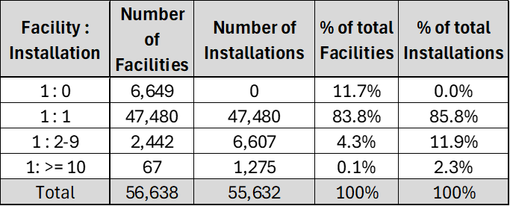
Source: EU Registry on Industrial Sites, Industrial_dataset_v_11_2024_07_10y.accdb.
In 2022 a total of 2,442 facilities had between two and nine installations, accounting for 6,607 installations. Sixty-seven facilities had 10 or more installations, totalling 1,275 installations. Germany dominated with 1,043 of these installations and has the top 13 facilities with high numbers of installations.

Germany also has the highest number of installations at a single facility (Table 6.2).
Table 6.2: Maximum number of installations at a facility for 2022 in the EU Registry on Industrial Sites
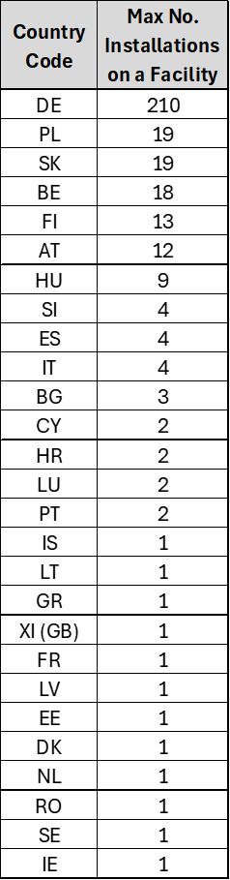
Source: EU Registry on Industrial Sites, Industrial_dataset_v_11_2024_07_10y.accdb.

Summary
This guidance document serves to standardise the definitions and reporting practices for industrial facilities and installations under the Industrial Emissions Portal Regulation (IEPR) 2024/1244, in alignment with the Industrial Emissions Directive (IED) 2010/75/EU. It provides detailed instructions on how data reporters should identify and report sites, facilities, and installations to ensure consistency across Member States. The document emphasises the hierarchical reporting structure required by the IEPR and IED, based on the INSPIRE Regulation, which aims to facilitate the integration of spatial and environmental data for policymaking.

The guidance explains the distinctions and relationships between sites, facilities, and installations, including the criteria for identifying technical units, stationary installations, and directly associated activities. It also addresses the complexities in determining when multiple installations should be considered part of a single facility, based on technical connections and operational dependencies.

An analysis of the 2022 EU Registry on Industrial Sites dataset reveals that most cases are straightforward: most facilities have a one-to-one relationship with installations, with some variations across Member States due to differing interpretations of regulatory requirements.

The aim of this guidance is to support harmonised data reporting, allowing for more effective monitoring, regulation, and decision-making concerning industrial emissions across the EU. The concepts described here should be applied practically. Most installations will be clearly separate but the specific permit arrangements may provide a useful approach.

In some cases technically connected units may need to be reported as separate installations if they have different operators; however if these installations and their parent facilities are reported at same site the connection between them will be recognised.

Complex situations will require case-by-case consideration and may require consultation with permit writers at the competent authority, with the EEA or with the Commission. The EEA Industry Helpdesk can be contacted at industry.helpdesk@eea.europa.eu.

List of abbreviations

Abbreviation | Name
CID | Commission Implementing Decision
DAA | Directly Associated Activity
EEA | European Environment Agency
E-PRTR | European Pollutant Release and Transfer Register
ETC HE | European Topic Centre on Human Health and the Environment
IED | Industrial and Livestock Rearing Emissions Directive
IEPR | Industrial Emissions Portal Regulation
INSPIRE | Infrastructure for Spatial Information in Europe
LCP | Large combustion plant
MCP | Medium combustion plant
MCPD | Medium Combustion Plant Directive
UNECE | United Nations Economic Commission for Europe
WWTP | Waste water treatment plant

European Topic Centre on
Human Health and the Environment
https://www.eionet.europa.eu/etcs/etc-he
The European Topic Centre on Human Health and the Environment (ETC HE) is a consortium of European institutes under contract of the European Environment Agency.

() https://eur-lex.europa.eu/legal-content/EN/TXT/?uri=CELEX%3A32024R1244&qid=1716560231787
() https://eur-lex.europa.eu/legal-content/EN/TXT/?uri=celex%3A32006R0166
() https://unece.org/DAM/env/pp/prtr/Protocol%20texts/PRTR_Protocol_e.pdf
() https://eur-lex.europa.eu/legal-content/EN/TXT/?uri=CELEX%3A02010L0075-20240804
() https://eur-lex.europa.eu/legal-content/EN/TXT/PDF/?uri=CELEX:32018D1135&from=EN
() Latest version as of 18/10/2024: https://cdr.eionet.europa.eu/help/euregistry/Documents/EU%20Registry_Manual%20for%20Reporters_v1.12.pdf
() https://eur-lex.europa.eu/eli/reg/2013/1253/oj, Annex IV section 8.2
() Combustion plants undertaking activities referred to in Article 2 of Directive (EU) 2015/2193
() The latest version available of the dataset was used at the time of drafting, Industrial_dataset_v_11_2024_07_10y.accdb

